










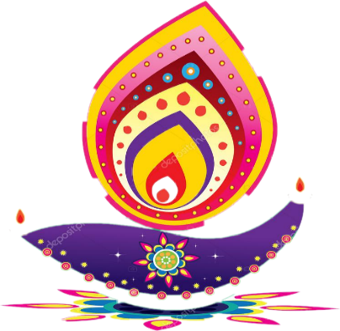


Winone Insight –“Aarambh”
Annual Newsletter Winone Precision Technology India Pvt Ltd I Edition 1 I Mar 22 – Mar-23



Leading Manufacturer of Smartphone’s
Precision Moulding Front & Back Cover
www.hz-winone.com
Winone Precision Technology India Pvt Ltd Greater Noida
(Precision Technology)



About This Edition  Welcome to the first edition of "Winone Insight," our company newsletter based on the theme of "Aarambh." From 01 March 2022, Sunwoda Electronic start its further journey with the name of Winone. This year is the most engaging and exciting time of the year as we celebrate various festivals and events, including the grand Diwali celebrations, Quality Month, Winone League of Legends, and more. Our employees have participated in these events with full energy, zeal, and enthusiasm, demonstrating their dedication towards the company's goals.  This edition of the newsletter is dedicated to our Winone employees who have displayed excellent team spirit and dedication towards sports. In addition, we have also contributed to society by reaching out to around 350 people in need of winter clothing through our clothing donation campaign.  This year has been highly productive, and each department has put in their 100% effort to achieve the company's objectives. We appreciate the continued commitment of our leaders and the Winone family towards the company's growth, and we hope to achieve new milestones together in the upcoming year.  We would like to express our gratitude to everyone who has made this year successful and enjoyable. Thank you! | Contents
   | Message from Leadership  03
  Key Highlights  07 | 
   | Customer Feedback  09
  New Hiring  10 | 
   | Feedback & Training  11
  Rewards & Recognition  12 | 
   | Winone-Aarambh  15
  Safety week & Women’s Day  16-17   | 
  Environment day & yoga Day
  18-19
  Party & Holi  20-21 | 
  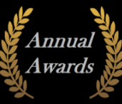   | Celebrations & Awards  22-31
  Tech. Updates  32-33 | 
     | Employee’s Corner  & Fun Corner  34-35
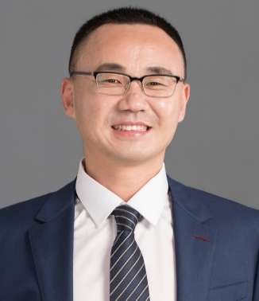  Mr. Denial Wang - Mentor | Many Time flies fast to the year of 2023. Wish you all have a happy and prosperous year in 2023.  2023 is a lucky year, there is no restriction any more for the pandemic of COVID all over the world. All of the people got right in their living & working | 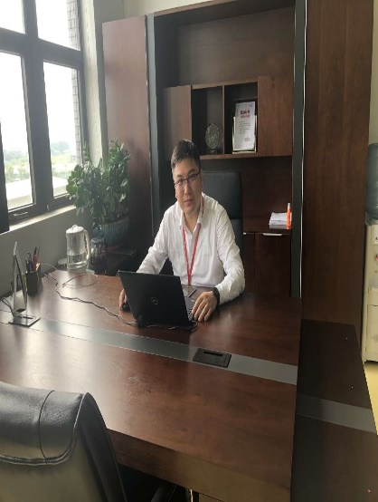  Message from Leadership  Mr. Kevin He- Director | In the past year, our company has overcome many difficulties, including difficulties in internal production and fierce competition in the external market, especially the great impact of COVID-19 on us.
ways already. However, we have to say, 2023 is a little bit tough. The global economic growth rate has declined and entered a medium to low speed growth track. From the current trend, it is almost certain that the global economic growth rate will decline in 2023, and the medium to long-term growth momentum of the global economy is also significantly.  But, we are very glad to see that the growth of India’s GDP in 2023 is expected at 7% which will be the highest in the world. Even though, we have to stress that, impacted by the shrinking of global economy, the market demand for smart phone was dropping, not only in global sites, but also in India. Source from Canalys, Indian smart phone shipment dropped 27% in Q4, 2022, comparing with the same quarter in 2021.  As one of the main suppliers for this industry, we are suffering from big pressure for our current business. Dear familiars, we sincerely hope that you guys should spirit up, focus on enhancing working/production efficiency and make good cost down in all operations to make WINONE more competitive in the supplying chain to earn more orders from our customers and clients.  I want to thank you for your continued efforts and encourage you to keep up the great work. Your contributions are invaluable. I know we can continue to achieve great things. Spring is coming; I hope that we can obtain success under everyone’s joint efforts to make WINONE better and better.  Let’s together, do better! |  | In the face of so difficulties, we are not afraid of difficulties, and we have made great progress under the hard work of all employees of the company. I sincerely thank everyone for every effort made to India Winone, We also hope that every employee can continue to accompany the company to a larger platform. With the increase of the company's business, every one of us should actively become the main force of the company's progress.  As we continue to handle this ever-changing landscape, I encourage you to stay positive and stay focused on the task at hand. By working together and supporting each other, I am confident that we can overcome any obstacle and emerge ever stronger on the other side.  Although we have passed the outbreak of COVID-19, we still hope that every employee can take good care of your health while working hard. I also believe that we also have the courage as we overcome COVID-19 to overcome all difficulties in the future.
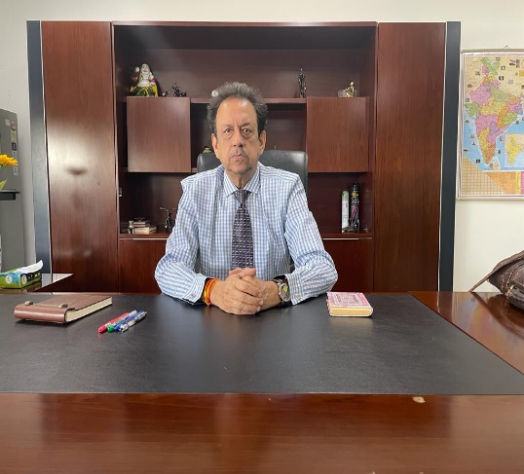  Mr. M.M. Shukla  Director |  | By all accounts, the process and pace of progress at Winone has never been a distant reality.  Our august organization’s work culture has been built upon – Teams, Togetherness, Talents & Time – powered by time-tested managerial expertise, experience and energy of team members, | 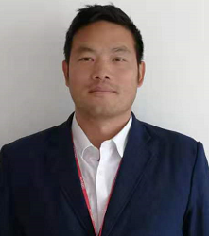  Mr. James  General Manager | As we enter 2023, it is my pleasure to reflect on the accomplishments of our India team at Winone Plant over the past year. I am proud to announce that in 2022, our business volume continued to increase, and we made significant progress as a company. In 2022, we continued to work  together as a team to
engaging in the various functions in the organization viz., Technical, Sales & Marketing, Customer’s Relations, Human Resource, Corporate Services & Administration etc., Undoubtedly, the unwavering commitment, unmeasurable dedication and unalloyed service-oriented mindset are hallmarks of our talented and top teams, which in clearer terms are our greatest assets, as well. More so, we stay steadfast in our beliefs, values, innovations and code of ethics and these are truly and thoroughly nurtured inside the company.  Leaders of these teams share a common focus and agenda, i.e., to serve our customers with quality products and services, please allow me to write down elevating ‘words of wisdom’ which would surely remain relevant, always and although.  Leadership First  “Great Leaders are not the best at everything. They find people who are the best at different things and get them all in the same team under one roof “.  Coming to conclusion, having High Hopes on the horizon, I am credibly clear and confident that all my good and great young colleagues would boldly shoulder the ‘wheel of progress and prosperity’ at Winone in the years to come. More importantly, let us stay connected to the Economic & Social eco-environment, circling around us.  With profound thanks to you and your families. Let us STAY AHEAD. |  |  | improve our factory's operations, ensuring the safety of all our colleagues. I would like to express my heartfelt gratitude to the entire team for their hard work and dedication. It is because of your efforts that we have been able to achieve such remarkable success. Let us continue to work together to achieve even greater accomplishments in the future.  I am thrilled to witness the continued growth of Winone Plant in India. Over the past three years, we have experienced rapid development and have become a leading performer on behalf of our company in the Noida region. Thank you all for your unwavering support and hard work. We are constantly developing new customers and resources, and we look forward to securing even more orders in the future.  Once again, I would like to express my appreciation to the entire team for their support and hard work. Let us continue to work together to achieve new heights of success in the coming year.
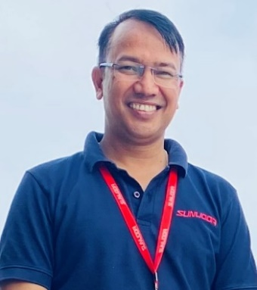  Mr. Shankar Singh  Head-HR & Admin |  | Greeting to all the team members!  I wanted to take a moment to express my gratitude for the hard work and dedication that each and every one of you brings to our organisation. Over the past year, we have faced | 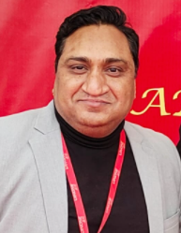  Mr. Rajinder Arya  AGM-Production | Hello all of you,  I congratulate and appreciate to see you and your hard work for this strong courage to the completion of your daily task and goals to making the customer happy and cheerful for our WINONE
many challenges, but you unwavering commitment to our shared goals has kept us moving forward.  As we continue to navigate the challenges of today’s business world, I want to assure you that your health and safety remain our top priority. We are closely monitoring the situation and taking every precaution to ensure that our work place is as safe as possible.  At the same time, I want to encourage all of you to stay focused on our goals and to continue working together as a team. Despite the obstacles we may face, I am confident that we will emerge from this stronger and more resilient than ever before.  Please know that you contributions to our company are deeply valued and appreciated. I encourage you to take care of yourselves and your loved ones, and to reach out to your colleagues and managers, if you need any assistance or support.  Thank you for your hard work, your dedication and your unwavering commitment to our shared success.  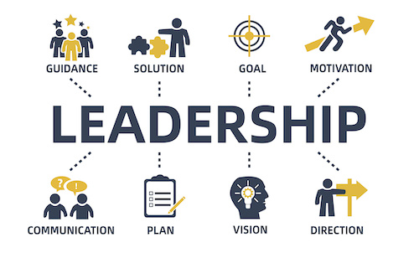 |  |  | Cheers to you all team for a job well done no one can compare to your creativity and passion towards your successful efforts which you always pushed your own abilities to the limits to make this success happen for development of the company.  As you worked towards this victory, you behaved with such humility, grace and kindness to others. We as management of Winone Precision always appreciates how you share your success with your whole team and your love and dedication towards your company members is one of the big reason that you are rising day by day to the top.  Best wishes to all of you for glorious future where still we have to touch the glorious sky by our continuity of positive efforts and amazing contribution for the company.  And be excited healthy and keep yourself more motivated towards the new goals and targets.  And let’s make coming HOLI festival together with full of JOY and frightful colours.  PASSION+ACTION= RESULT  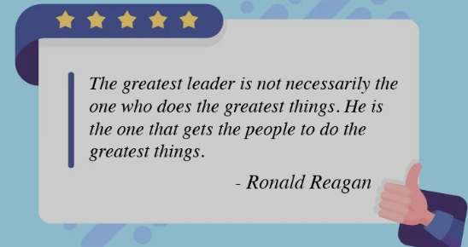

Key Highlights
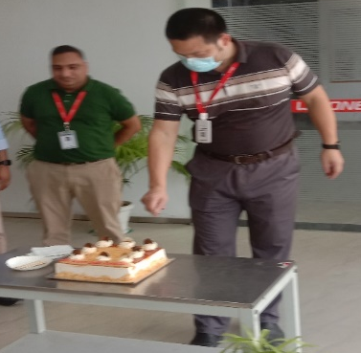
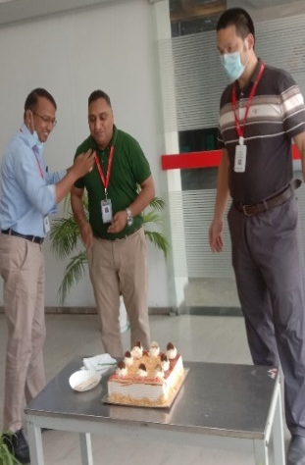

3rd foundation day of Winone
Congratulations on the 3rd anniversary of our plant Winone-Greater Noida! It is wonderful to hear that our plant has achieved significant milestones in both production and quality in the past three years.
It is a testament to the dedication and hard work of your Factory Manager and AGM-Manufacturing, as well as the guidance and support of your top management. It is always great to feel proud of being part of a successful team, and I can understand your enthusiasm for greater success and progressive growth for the company.
I wish you all the best as you continue to strive for excellence and look forward to hearing more about Winone's achievements in the future.
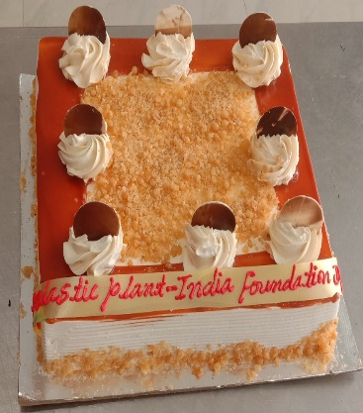


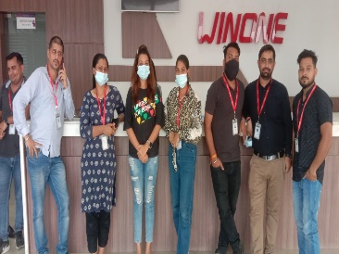
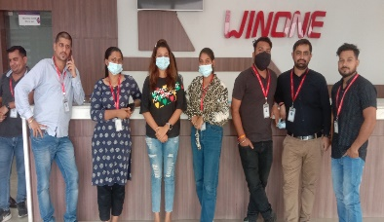
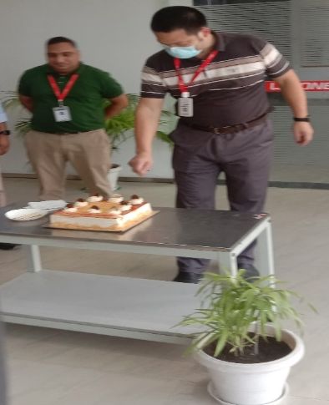
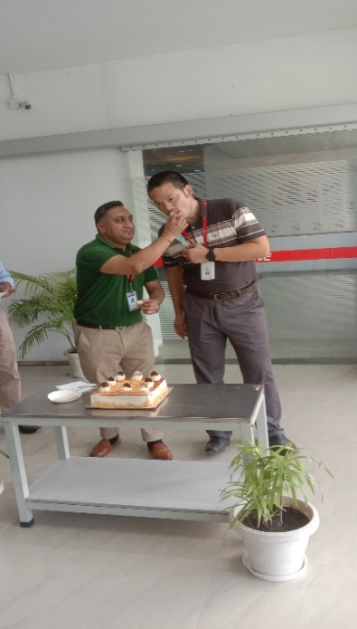
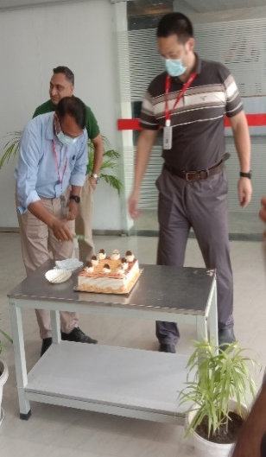
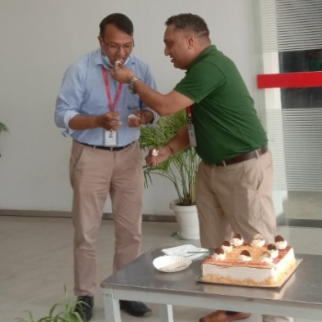
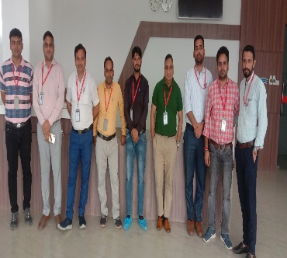


Customer’s Feedback
I am writing to express my sincere appreciation for the exceptional quality of your products and services. As a long-time customer of Winone, I have always been impressed with the consistent high-quality products that you manufacture.
Your commitment to excellence and attention to detail is evident in every product you produce. The manufacturing unit operates with remarkable efficiency, which ensures that your products are always delivered on time and with precision. The professionalism and expertise of your team is truly impressive and it reflects in the superior quality of your products.
Thank you for your dedication to excellence and for being such a reliable supplier of quality products. I look forward to continuing our business relationship for many years to come.

Mr. Pankaj Pandey
DBG Technology (India) Pvt. Ltd.

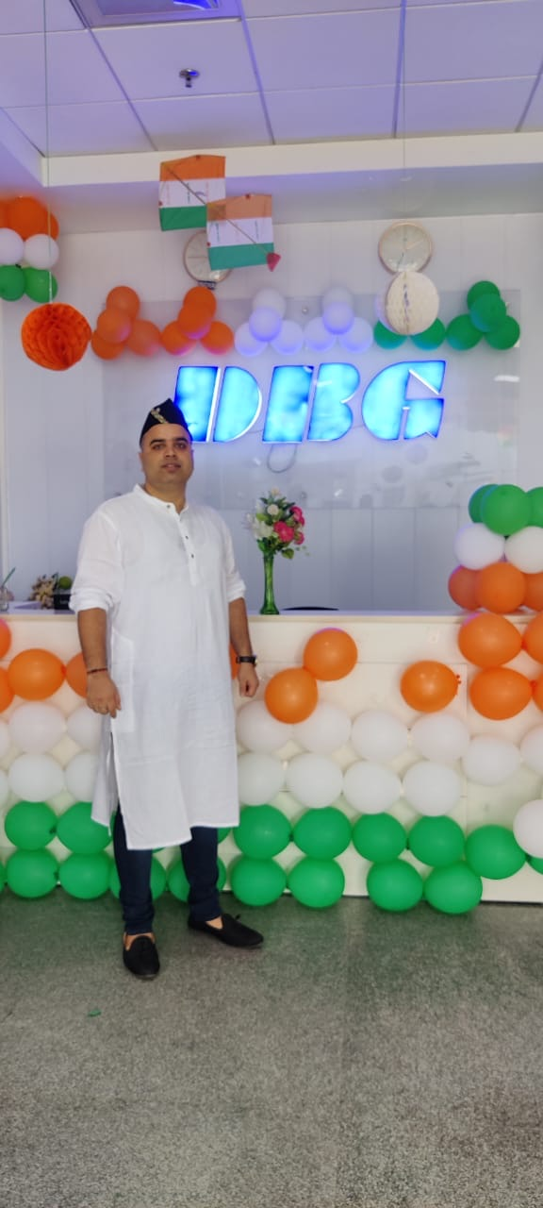

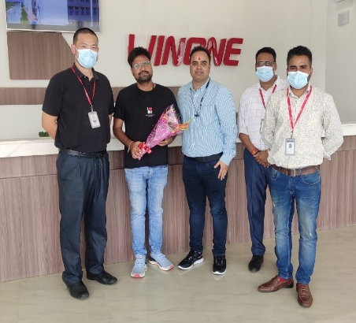
The "new normal" has undoubtedly altered the way we think and live, and Winone has shown the ability to effectively manage both customer satisfaction and quality production. Their well-established procedures for providing prompt customer support and ensuring defect-free, timely delivery are commendable. We extend our appreciation for their commitment to customer satisfaction and their policies aimed at meeting the needs of their customers.
Team
Vivo India Pvt. Ltd.

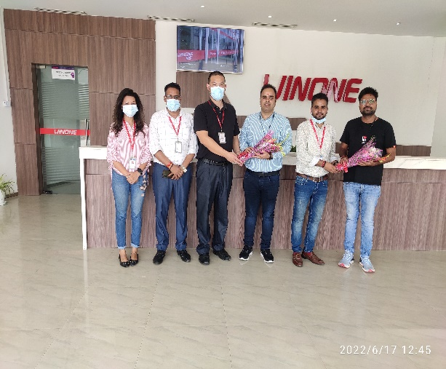




Welcome New Joiners!
We are Happy to Have You On –board
Welcome aboard! We are thrilled to have you as part of our team. As you embark on this new journey with us, we want to extend a warm greeting and share some important messages with you.
First and foremost, we are a team that values collaboration, inclusivity, and mutual respect. We believe in fostering a positive and supportive work environment where everyone's ideas and contributions are valued. We encourage you to bring your unique perspectives, skills, and talents to the table and actively participate in team discussions and activities.
Once again, welcome to the team! We look forward to getting to know you and working together towards our common goals.
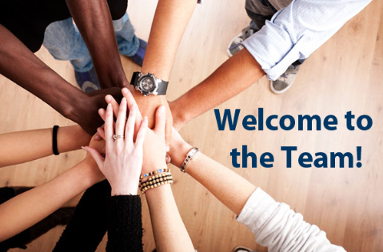

I consider Joining Sunwoda as a turning point in my career, it is great pleasure in itself to associate with diverse and skilled people here and the best part is that it works like a family here. Sunwoda's working environment is great and it makes me feel Confident, the teammates are also very helpful and supportive in nature. I am grateful to have Supportive Seniors and Management, look forward to learning more and using my skills for the betterment of Organization, Department and Individually.

Akash Rana-Finance
मैं महिपाल, आपका नया सहयोगी, और मैं गर्व से घोषित करता हूँ कि मैं विनवन कंपनी का हिस्सा बना हूँ। यहां काम करते समय मेरी अनुभूति बहुत अच्छी रही है, और मैं अपनी नौकरी को बहुत मान्यता देता हूँ। यहां कंपनी का समर्थन बहुत बड़ा है और हमें समय पर बड़े सामर्थ्य और संबद्धता के साथ पुरस्कृत किया गया है।
मैं खुशी से बताना चाहूंगा कि यह कंपनी मुझे ऑफ रोल से ऑन रोल में भी बढ़ाने में सक्षम रही है। मेरी कामगिरी और प्रगति को मान्यता देते हुए मेरी पदोन्नति की गई और यह मेरे लिए गर्व की बात है। मेरी इस यात्रा में आप सभी का साथ और समर्थन मेरे लिए बहुत महत्वपूर्ण था और मैं आपकी सभी की आभारी हूं /
Mahipal-Warehouse

I express my gratitude for the warm welcome I have received since joining the company as a Jr. Executive in the Purchase Department. My name is Monika Gupta, and I am thrilled to be a part of such a wonderful team.
I would like to take this opportunity to thank all the members of the company, my managers, and colleagues who have supported and encouraged me during difficult times. Your kindness and guidance have been invaluable, and I am grateful for the opportunity to work with such an amazing team.
Monika Gupta-Purchase



First Aid Training
On 30th Sept 2022, Frist Aid Training had organised by Trainer Ms. Lissy Mol Abraham. First aid training is a crucial component of workplace safety and preparedness. It equips employees with the knowledge and skills to respond effectively to medical emergencies and provide initial care until professional medical help arrives. Here's an overview of what could be covered in a first aid training program:
1-Basic Life Support
2-First Aid for injuries
3-Medical Emergencies
4-Environmental Emergencies
5-Emergency Action Plan
All the participants had awarded by the First Aid Trained Certificates.

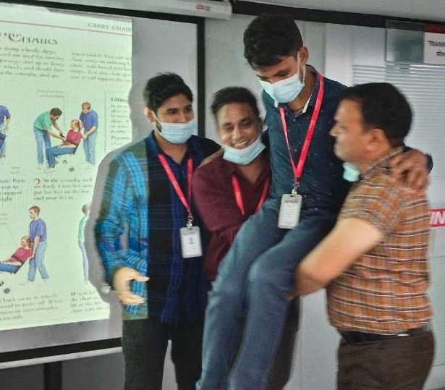
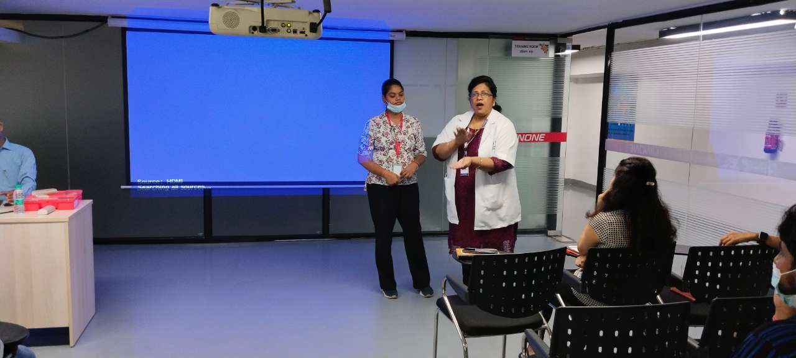
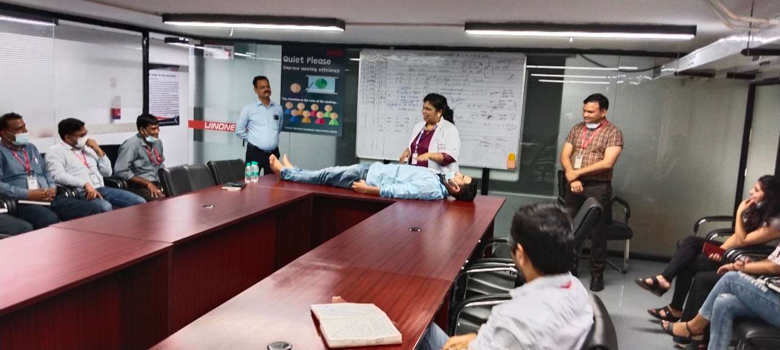
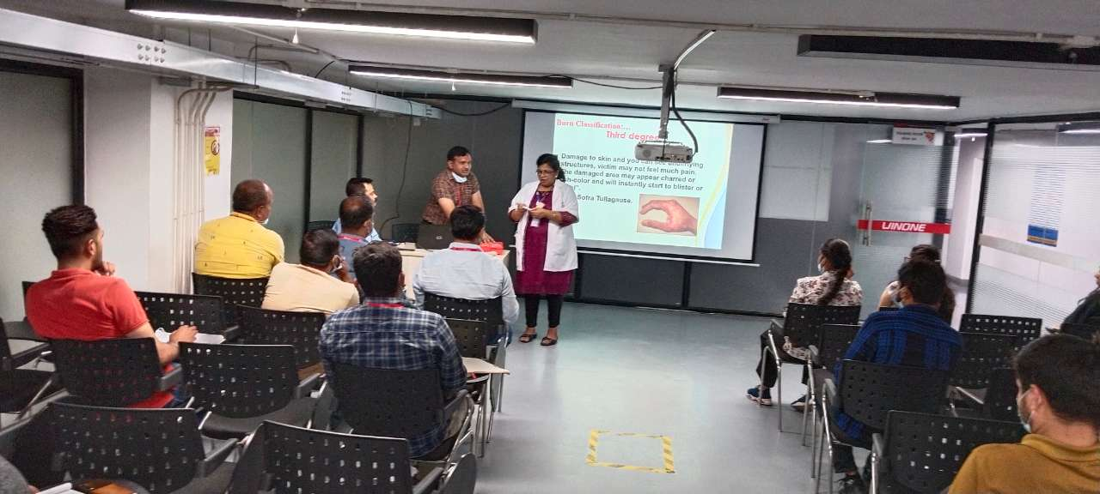

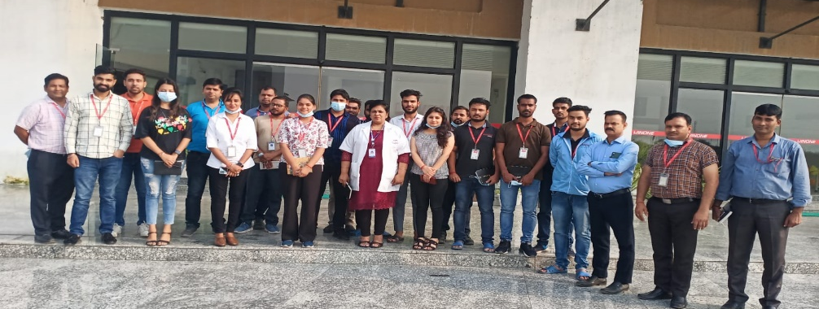

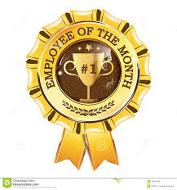
Reward & Recognition - 2022
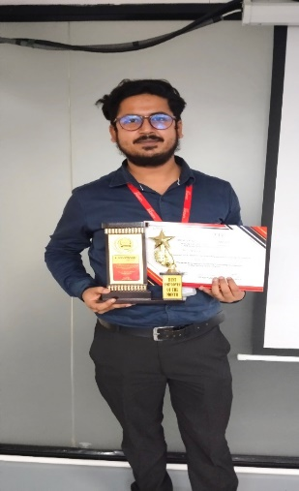
I would like to thanks you for this award. I am glad that you found me capable and chose me for this award. This award means a lot to me. This will help me grow my professional skills.
I am immensely humbled to be receiving this special certificate from you. This certificate sincerely acknowledges my effort, and it is a huge admiration. I am exceedingly overjoyed to receive this great honor. I want to give my sincere thanks to everyone who supported me and encouraged me to get this far.

I am deeply grateful to receive this award. Being recognized for my work means a lot to me, and I am honoured to be included among such an esteemed group of recipients. I want to thank you for your support and encouragement throughout my career.
I would also like to acknowledge the team who helped me achieve this award. Their hard work and dedication have been instrumental in my success.
Thank you again for this award. I will cherish it always.
Mr. Pratik Kumar – Winner – June 2022 2022.
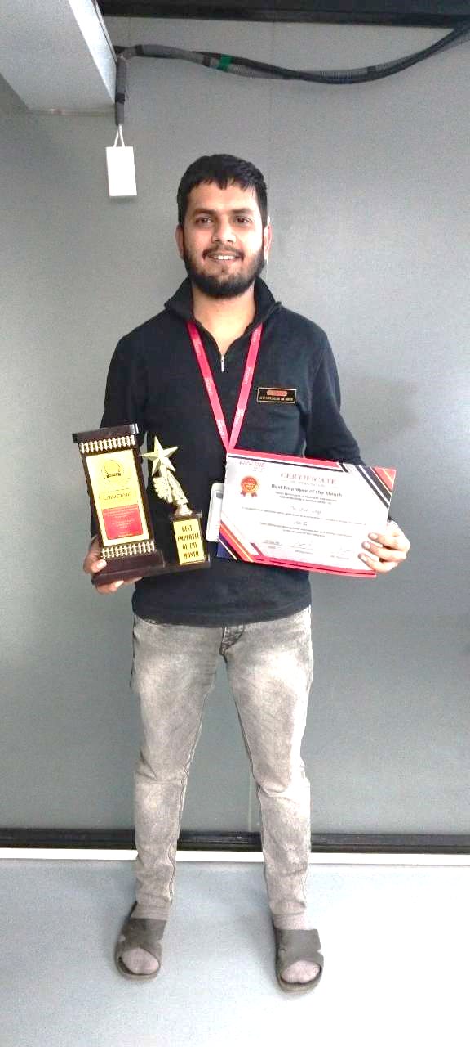
Ms. Sabiya Fatma
(HR)
Mr. Utsah Singh – Winner – Nov 2022.
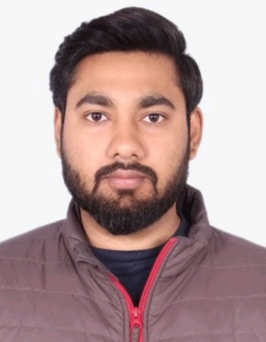  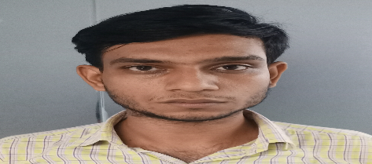  July  June  August  May  Mr. Rishabh Awasthi  (Plastic Assembly)  Mr. Aman Singh  (Paint Shop)  January  February | 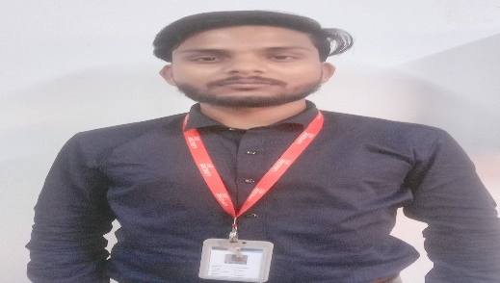  Mr. Aakash  Quality  March | 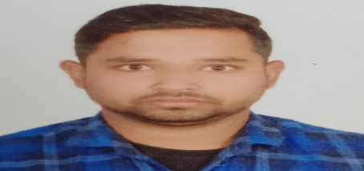  Mr. Ramesh Kumar  (Tool Room)  April
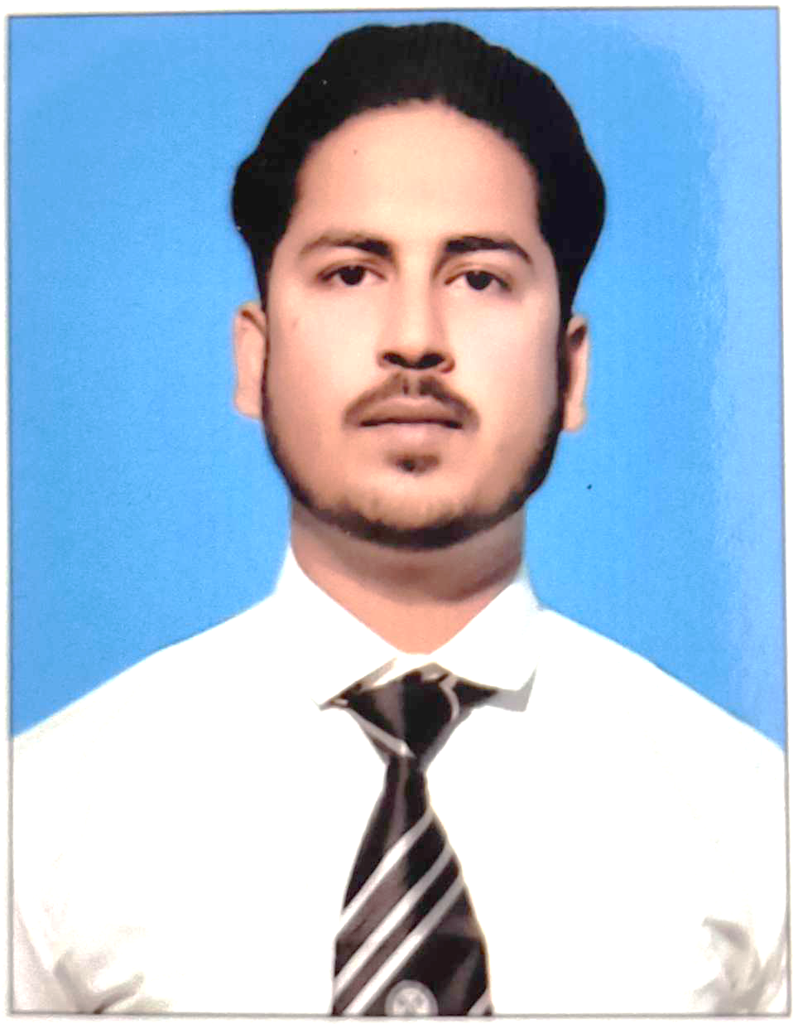  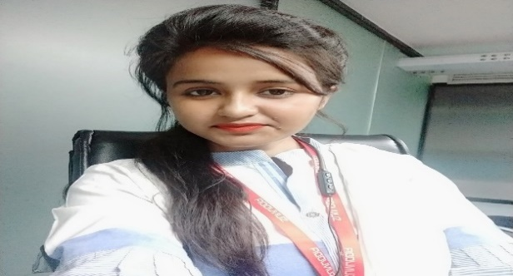  Mr. Pratik Kumar  (Quality) | 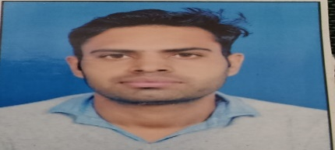  Mr. Ravindra  (Moulding) | 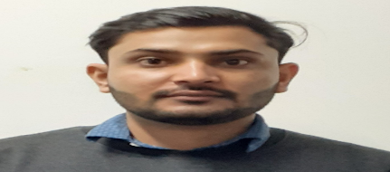  Mr. Arvind Panwar  (Assembly)
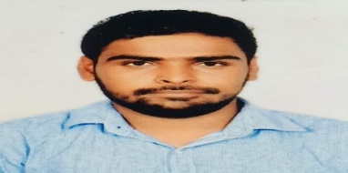  Mr. Ajay Kumar  (Quality) | 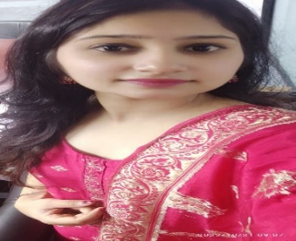  November  October  September  Ms. Varsha Singh  (Admin) | 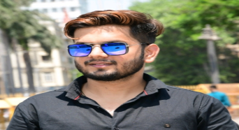  Mr. Utsah Singh  (Assembly)

Meet our Star Performer of the Month - 2022 2022


Star Performer of the Month to improve skills of operators, as well as Work Knowledge, Productivity, Quality of performance, Behaviour, Discipline, Punctuality of manpower at shop floor. Operator’s skills are enhancing day by day. There is lot of competition developed among the workers to win Star performance awards.
To encourage and appreciate our off roll employee’s work, every month this awards gives to each Production, Quality, Security & Housekeeping. This will lead them competitive. This year we have 234 Star performers from Plastic Assembly, Paint Shop, Injection Moulding, Quality, CNC, Security & Housekeeping.

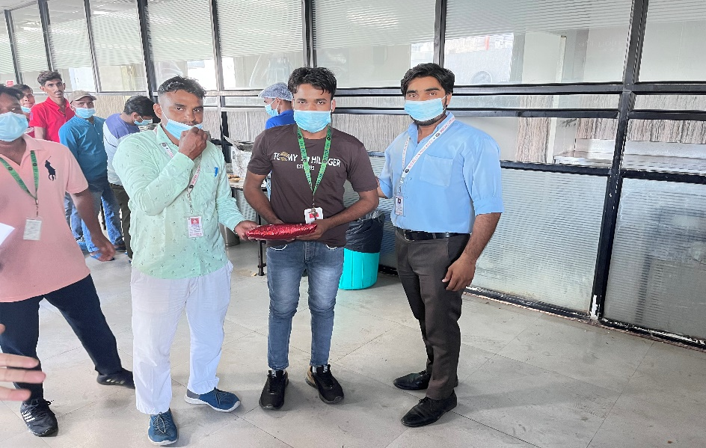
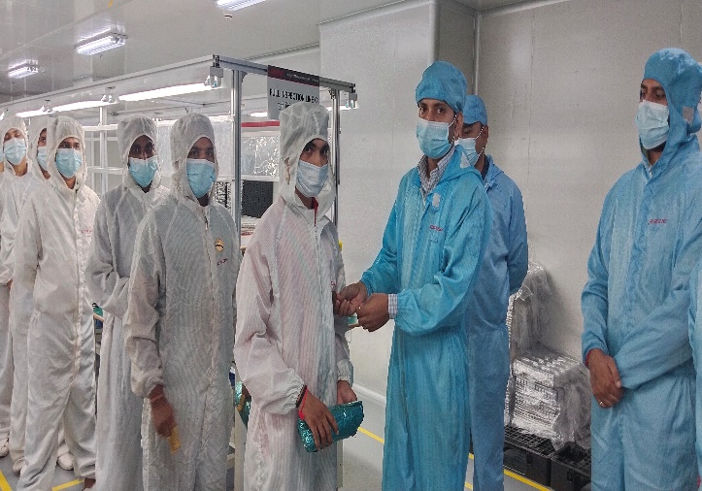
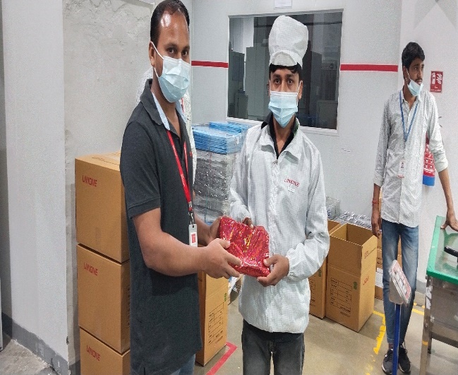
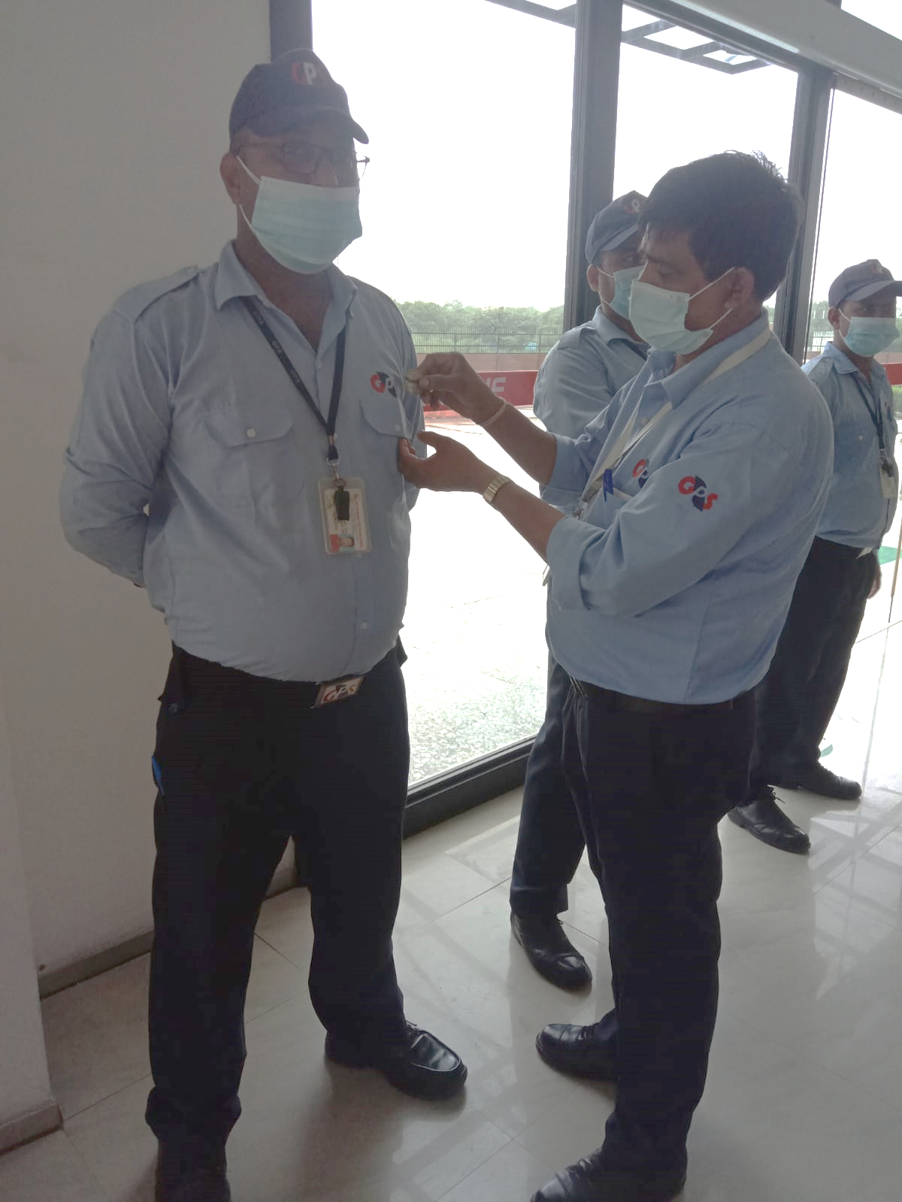
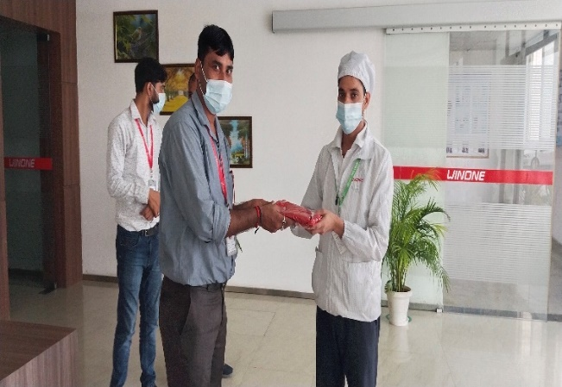
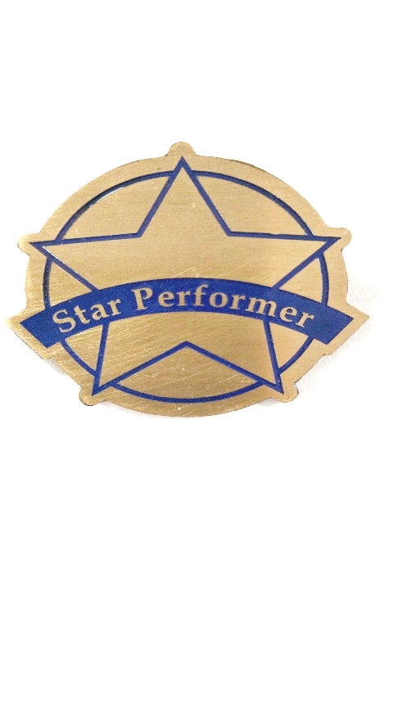
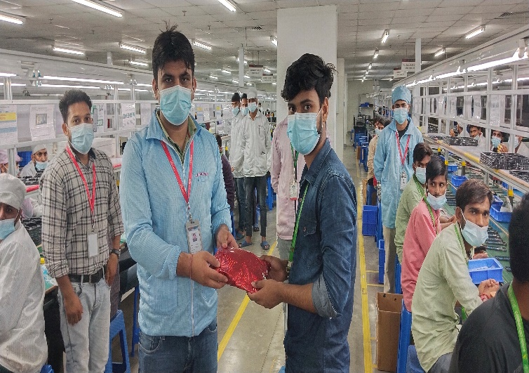
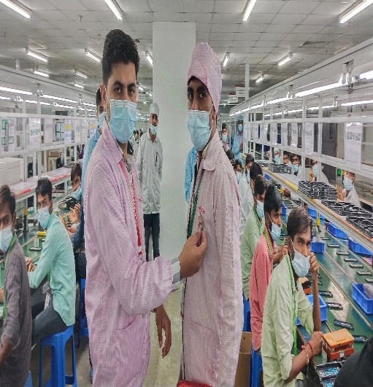
“Courage is the most important of all the virtues because without courage, you can't practice any other virtue consistently.” ―Maya Angelou


“Quiz on the Go”- Workplace Activity
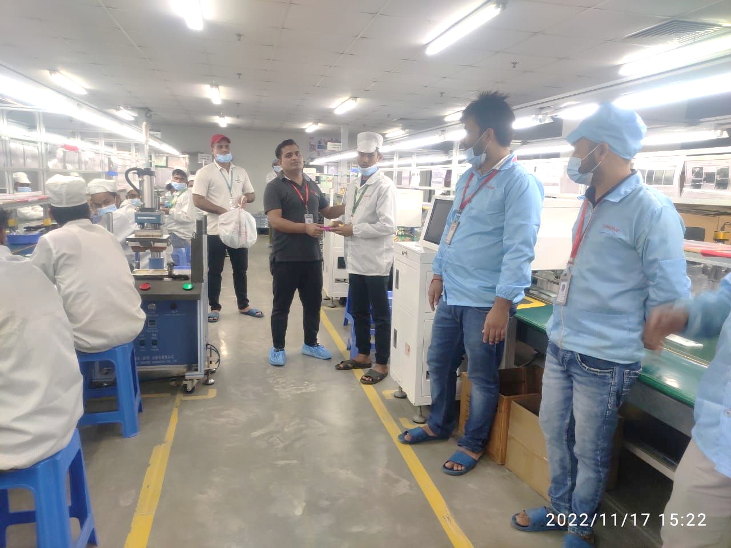
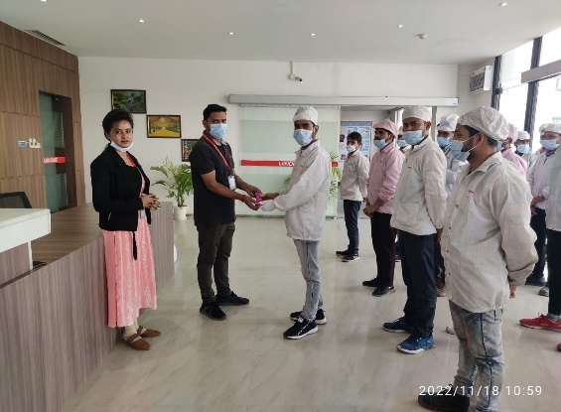
The objective of this activity is to ensure the knowledge flow between off- roll manpower related with organization and their daily work which help to enhance the active learning and increase motivation towards their job. This will also give them a platform to interact and communicate. HR Team have visiting all production department floors to interact with employees. It was an interactive session with active participation from employees. All the winners are awarded with spot gift.

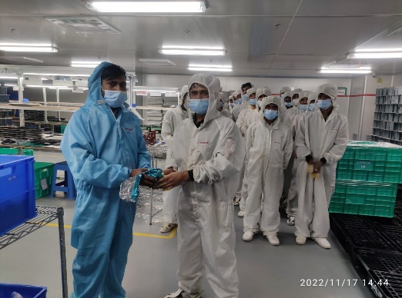
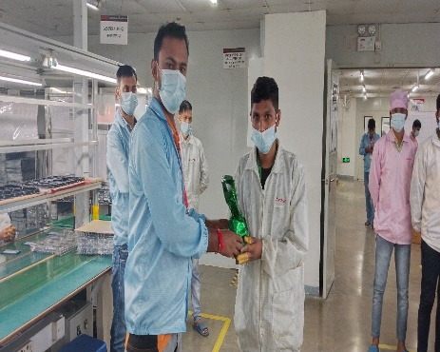

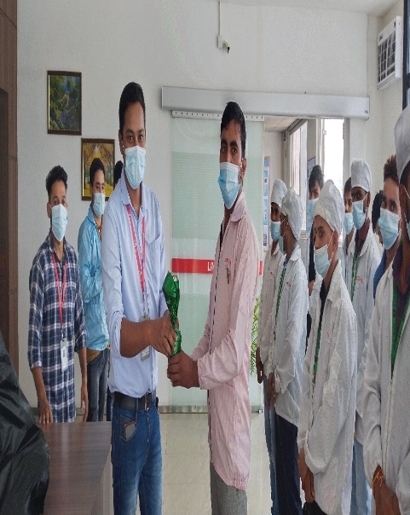

Focus on being productive instead of busy.
~Tim Ferris~
Mr. Aman Kumar – Operator - Paint Shop
“मैंने यहाँ Winone में अक्टूबर २०22 में ज्वाइन किया है और तभी से मै यहाँ बहुत सी नयी चीजें सीख रहा हूँ। यहाँ पर होने वाली प्रतियोगिता और क्विज एक्टिविटी हमें अपना हुनर दिखाने का अवसर देती है। यहाँ हमारे सीनियर भी बहुत ही सहयोग करते है और हमेशा नयी चीजों को सीखने के लिए प्रेरित करते है। सभी ऑपरेटर को समान अवसर मिलना उनके आत्मविश्वास को बढ़ावा देता है।“

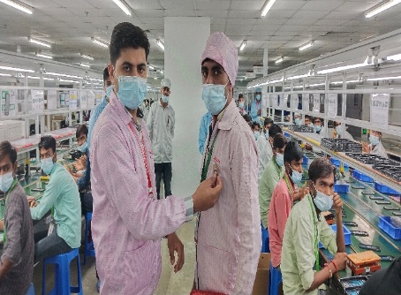
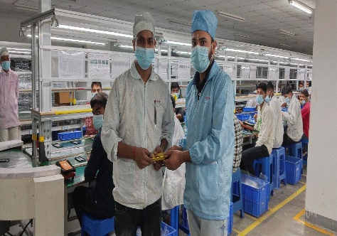

Ability
Is what you’re capable of doing.
Motivation
Determines what you do.
Attitude
Determines how well you do it.


On March 1, 2022, Sunwoda Precision unit underwent a significant change and was rebranded as Winone Precision Technology. The inauguration ceremony was graced by the honourable presence of Mr. Denial and Mr. B.K. Sirohi, Directors of Sunwoda, Mr. Manmohan Shukla, Director of Winone, Mr. James, General Manager and Mr. Shanakr Singh, Factory Head. This event marked a significant milestone in the company's history, signalling a new beginning and a commitment to making a positive impact on the world.
As a leading company in its field, Sunwoda Precision unit has been known for its innovative solutions and cutting-edge technology. With the new name Winone Precision Technology, the company aims to continue its legacy and pursue new opportunities for growth and development.
The inauguration ceremony, held at Winone Plant location, was attended by a large number of people from the company's management and staff. The speakers Mr. Denial, Mr. Manmohan Shukla and Mr. Shankar Singh delivered inspiring speeches that emphasized the company's values and vision for the future.
Overall, the rebranding of Sunwoda Precision unit as Winone Precision Technology represents a significant step forward for the company. With a renewed focus on innovation, technology, and sustainability, Winone Precision Technology is poised to make a positive impact on the world and lead the way in its field.

Winone –Journey continue with new cover
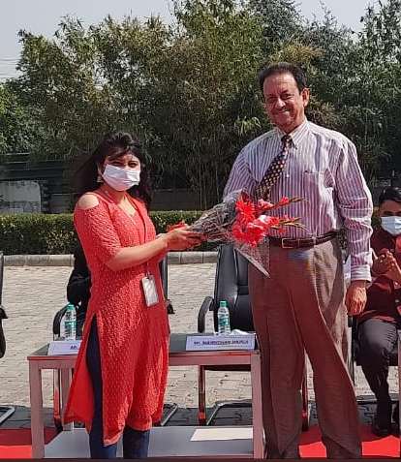
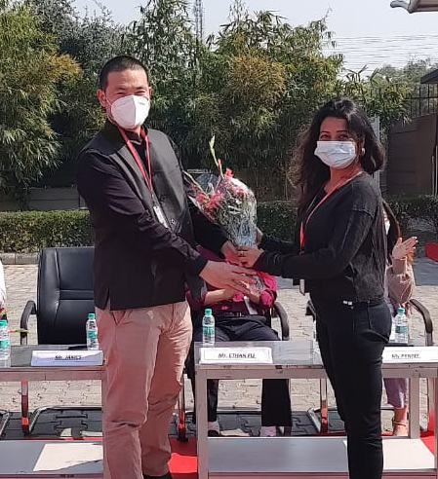

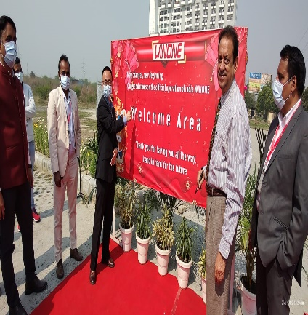
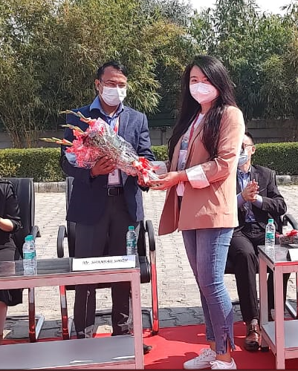
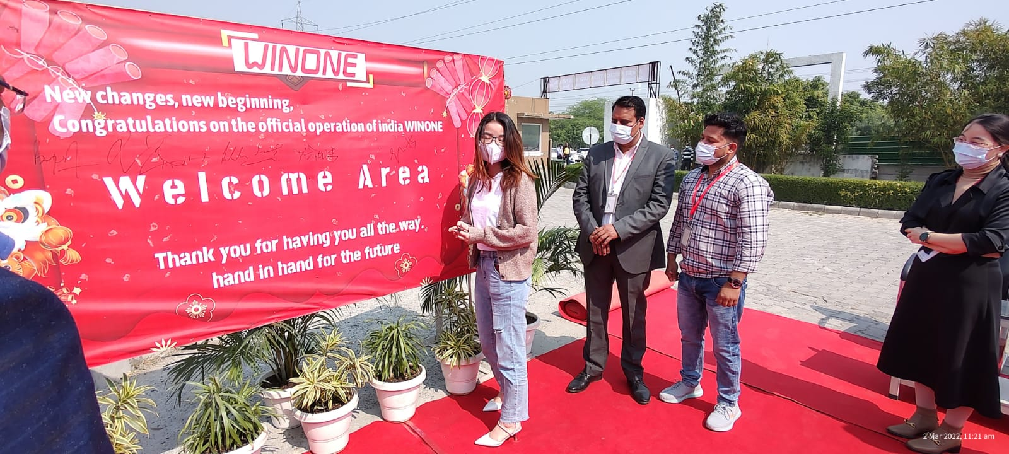
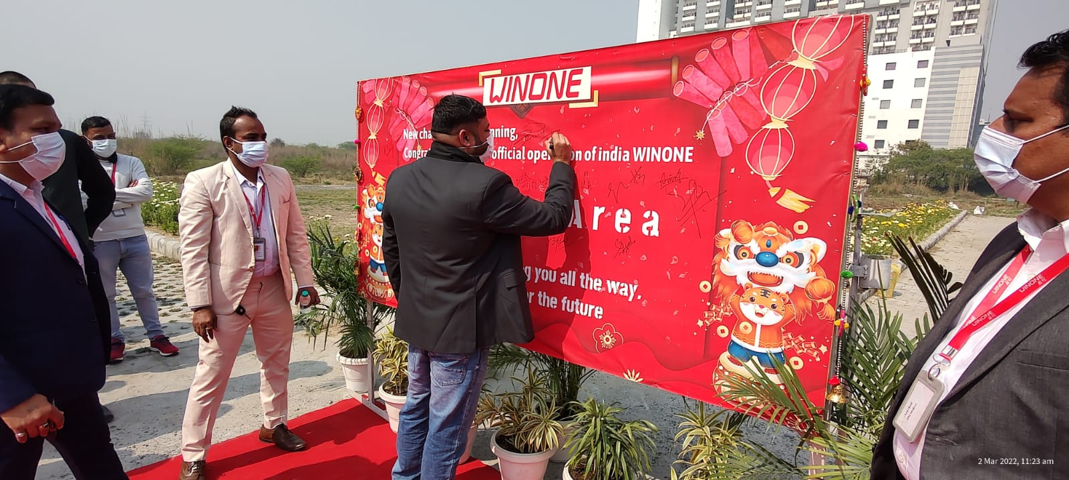

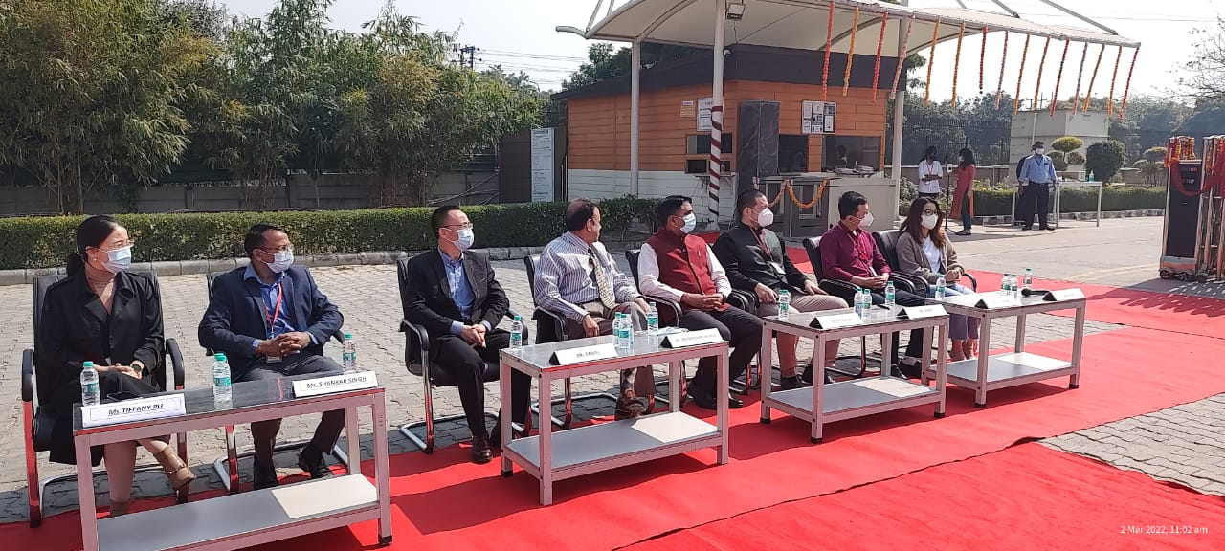

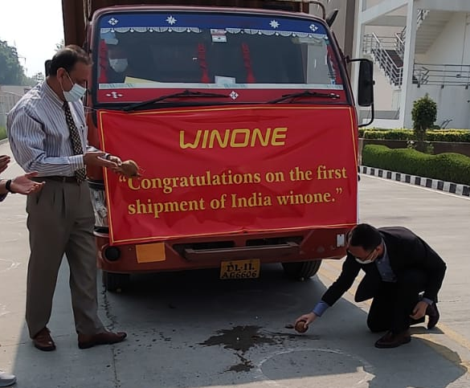
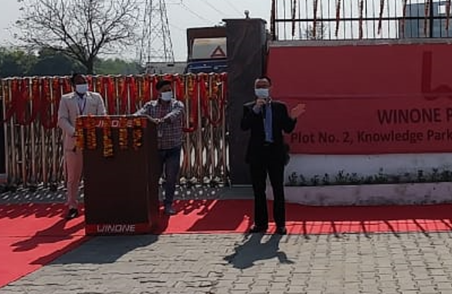

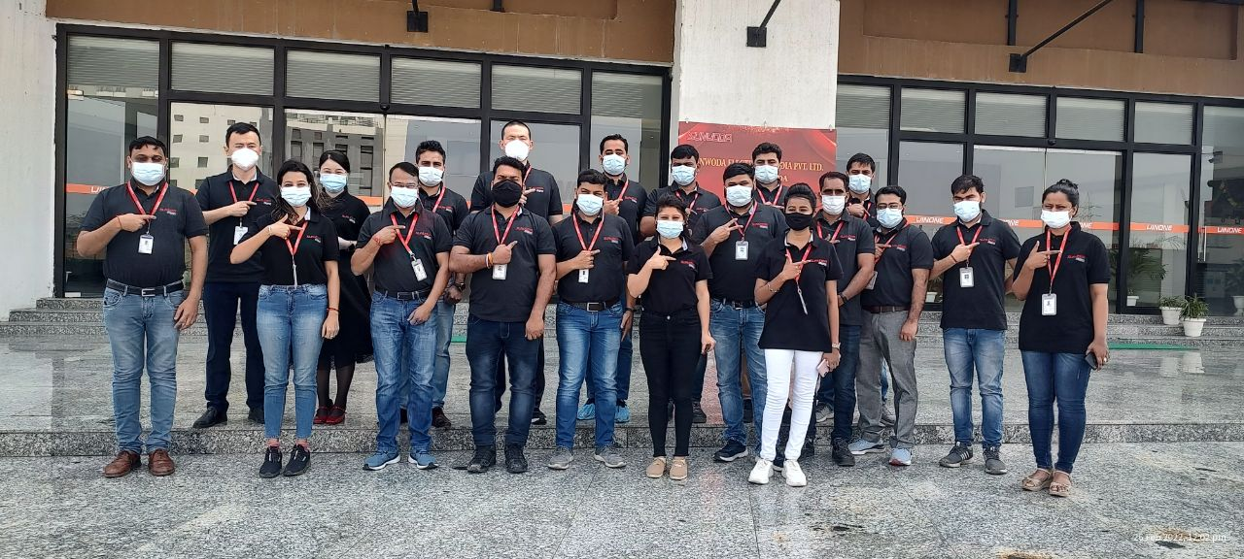
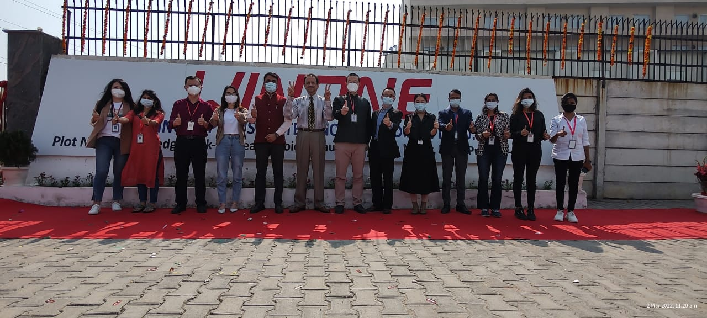

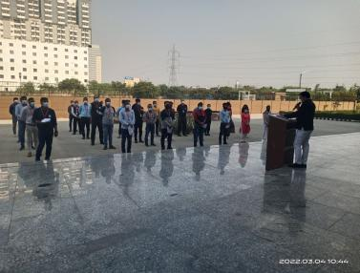
National Safety Week (4 -10th March-2023)
National Safety Week is an opportunity for everyone to come together and work towards creating a safer and healthier workplace and society. It is a reminder that safety should be a priority and not just an afterthought. By promoting a culture of safety, we can build a sustainable future where everyone can work and live without fear of accidents or injuries.
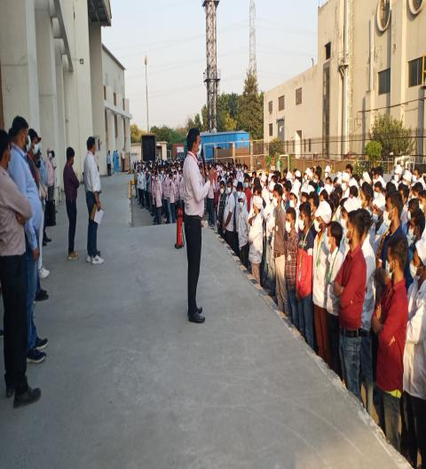

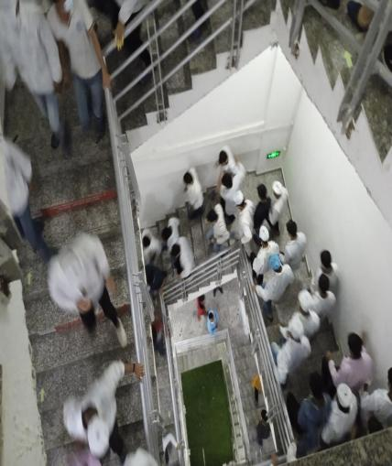
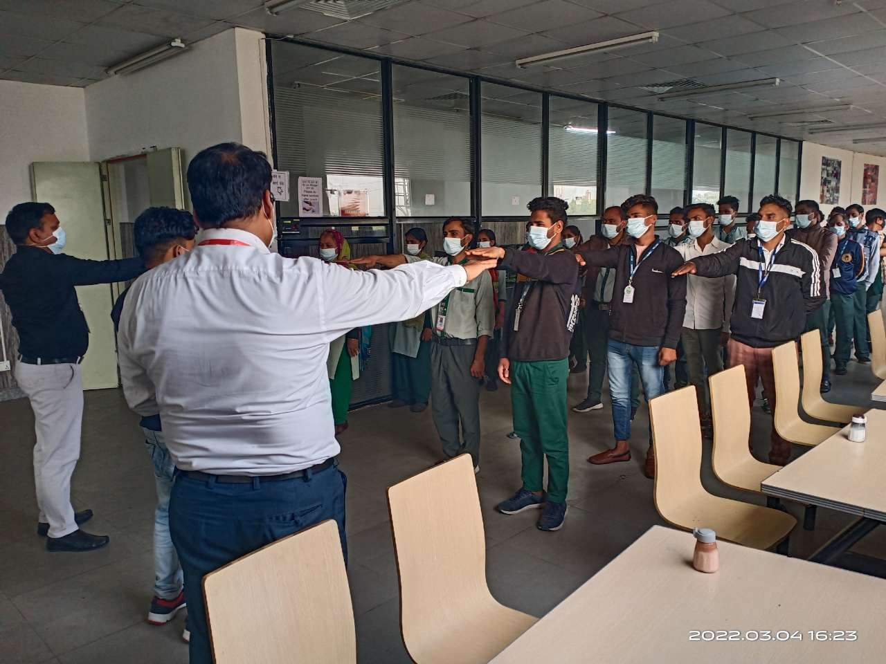

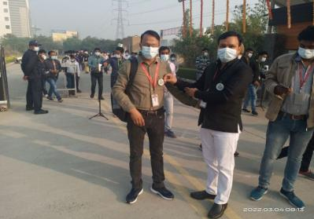
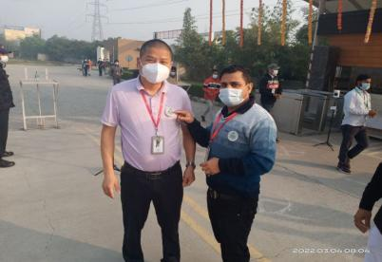
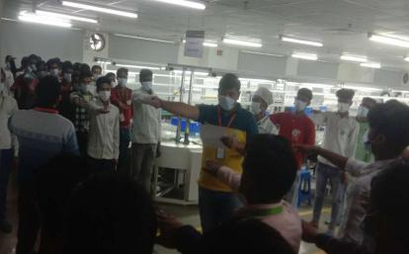

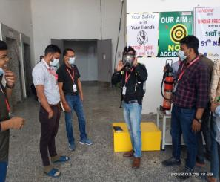
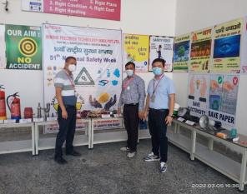
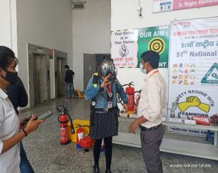

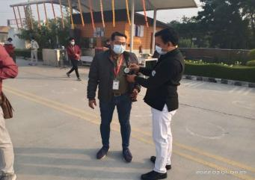
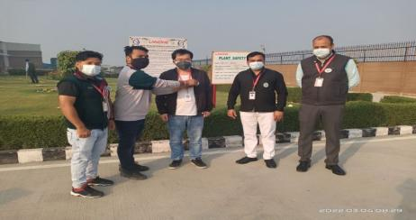

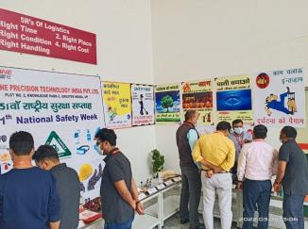
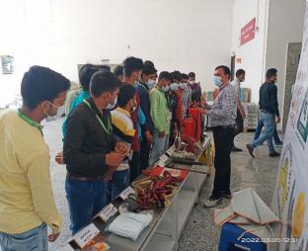
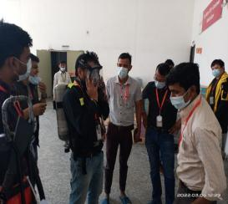

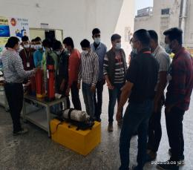
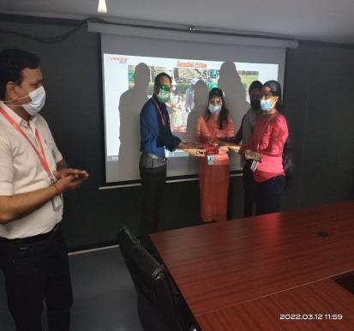
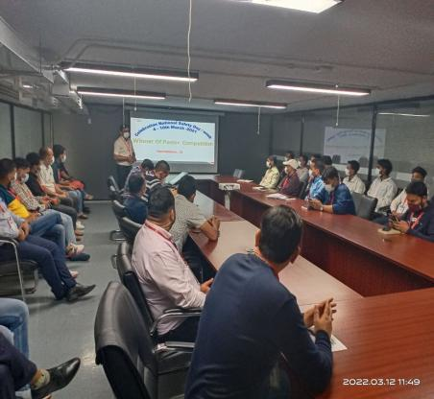

National safety week started on 04 March-10 march 2023 during this period the main emphasis was on safety-related activities, programs & workshops.
In 2023, there were various activities organized such as Badge Distribution, Safety Oath by all the company Staff & workers, Safety Poster competition, Safety slogan competition, PPE exhibition, Safety role-play, Mock Drill, Fire Fighting competition & many workshops & training organized throughout the week. These activities provided awareness to all manpower, creating a safe & accident-free environment in the company.

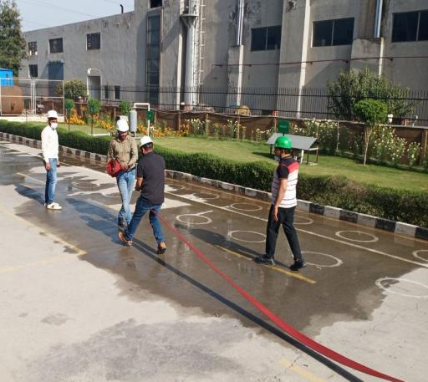
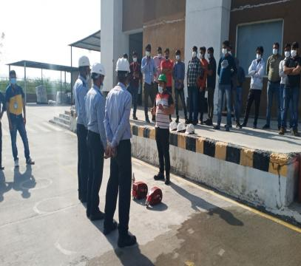

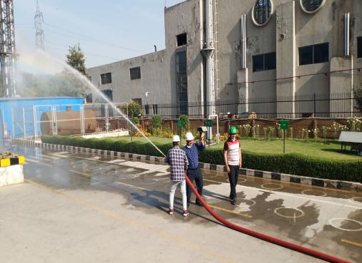
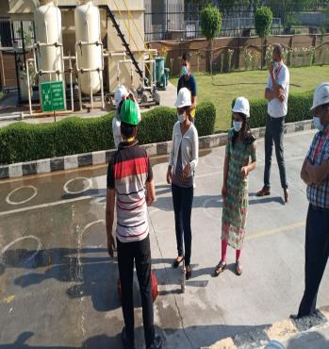
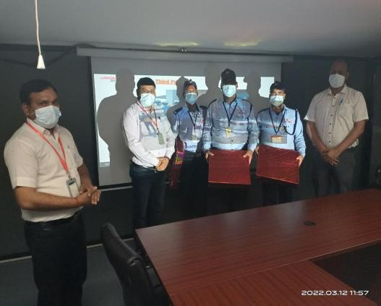
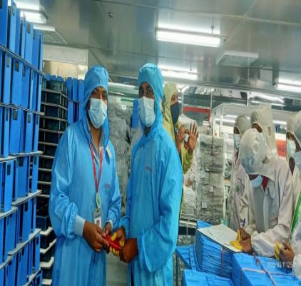
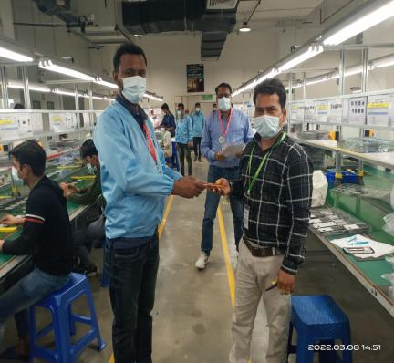

Women’s Day


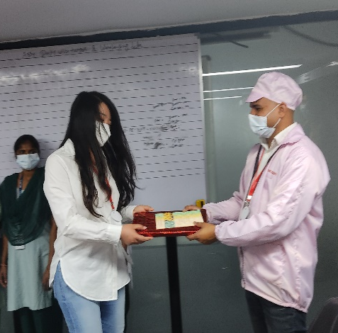
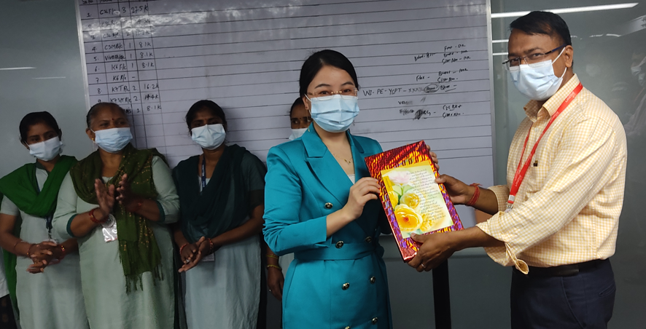
International Women's Day, celebrated on March 8th every year, is a time to recognize the incredible achievements and contributions of women throughout history. It is also a reminder that there is still work to be done in achieving gender equality around the world.  This year's theme for International Women's Day is #ChooseToChallenge, calling on all of us to challenge gender bias and inequality, and to create a more inclusive and equal world.  As we Winone celebrate International Women's Day, let's not only recognize the progress that has been made, but also commit to doing our part to create a more equal and inclusive world. Let's choose to challenge gender bias and inequality wherever we see it, and support women in their pursuit of equal opportunities and rights.  Let's celebrate the incredible achievements of women throughout history, and the inspiring women in our own lives. And let's work together to create a world where every woman and girl can achieve their full potential.  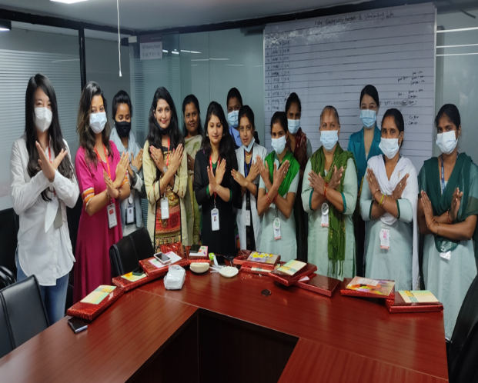 | 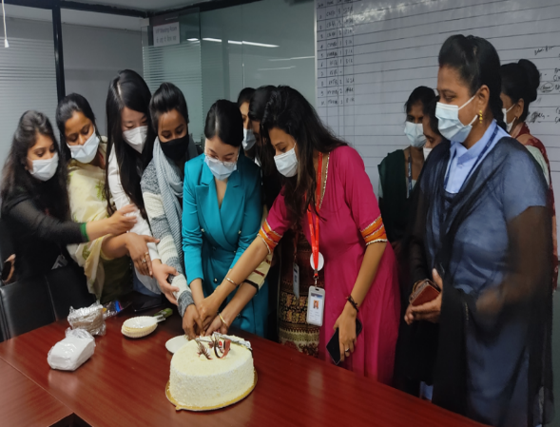
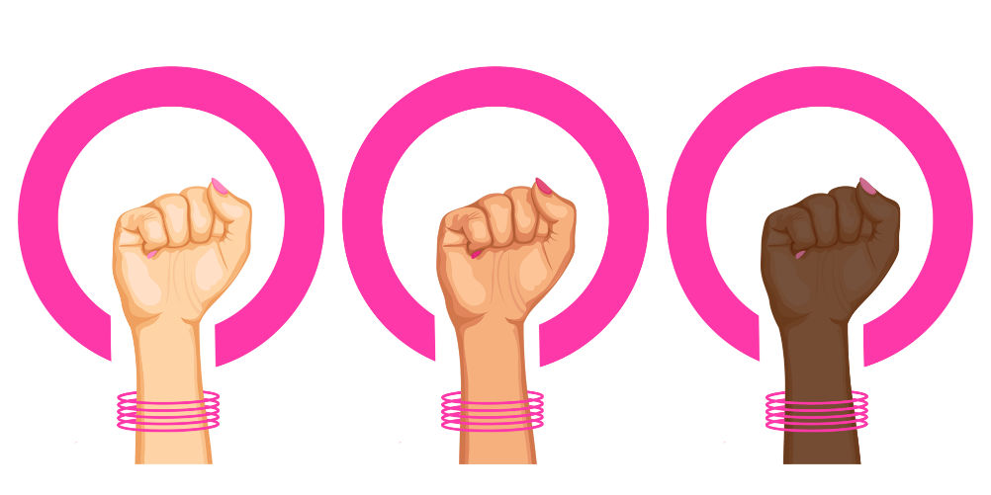  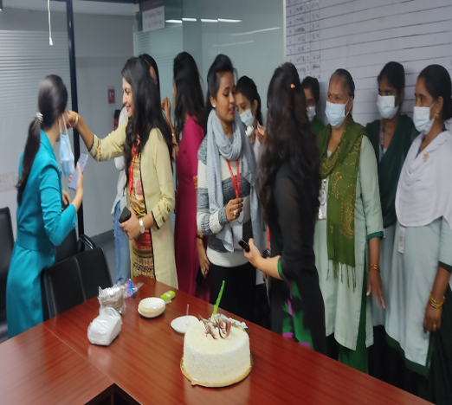 | 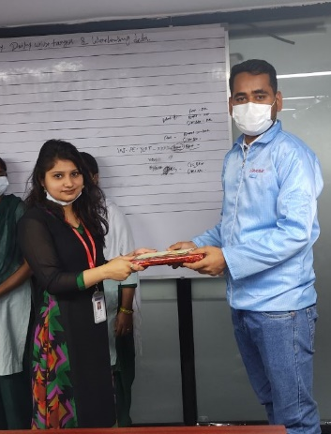  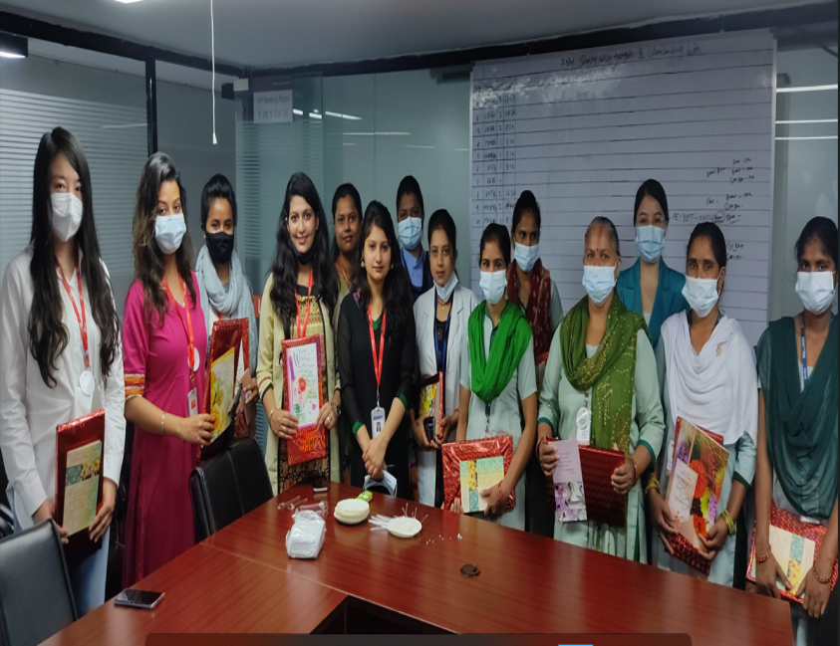  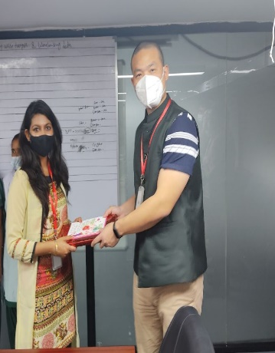

World Environment Day
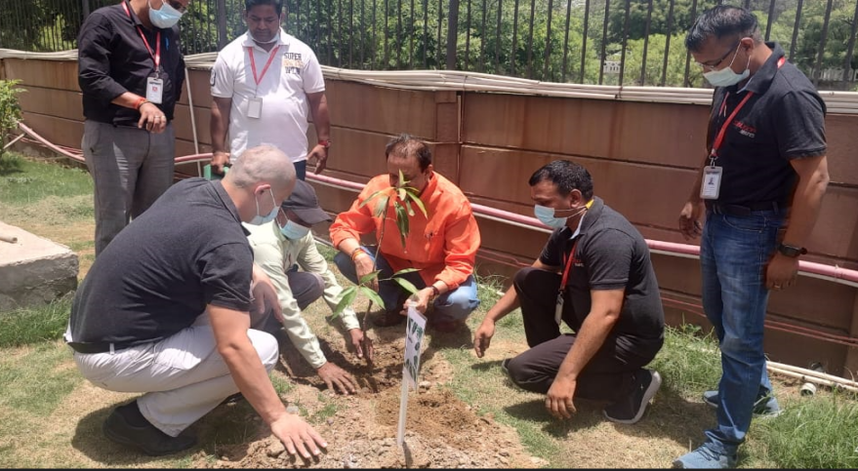
World Environment Day 2022 will be celebrated on 5 June. It is the biggest international day for the environment. The purpose of celebrating this day is to raise awareness among people to protect the environment.
The theme of World Environment day 2022 is “Only One Earth”, under this theme, World Environment day will be observed, highlighting the need to live sustainably in harmony with nature. This day provides us with an opportunity to take responsible steps to preserve and enhance the environment.
This day is celebrated every year to remind the people across the globe about the harm we have been causing to our environment, how we have disturbed the natural balance of our environment, and what measures can be taken to reverse the damage. Winone India also celebrated this Day by planting trees across the premises and taking pledge to contribute toward environment sustainability.

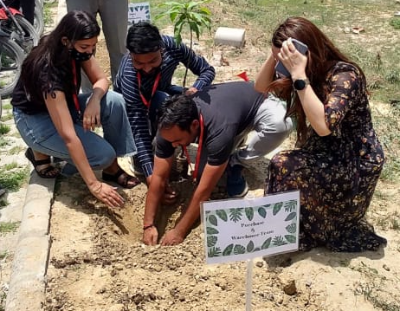

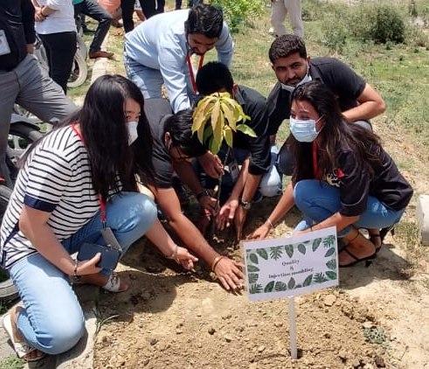

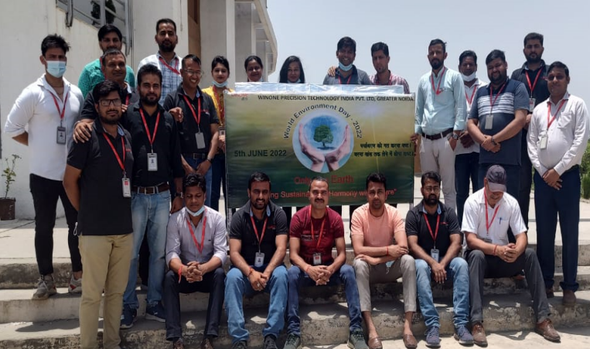

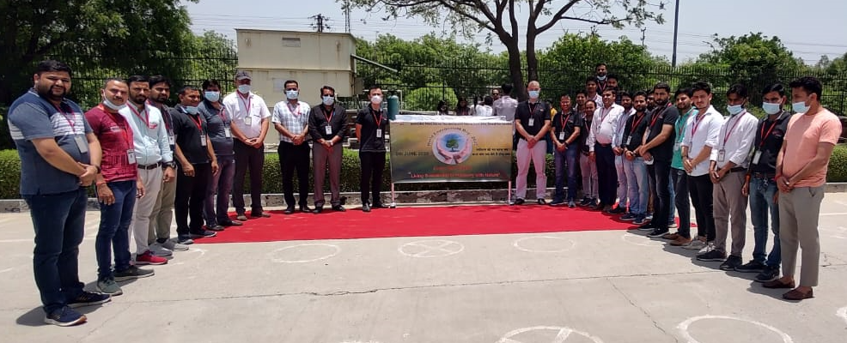




International Yoga Day



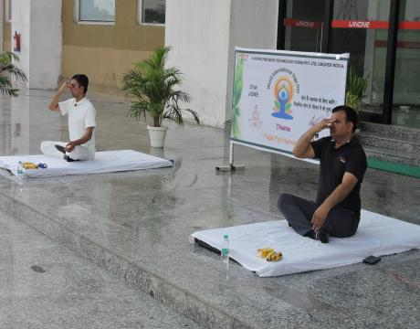
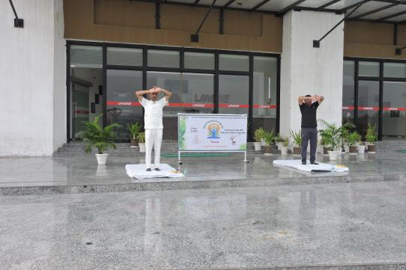

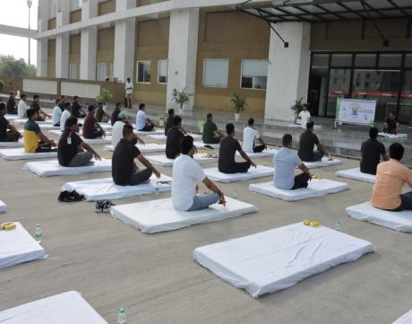
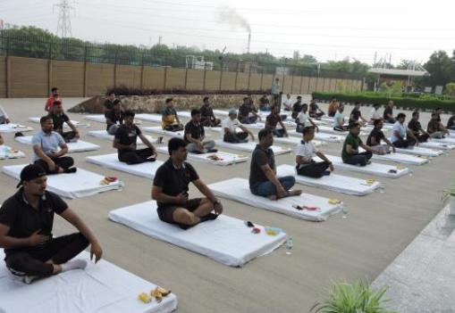
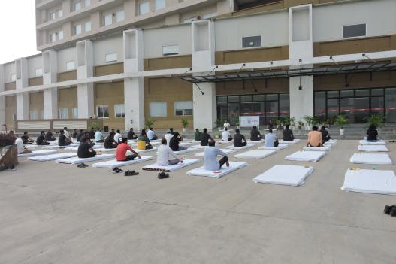

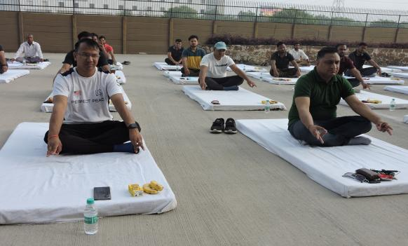
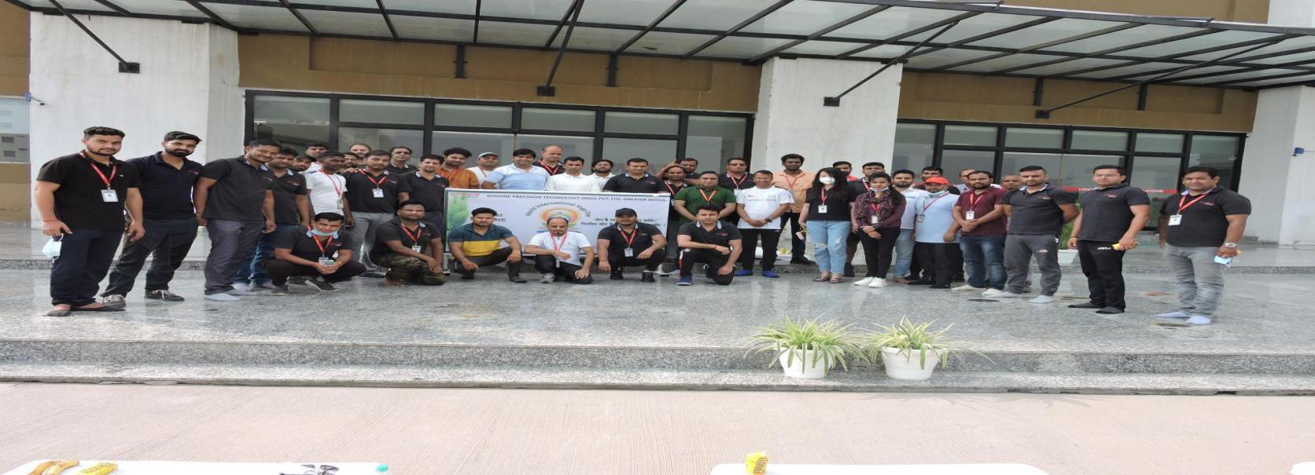

Yoga se hoga
Practicing yoga and exercising in the early morning can help us achieve good health and fitness. Yoga originated in India, and the International Yoga Day is celebrated on June 21 every year. This day was officially recognized by the United Nations General Assembly on December 11, 2014, following a proposal by our Prime Minister, Mr. Narendra Modi, on September 27, 2014. Mr. Modi suggested June 21 as the date for International Yoga Day, as it is the longest day of the year in the northern hemisphere and holds significance in many parts of the world. The first International Yoga Day was celebrated on June 21, 2015. Yoga is an effective way of connecting with our soul and achieving balance between our mind and body.
Winone Precision Technology, organized a yoga activity on 21 March 2022 and that the yoga instructor, Mr. Diwakar Shukla, did a great job. Participating in activities like yoga can have numerous benefits for employees, including improved physical fitness, stress reduction, and improved mental health. Encouraging employee wellness activities can also have a positive impact on employee morale and productivity.

On May 21, 2022, Winone Company held a fun and engaging employee get-together to boost employee engagement and motivation. The event was organized to provide an opportunity for employees to socialize, build camaraderie and foster team spirit while having fun.
We grow and prosper because of the dedication and hard work put in by our Employee. They are a vital part of our success story and the company needs them as much as they need it. Both are mutually depended, In order to celebrate the existing relationship /dependency, Winone India get together was held on wherein a platform was given to employee where they can share their ideas, discuss their concerns openly and effectively contribute in the growth of the company. This event will energised them and will inculcate feeling of belongingness among employee to work effectively and efficiently.
The event began with a motivational speech by our Directors & Head-HR & Admin, who emphasized the importance of teamwork, hard work, and dedication. He thanked the employees for their contribution to the company's growth and encouraged them to continue working towards achieving the company's goals.
Overall, the employee get-together was a huge success, with employees enjoying the fun games, entertainment, and socializing with colleagues outside of work. The event not only provided a break from the usual work routine but also helped in boosting employee morale, building team spirit, and fostering a sense of belongingness among colleagues. These events provide an opportunity for employees to connect, build relationships, and have fun, creating a positive and engaging work environment.


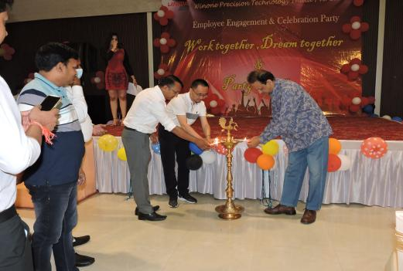
Winone Get Together

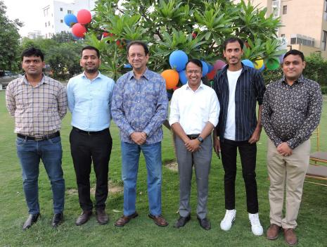



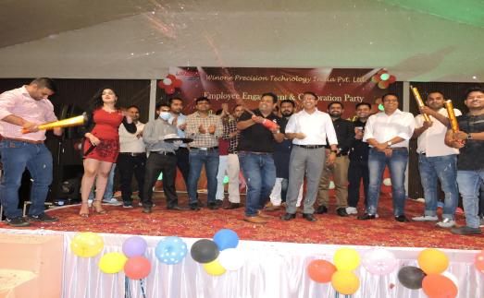

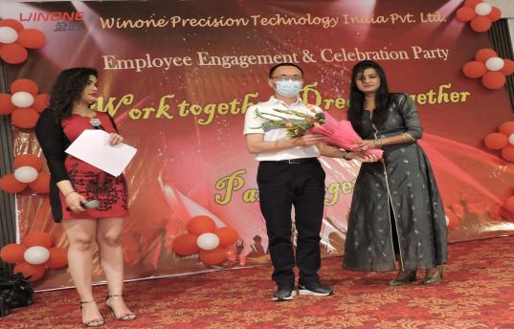

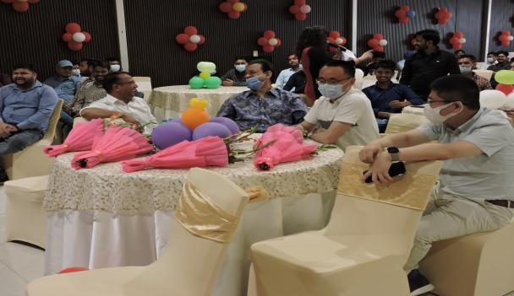

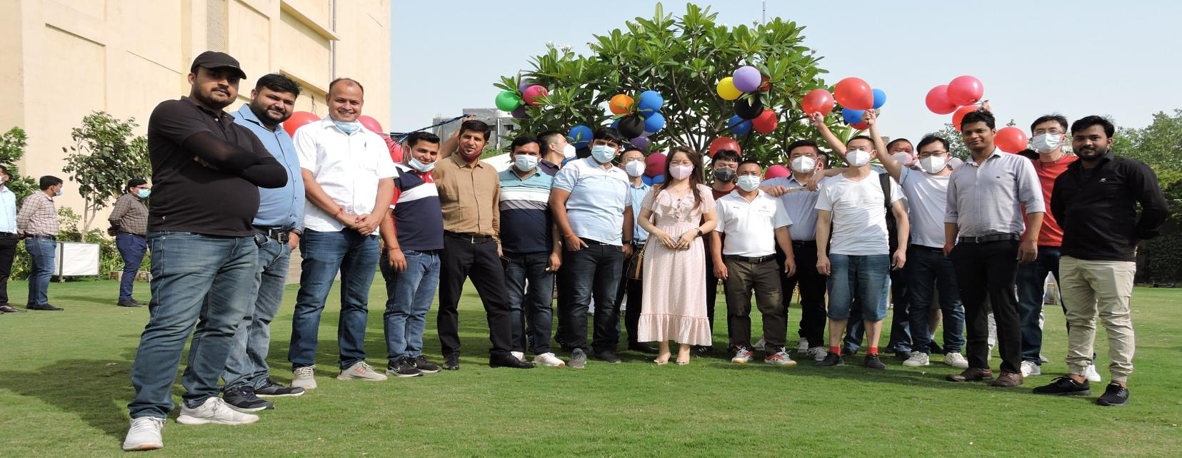

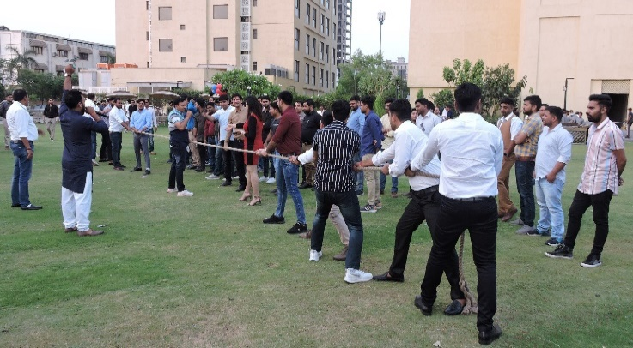


"Festival of colors - Holi"
That sounds like a wonderful celebration of Holi! Holi is indeed a colorful and vibrant festival that marks the arrival of spring and celebrates the triumph of good over evil. It is a time when people come together to forget their differences and spread love and joy by smearing each other with colored powders, exchanging sweets, and enjoying music and dance.
It's great to hear that Winone Precision India office celebrated the festival with organic colors, which are a safer and more eco-friendly option than synthetic colors. It's also good to see that everyone had a good time singing, dancing, and enjoying sweet dishes, Thandi (a traditional Indian drink), and music.
Holi is not only celebrated in India but also in other parts of the world, where people of different cultures and backgrounds come together to participate in the festivities. It is a festival that promotes unity, harmony, and happiness, and it's always great to see people celebrating it with such enthusiasm and joy.
Holi Celebration




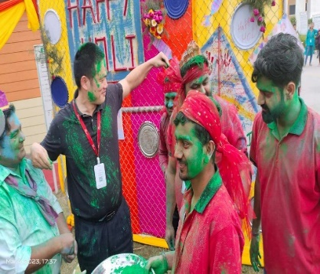
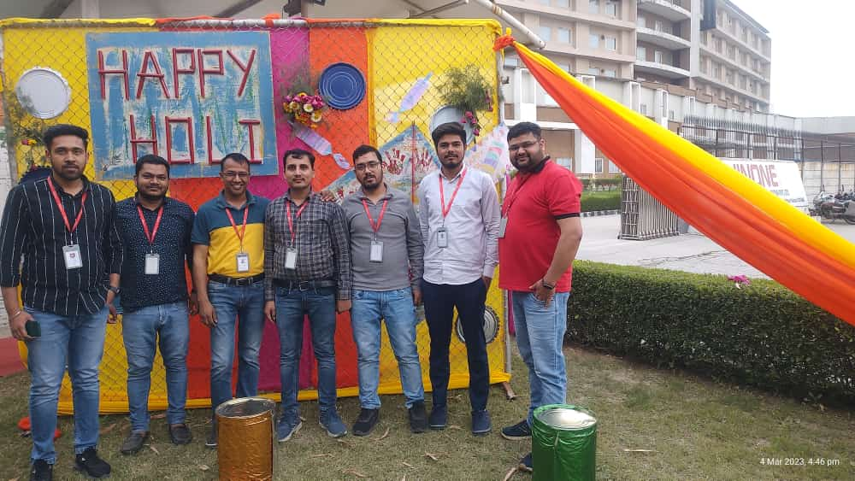
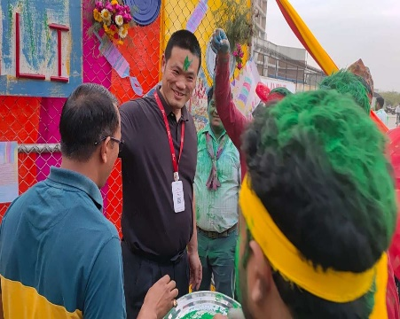



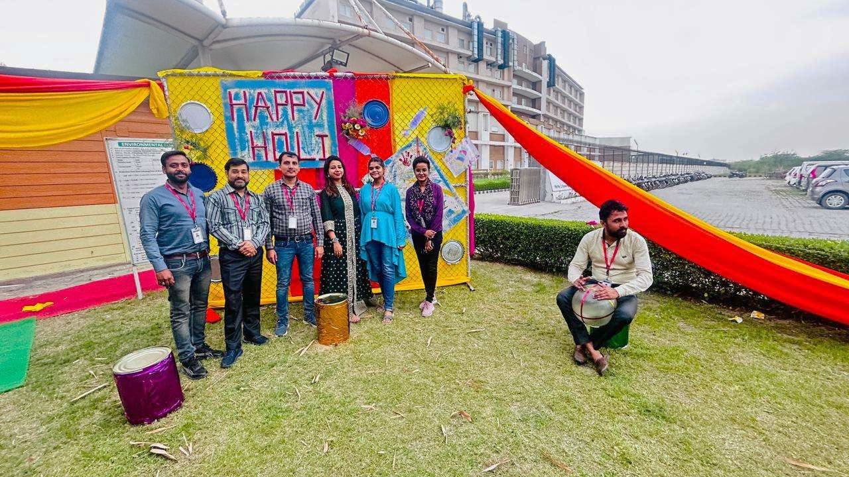
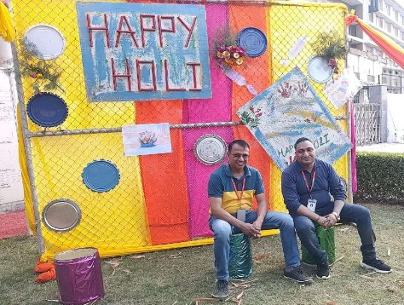

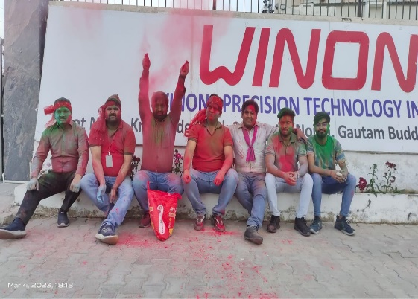
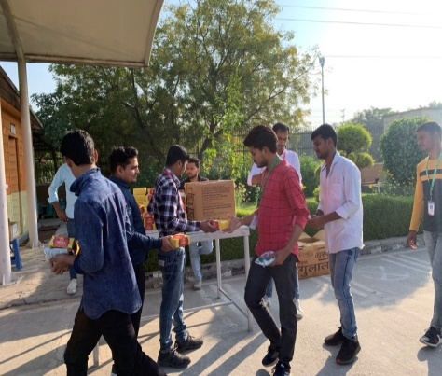
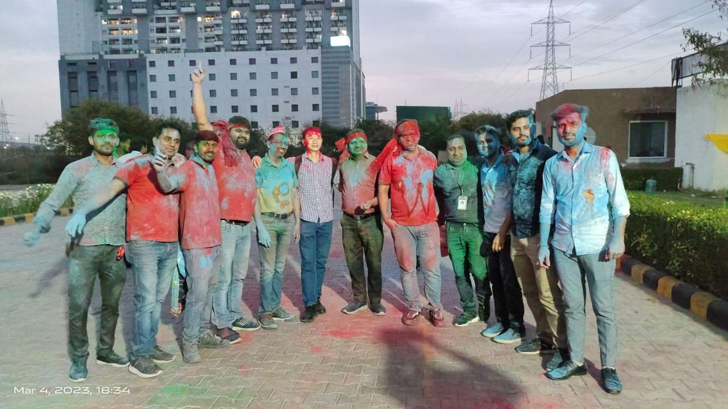

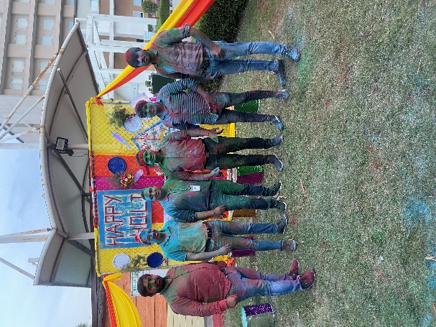
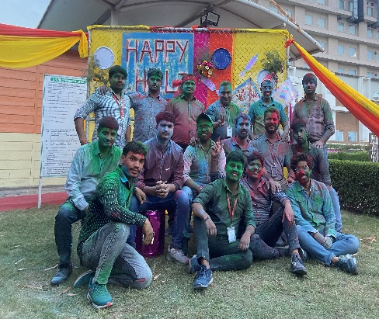
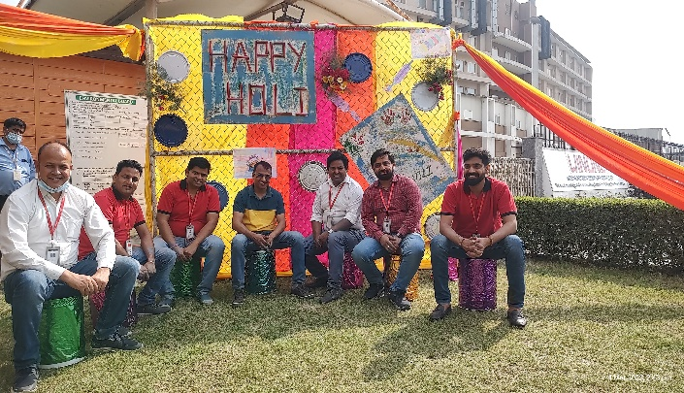

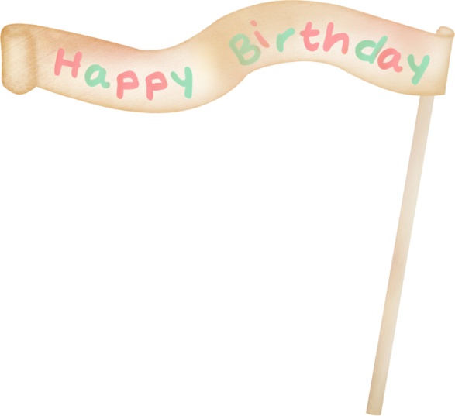

Monthly Birthday Celebration

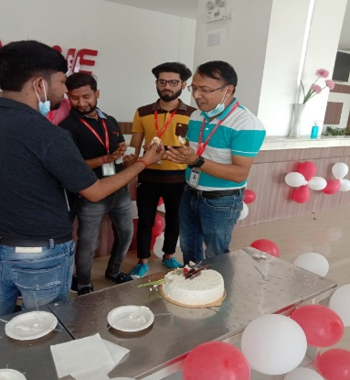
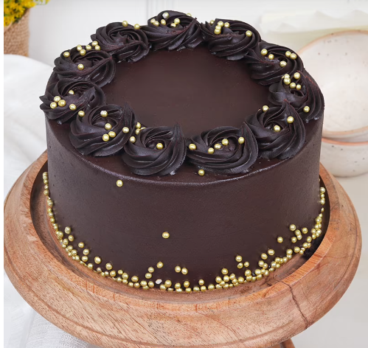

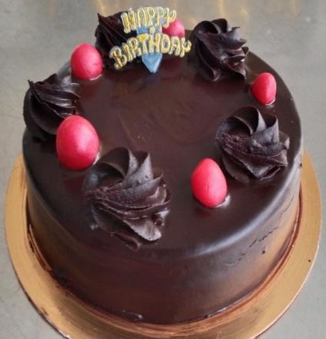

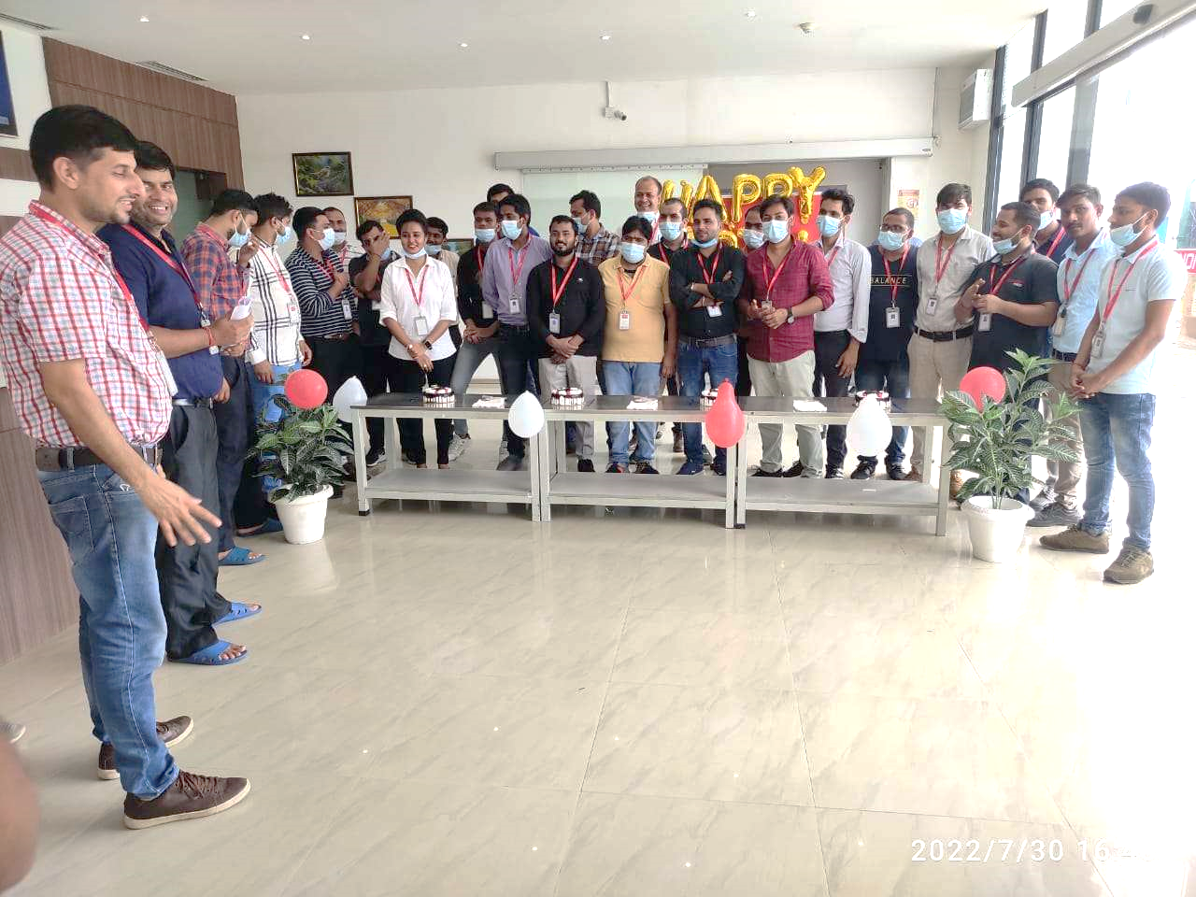
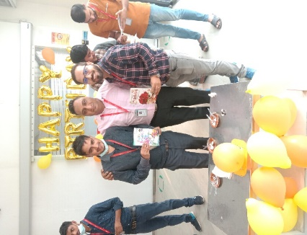
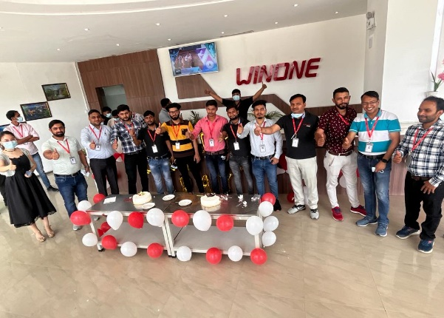

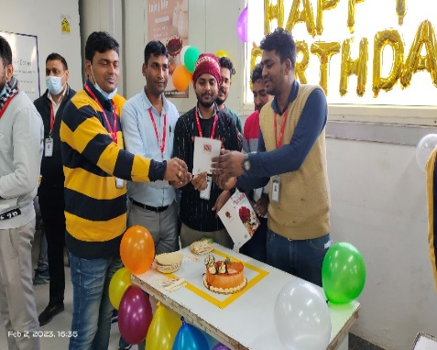
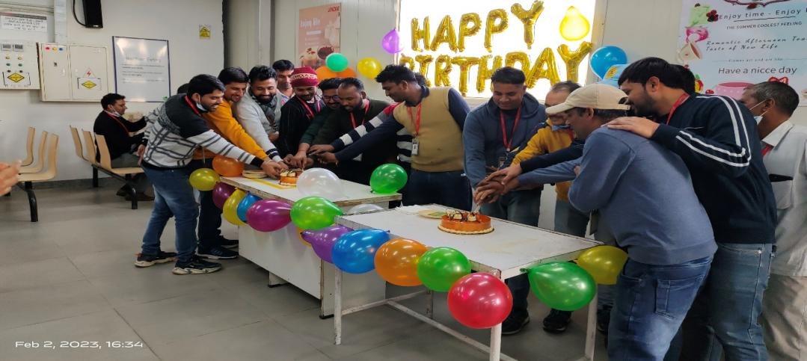
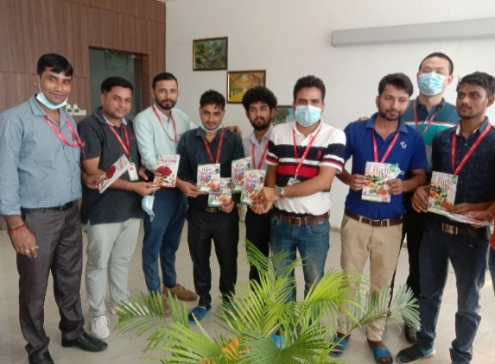


We are thrilled to announce that we will be continuing our tradition of monthly birthday celebrations to honour and appreciate our employees whose birthday falls in a particular month. We believe that this is a fantastic way to bring us all together and create a strong sense of community and belonging.
On the last day of each month, we will gather to celebrate with cake cutting, snacks, and drinks. We will also be distributing greeting cards to all the birthday celebrants to show our appreciation for their hard work and dedication to the company.
We would like to take this opportunity to express our good wishes to all our employees celebrating their birthdays in the upcoming months. Your contributions to the company are greatly valued, and we hope that this celebration will help to create a positive work environment for all of us.

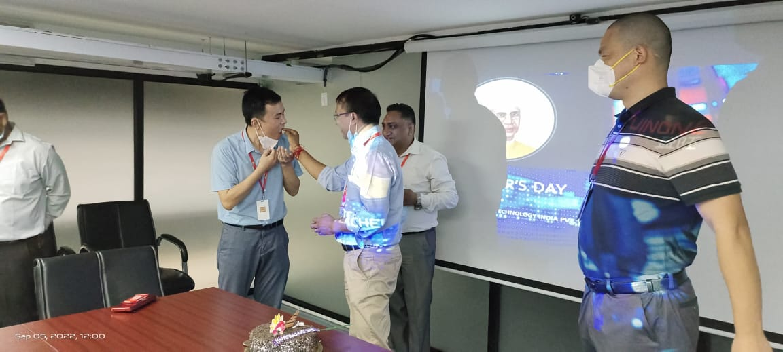
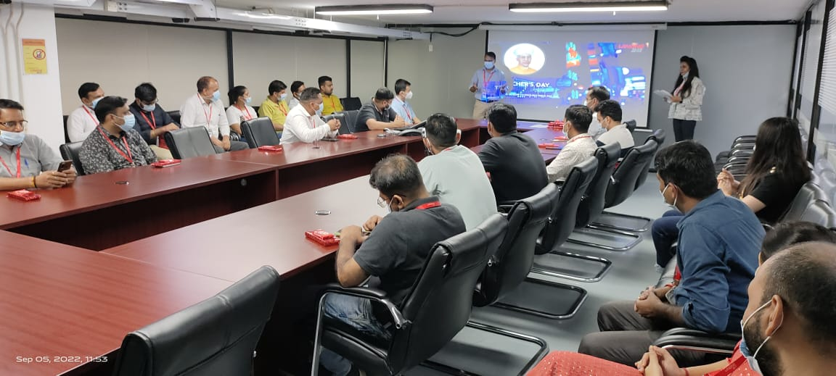
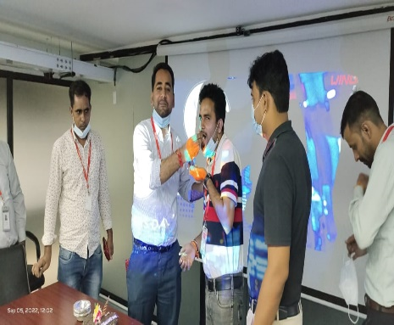
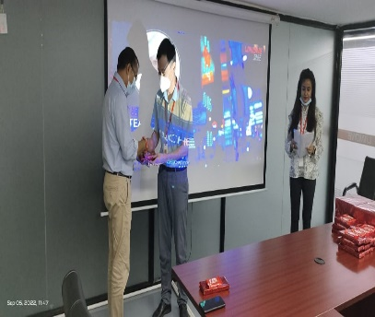
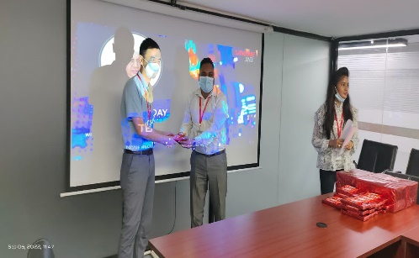
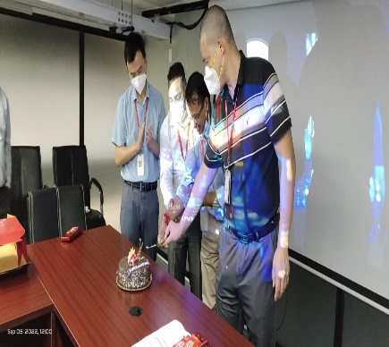
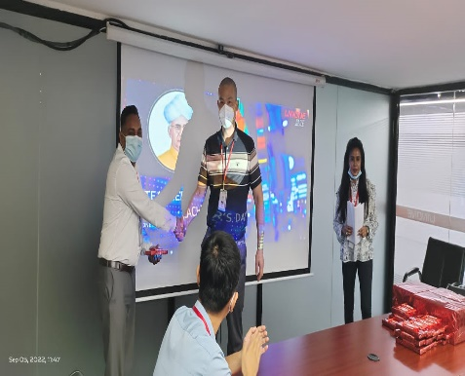
Teachers Day Celebration & Trainer’s Recognition Program

5th September 2022, we have celebrated teachers’ day in a unique Way. Every trainer was awarded gifts for their enthusiasm and support towards spreading awareness in their respective professional era. We have a large team of about 69 internal trainers who are spreading their knowledge throughout years to their colleague and sub ordinates.
Trainers have played vital role in the growth of our company. Now days every trainer become the important resources in the growth of the company. Primarily, teacher days is celebrate as a mark of tribute to contribution made by teachers to society.
Training helps our employees for enlarge their personal as well as professional skills. We now accept the fact that learning is a lifelong process of keeping abreast of change and the most pressing task is to teach people how to learn. You don’t learn to walk by following rules. You learn by doing, and by falling over. The beautiful thing about learning is that nobody can take it away from you.

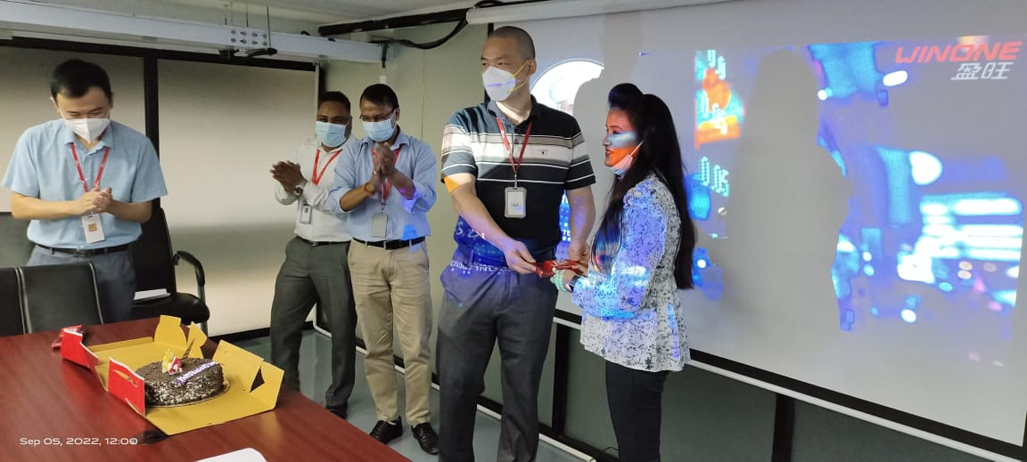

“A heartfelt thank you to all the trainers who spend their time, energy, and love to care to skill our employees”.



Admirable Team of Winone Trainers

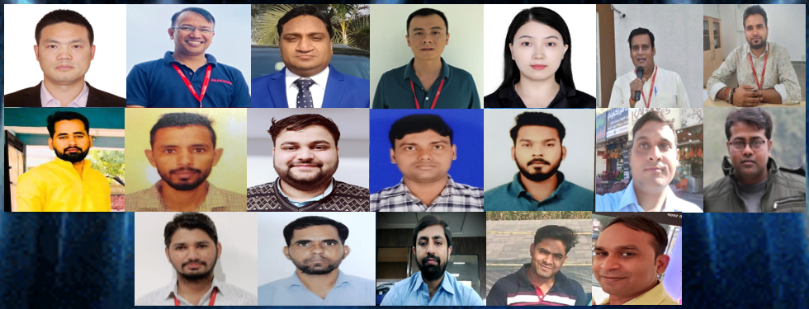
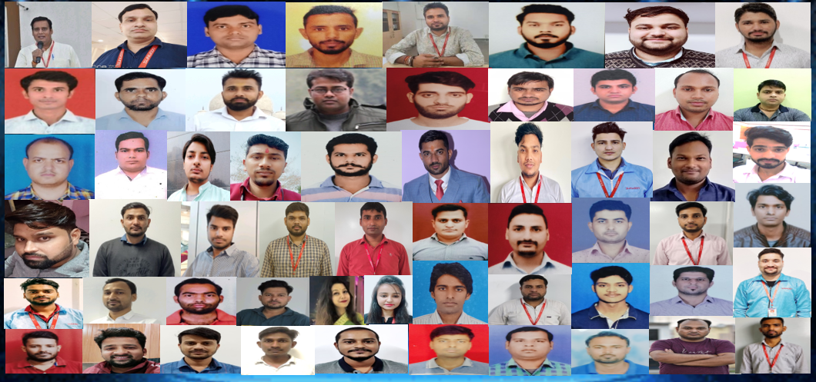

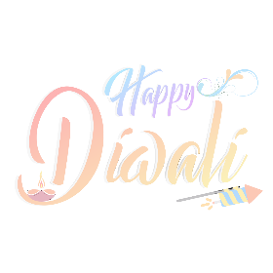
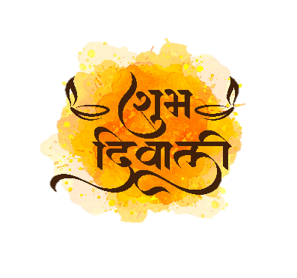
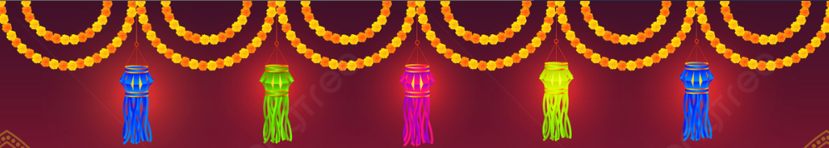
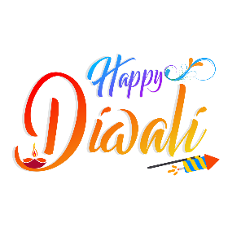
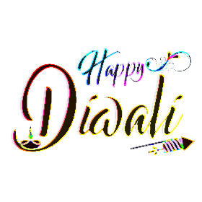
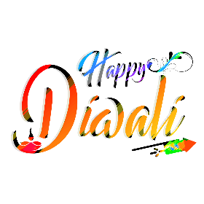


The festive season at Winone Precision Technology India Pvt Ltd was kicked off with great fervour as Diwali, the festival of lights, was celebrated with grandeur and enthusiasm. The two-day celebrations, held on 20th and 21st October 2022, were filled with a variety of entertainment activities that left everyone in high spirits.
To mark the occasion, Bay decoration and Creative Clicks competitions were organized on 01st November 2021, where employees showcased their creativity and talent. The next day, on 02nd November 2021, the celebrations continued with the traditional Lamp lighting ceremony and Rangoli Competition, followed by a Dance Competition and other fun activities.
The atmosphere was electric, and the event concluded with a prize distribution ceremony and the distribution of Diwali gifts, making it a memorable experience for all who attended. It was heartening to see everyone come together and share in the joy and happiness that Diwali brings.
Winone Precision Technology India Pvt Ltd's Diwali celebration was a testament to our commitment to creating a positive and engaging work environment. By recognizing and appreciating the efforts of our employees, we are fostering a culture of teamwork and camaraderie, which is essential for the growth and success of our company.

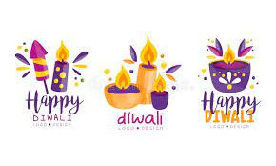
Bay Decoration- Workspace to feel more open and inviting.
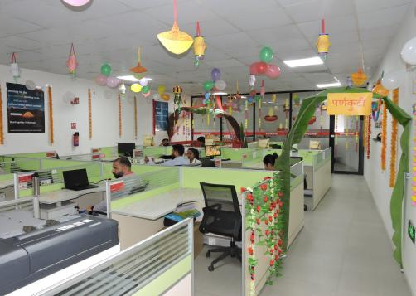
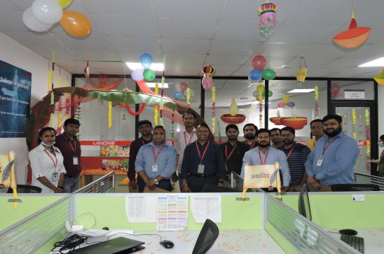
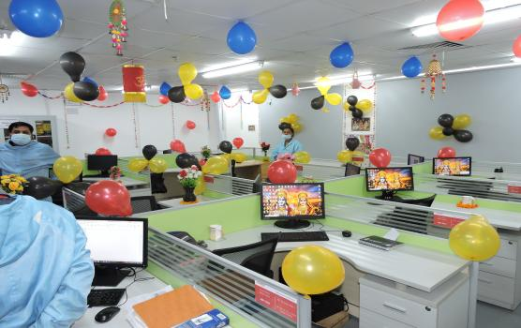
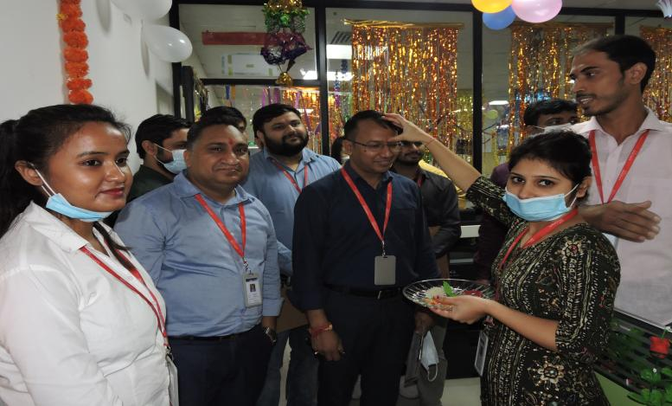
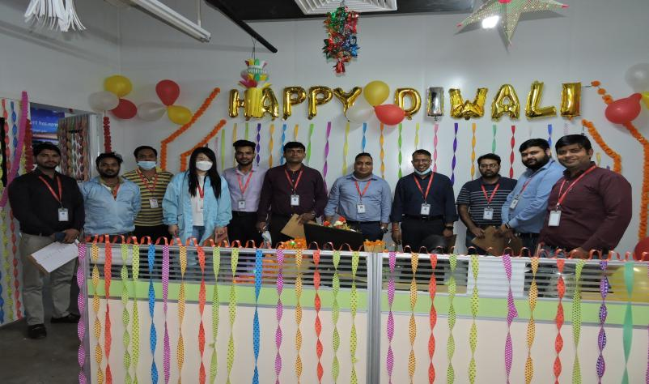
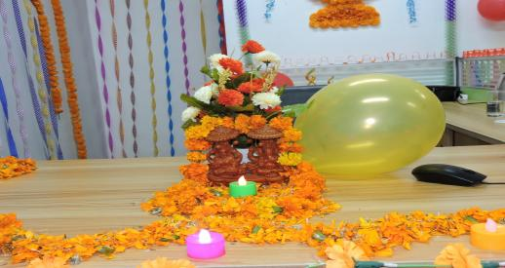
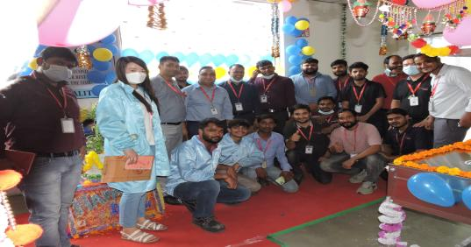
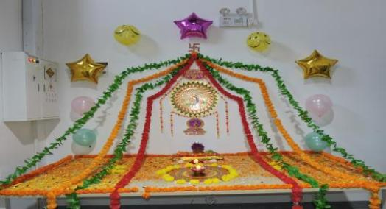


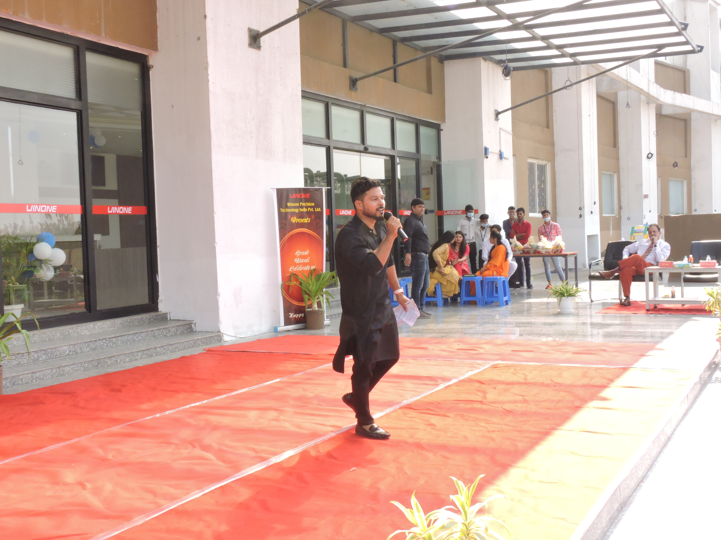
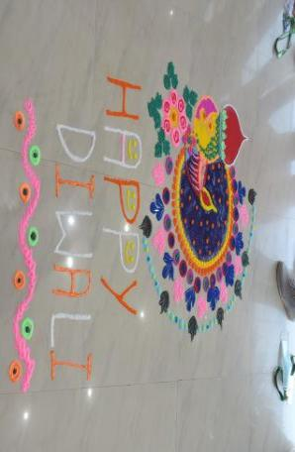
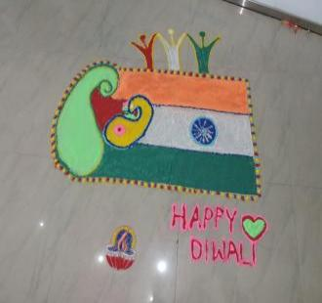
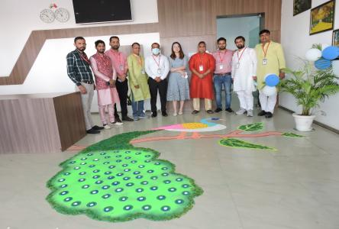
RANGOLI COMPETITION Rangoli represents happiness and liveliness.

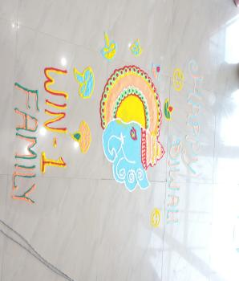

TECH-EXHIBITION Art is not a handicraft, it is the transmission of feeling the artist has experienced.
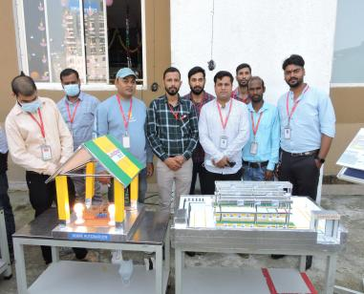
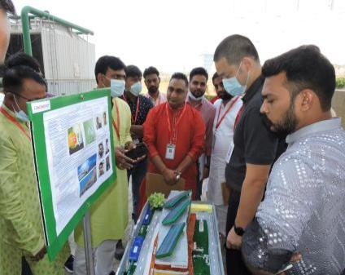
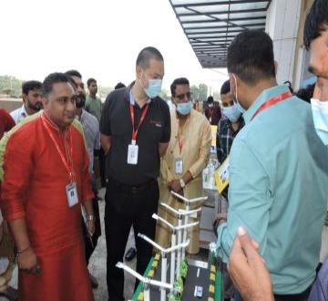
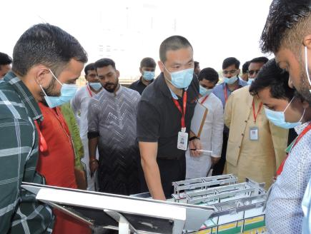
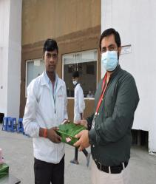
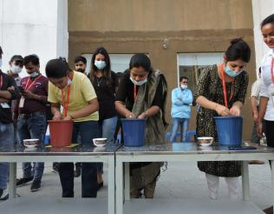
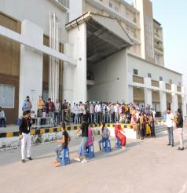
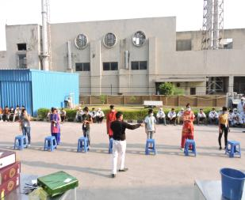
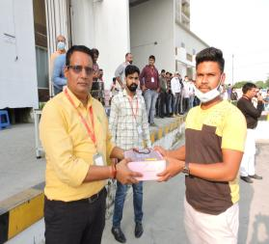
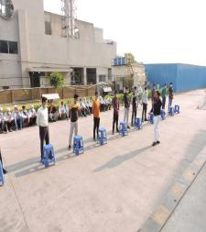
ACTIVITIES Induces team spirit and an overall positive atmosphere.

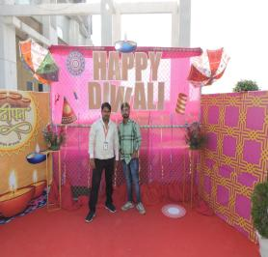
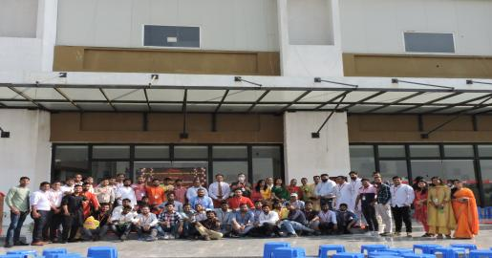
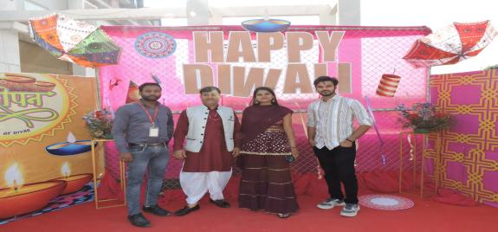

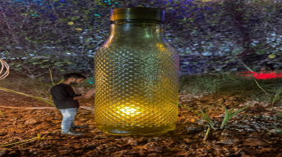

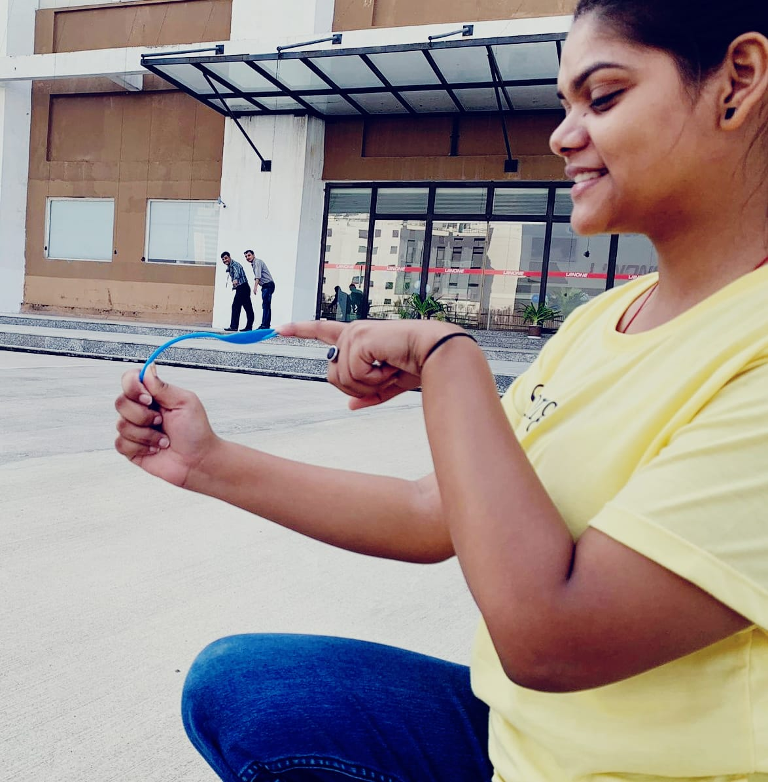
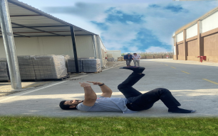
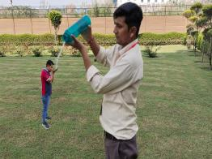
CREATIVE CLICKS New platforms and channels will rise, some performing better than others.

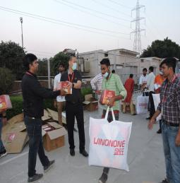
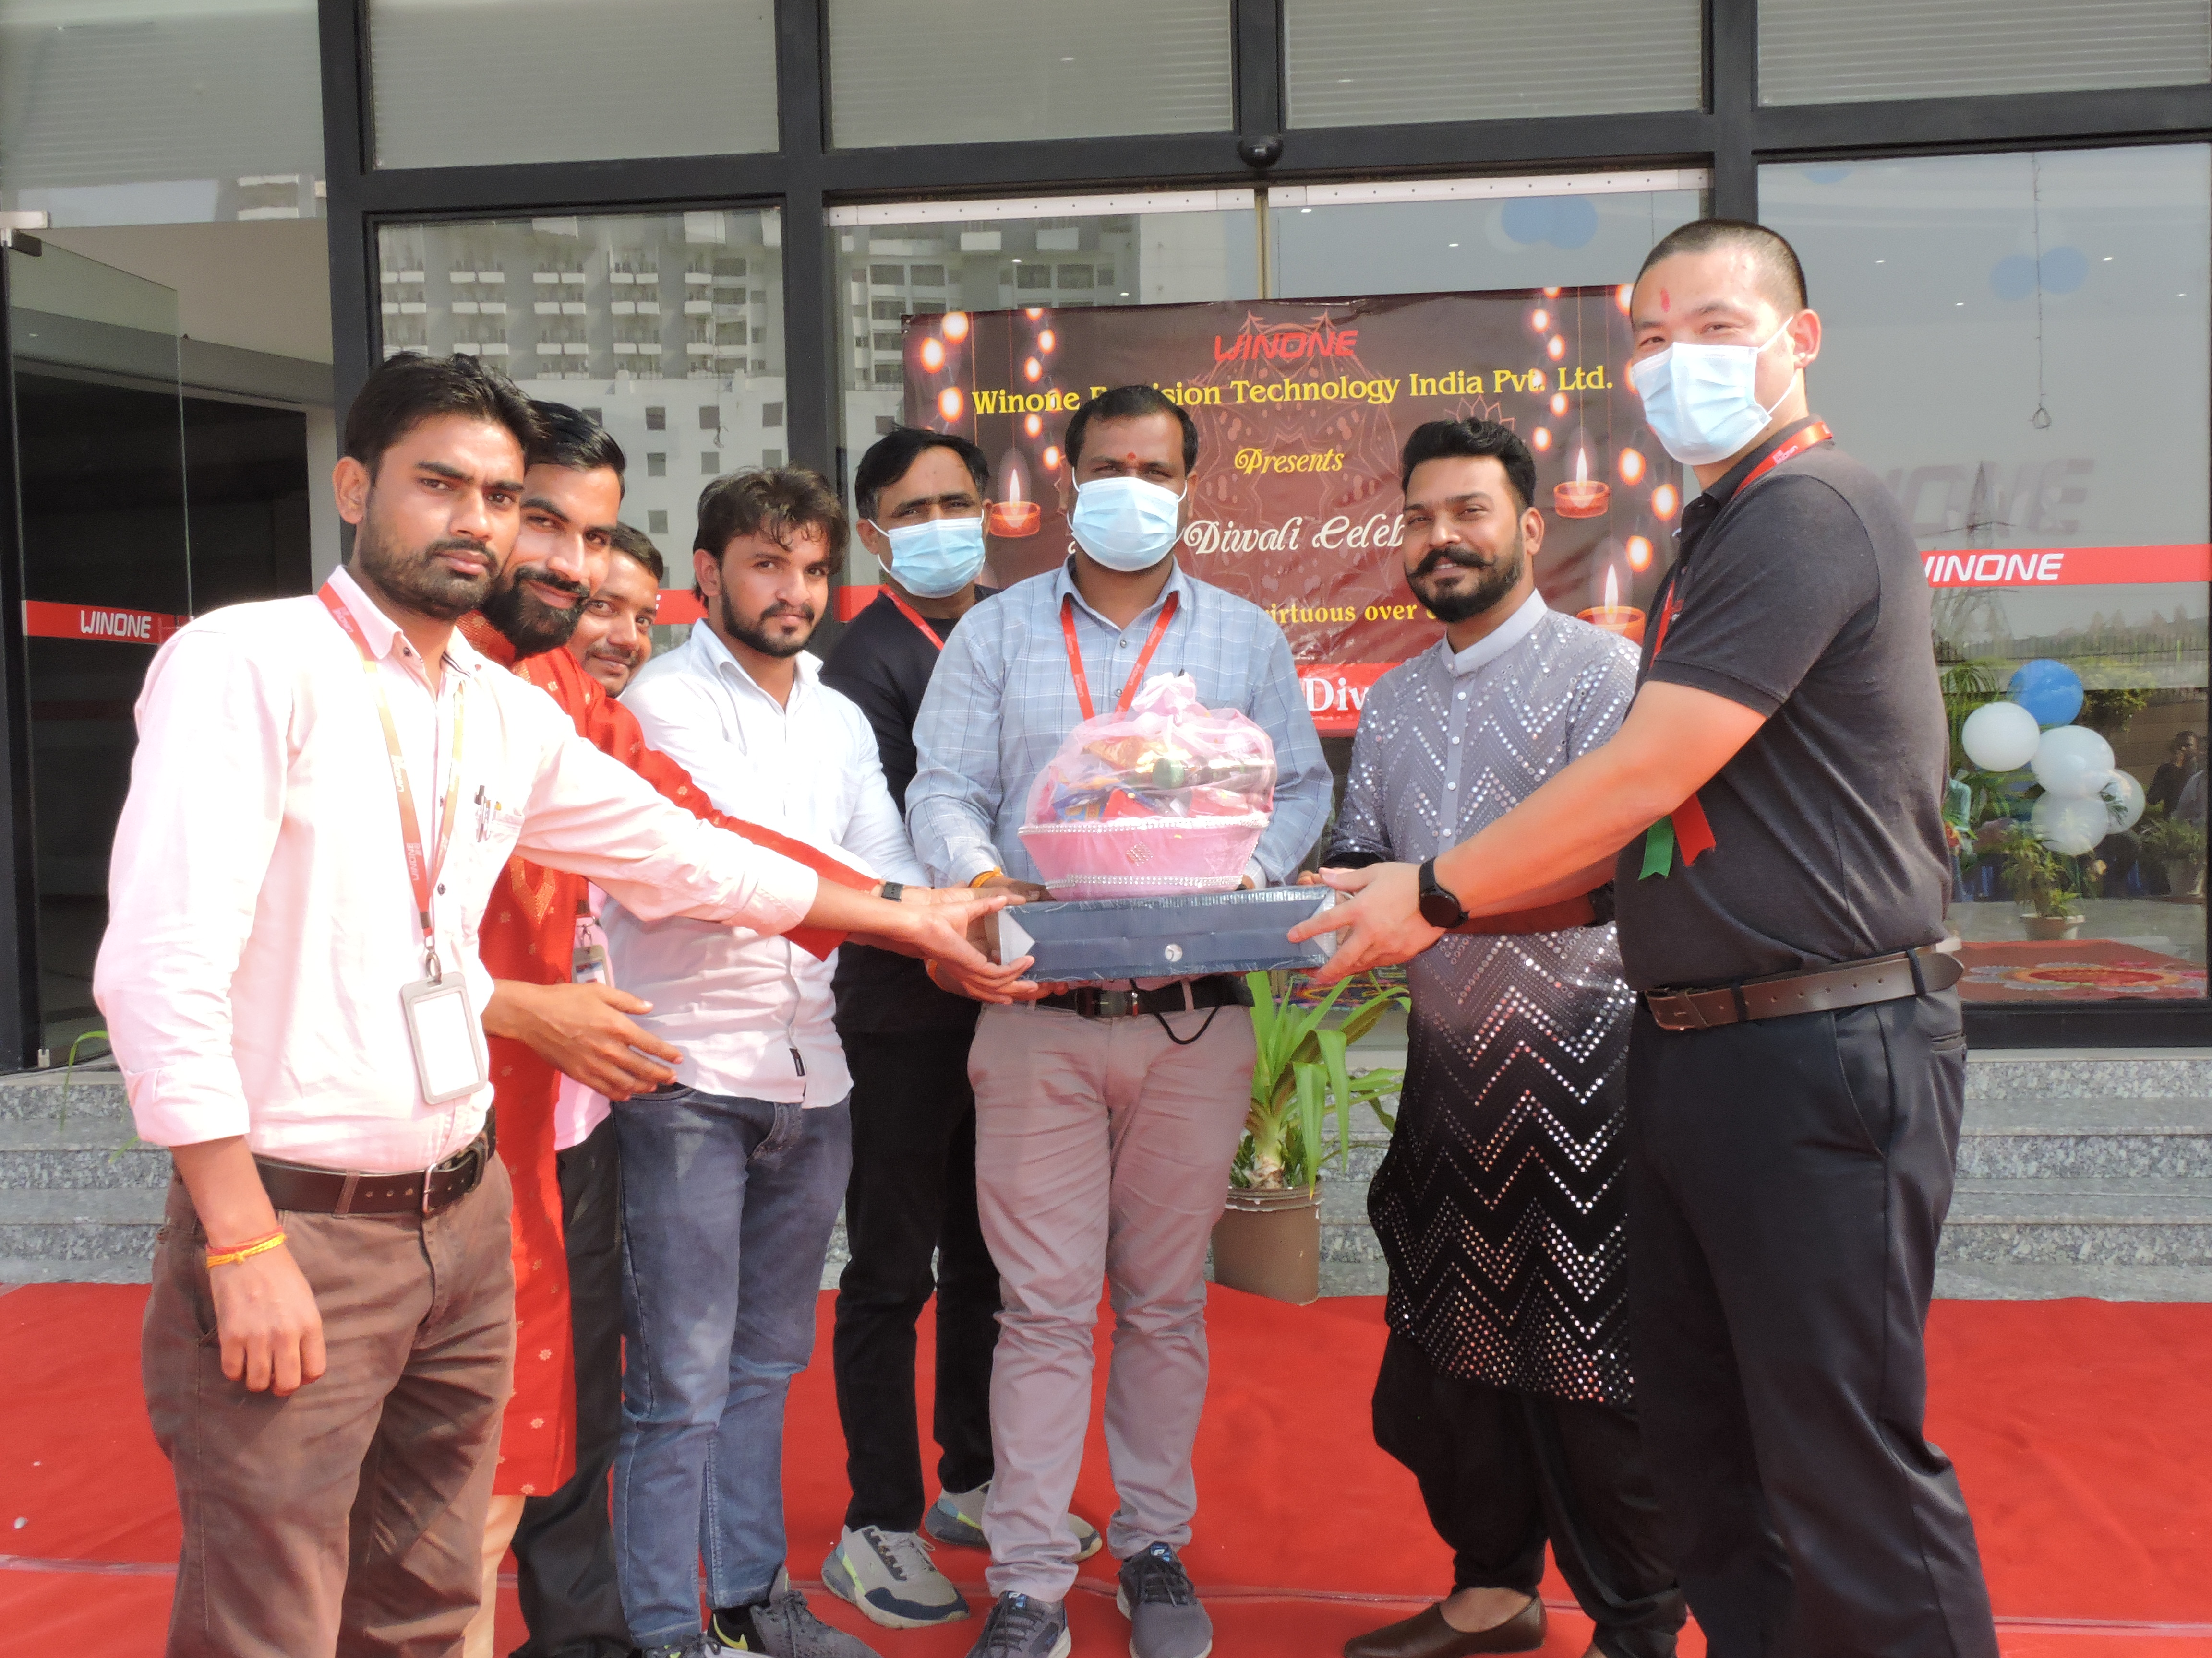
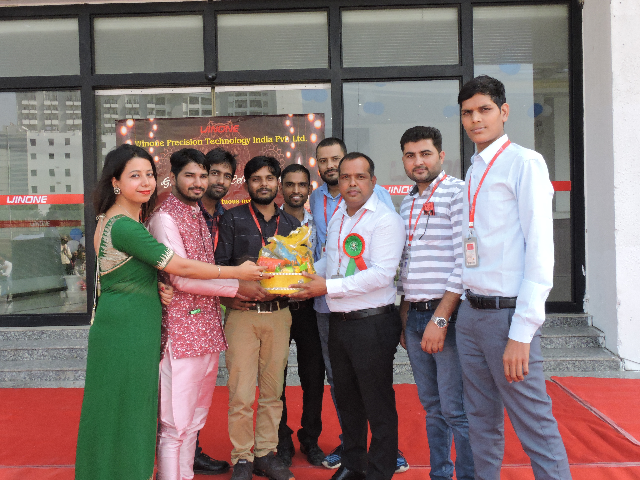
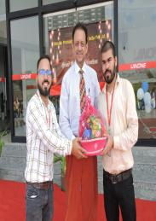
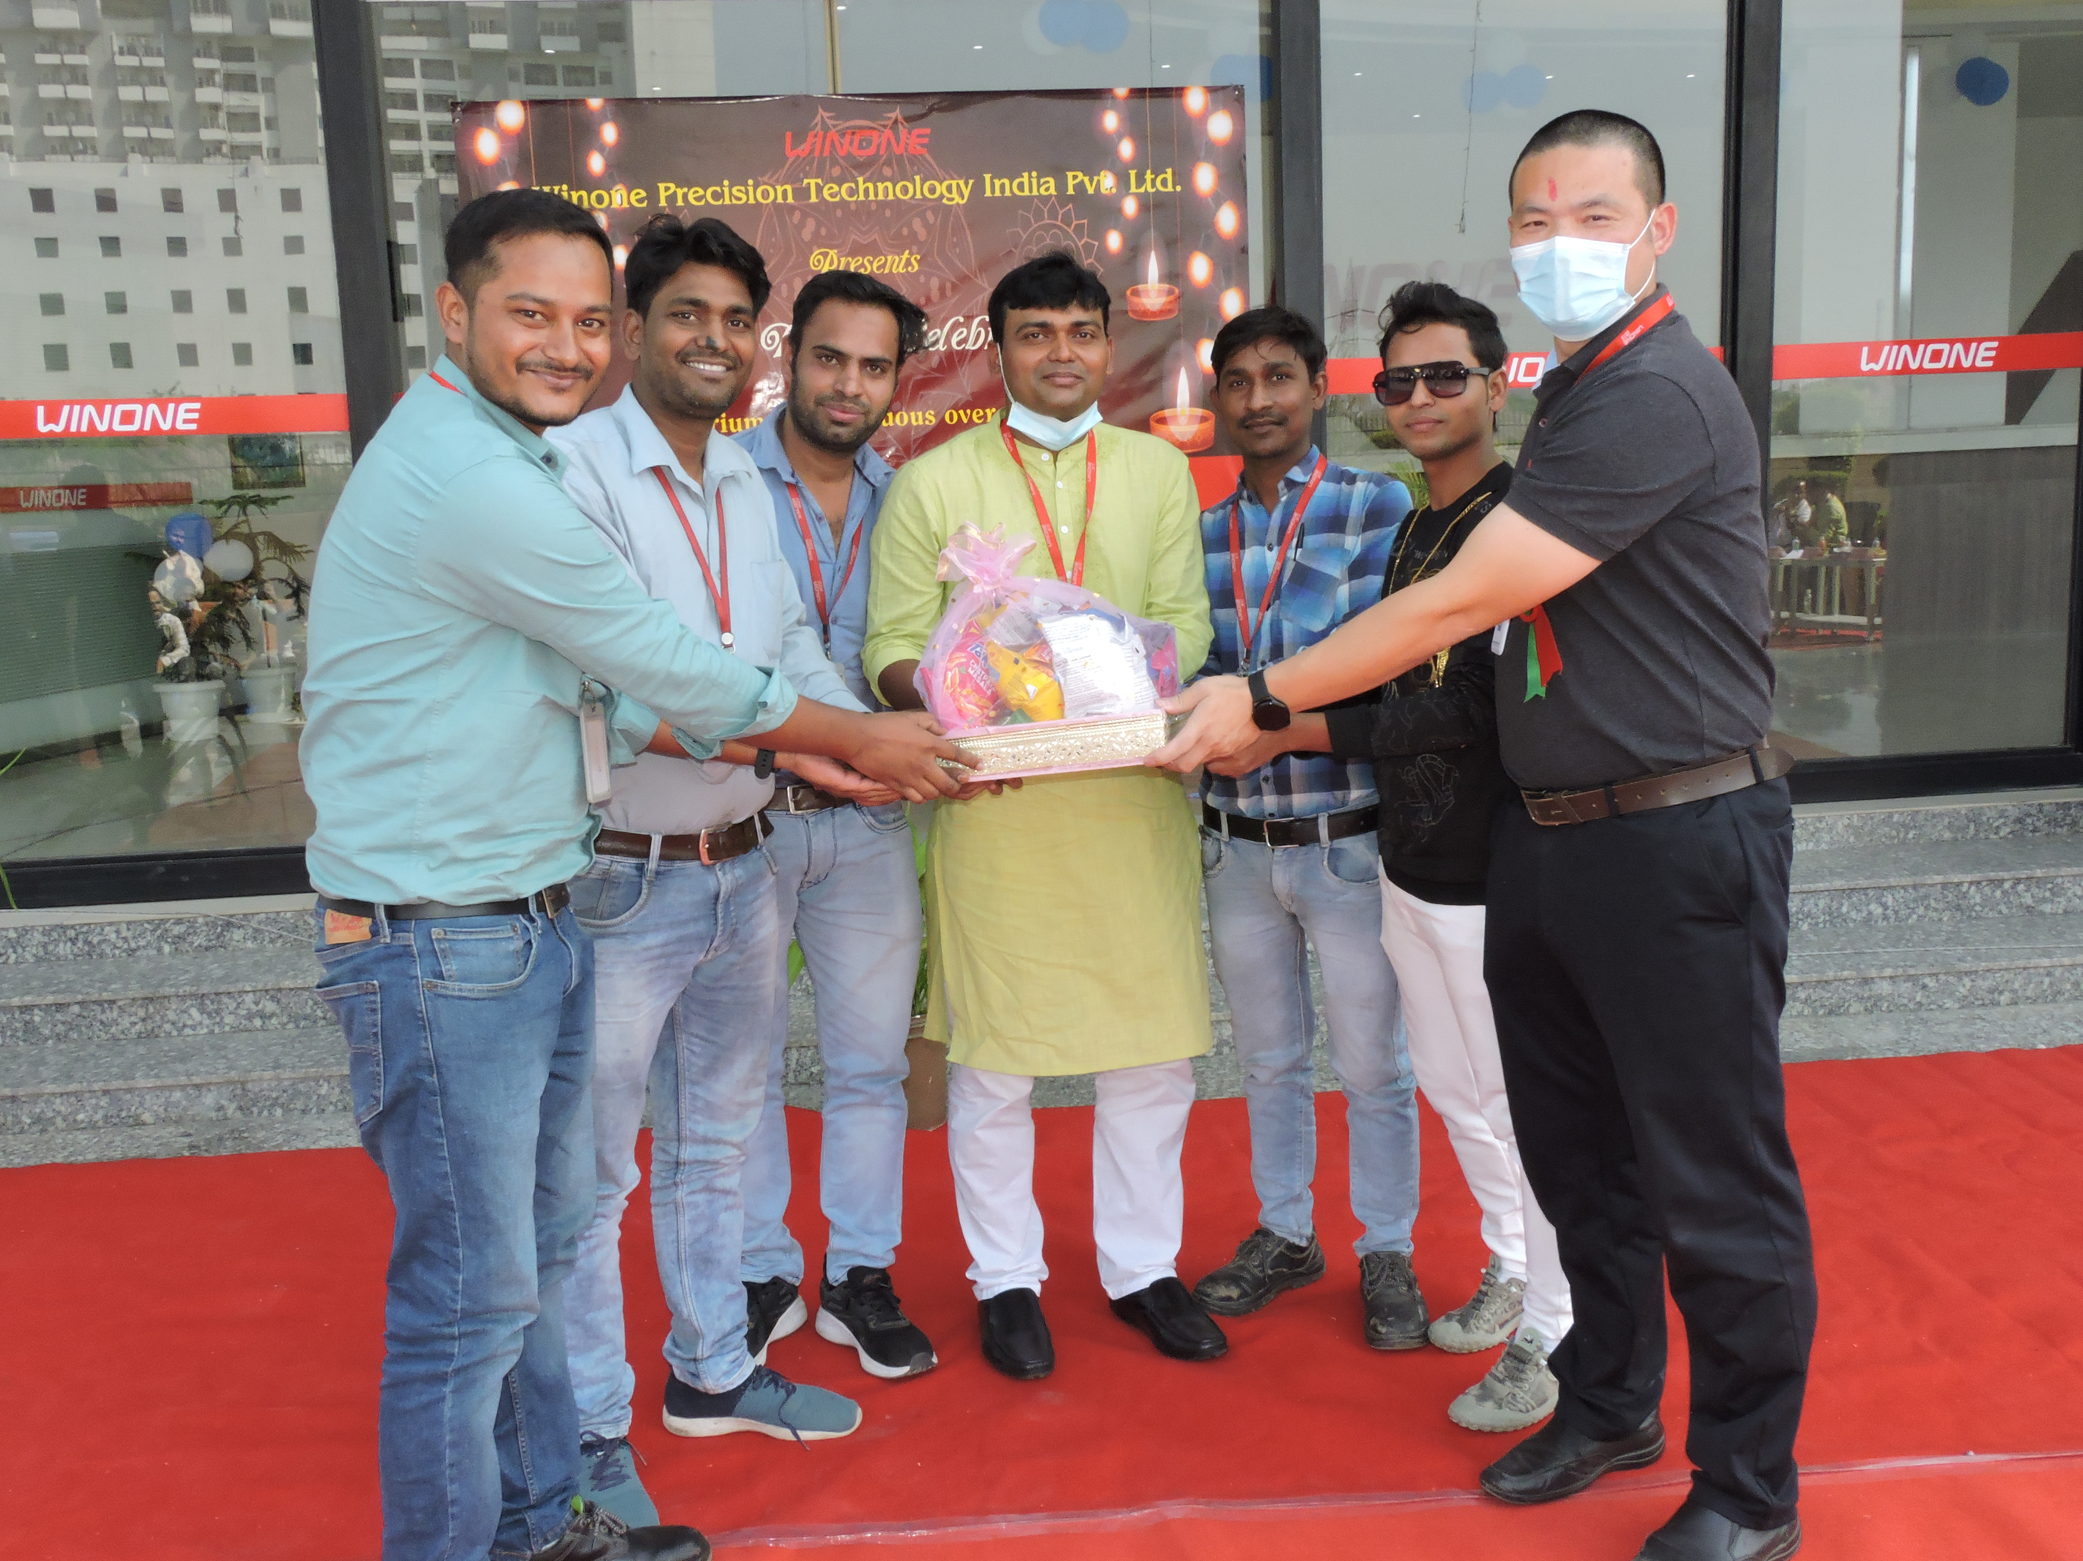
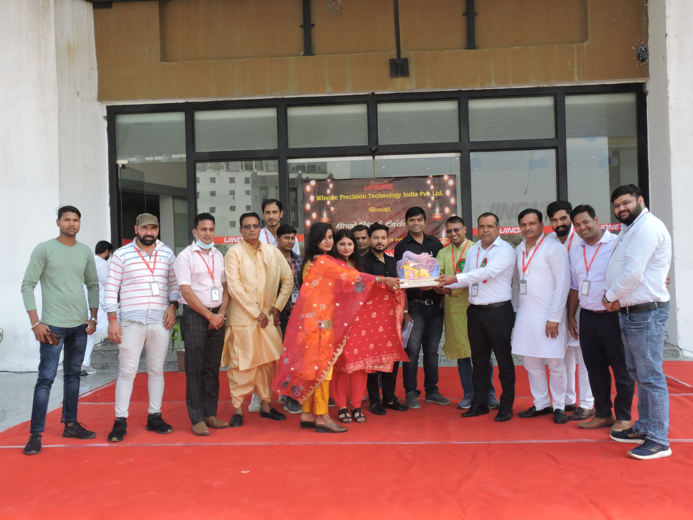
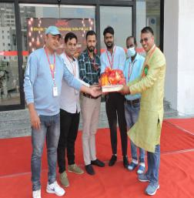
GIFT DISTRIBUTION “Happy Diwali and a wonderful new year!”

“May the auspicious occasion of Diwali bring along many new opportunities for you to grow….. Wishing a very Happy Diwali to you and your family.”


Winone League of Legends-2022
Corporate sports events can have a positive impact on employees' health and well-being, as well as on their engagement, team cohesion, culture, and productivity. Winone - Greater Noida recently launched the "Winone League of Legends-2022" in November and December 2021, which featured four different games: Volleyball, Badminton, Carrom, and Chess. A total of 123 employees participated in these games, representing all departments.

The league was well received, with overwhelming support from both the departments and Winone's management. This sports event helped to increase employee engagement, improve employee well-being, foster team spirit, and strengthen inter-departmental relations. By including all departments in the league, Winone ensured that every employee had the opportunity to participate and benefit from the event.

Winner Team
Eagle-The Fighter

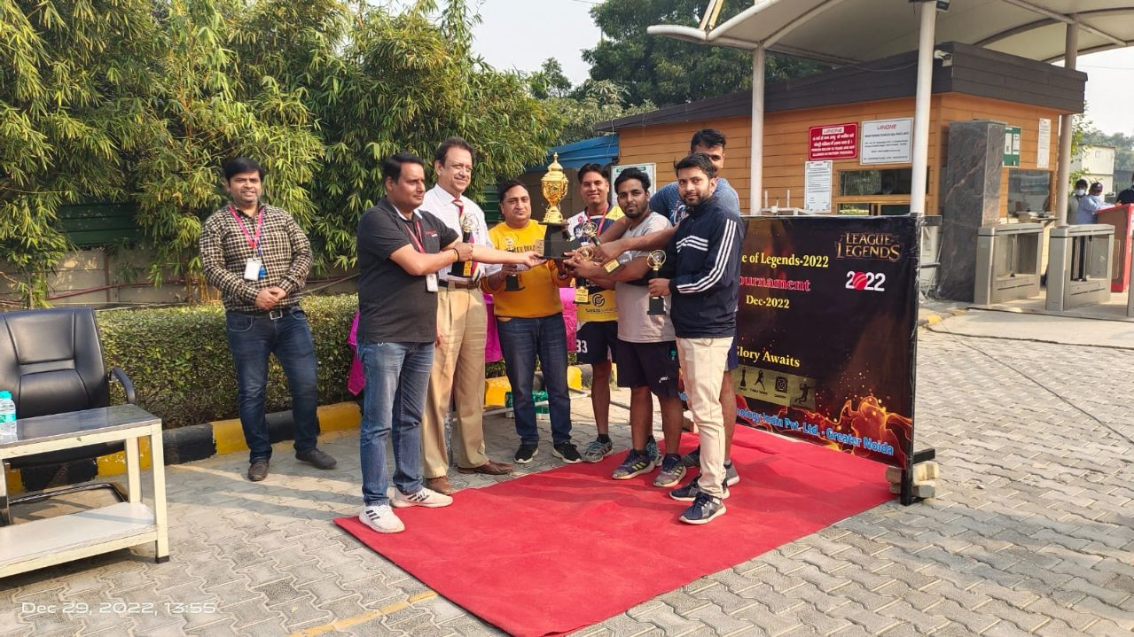

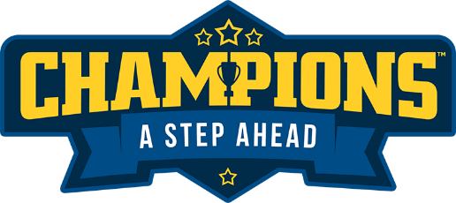
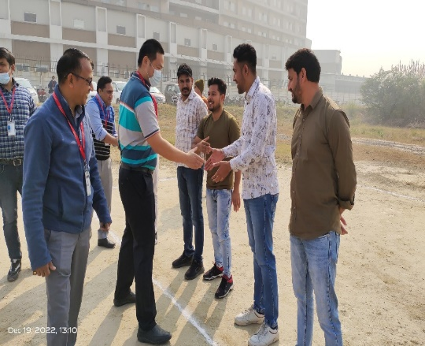
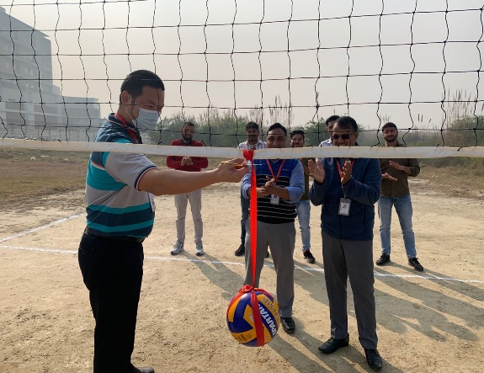

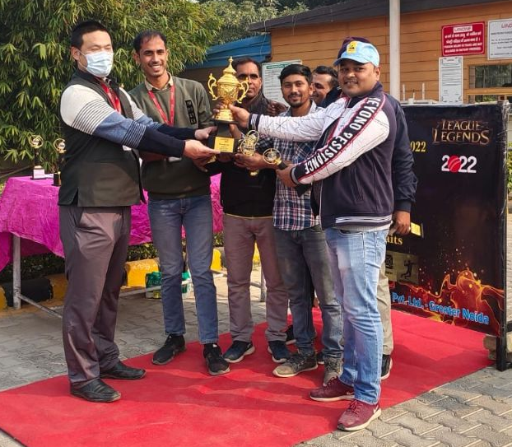

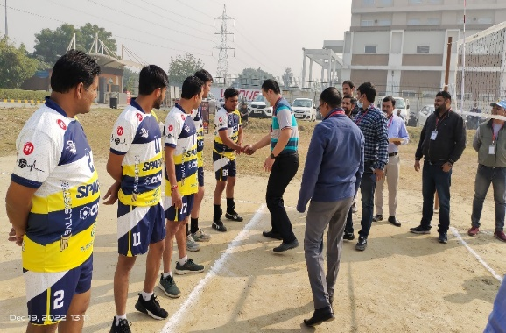
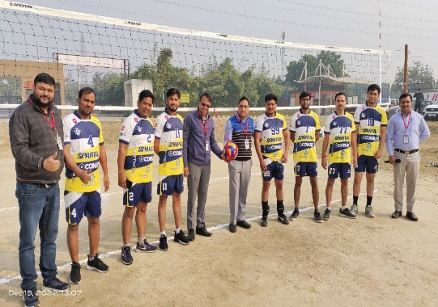

Runner-up Team
Yodhha

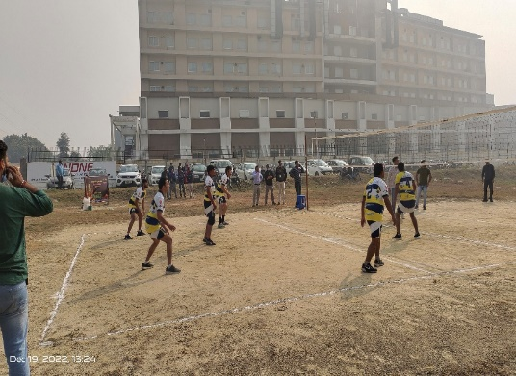
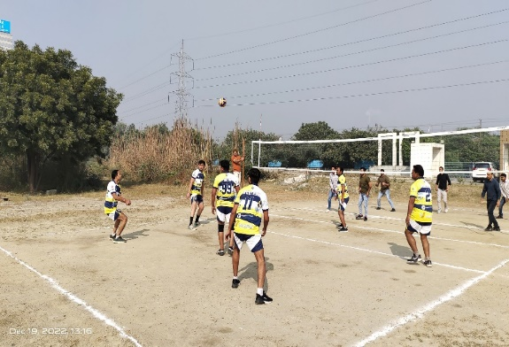
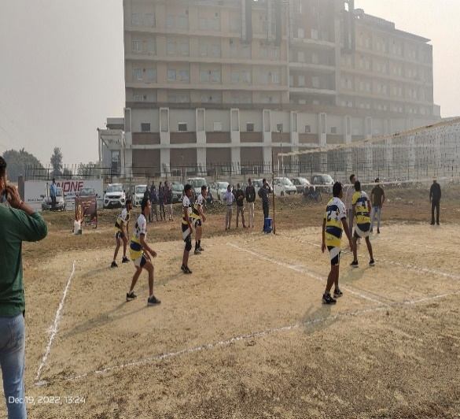



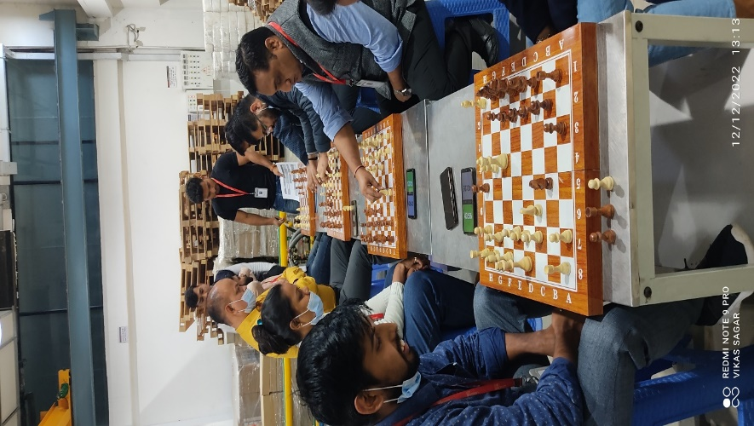
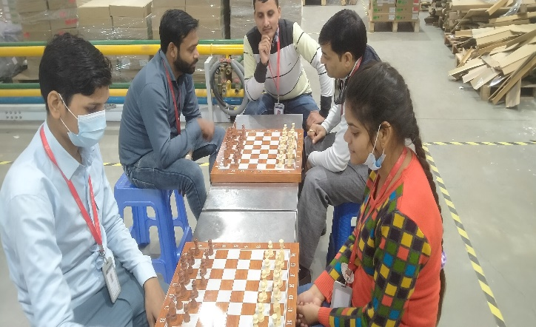
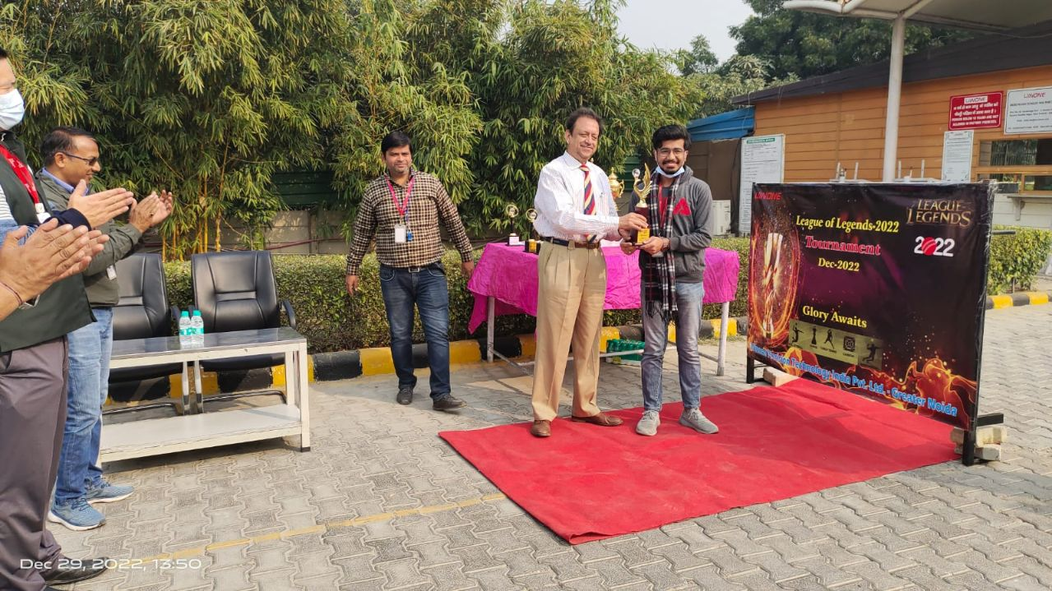

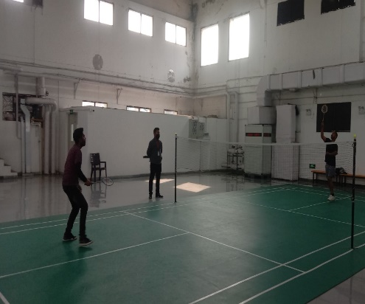
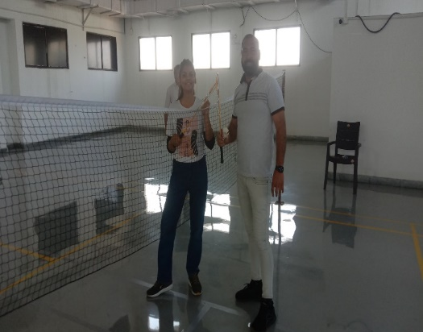
Mr. Tanish –Winner (Chess)
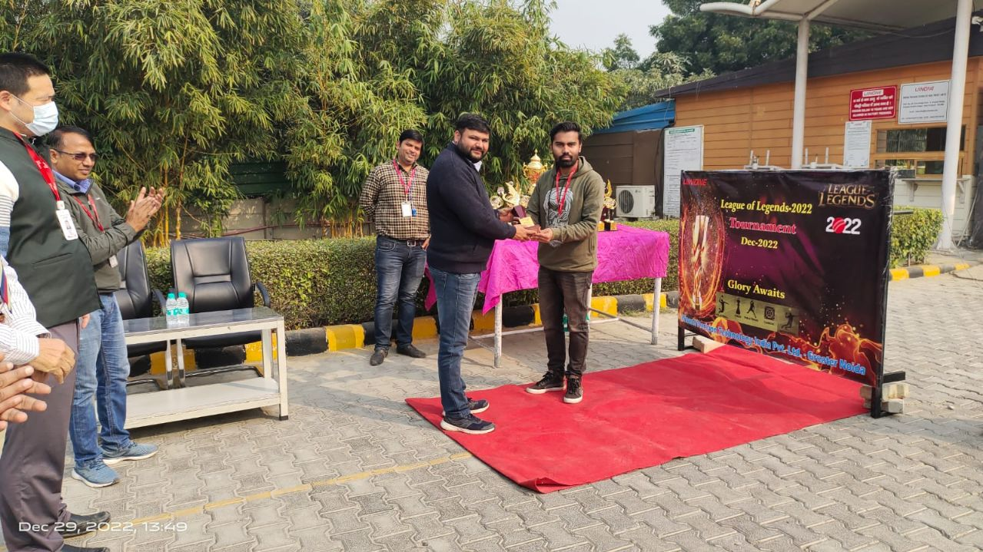
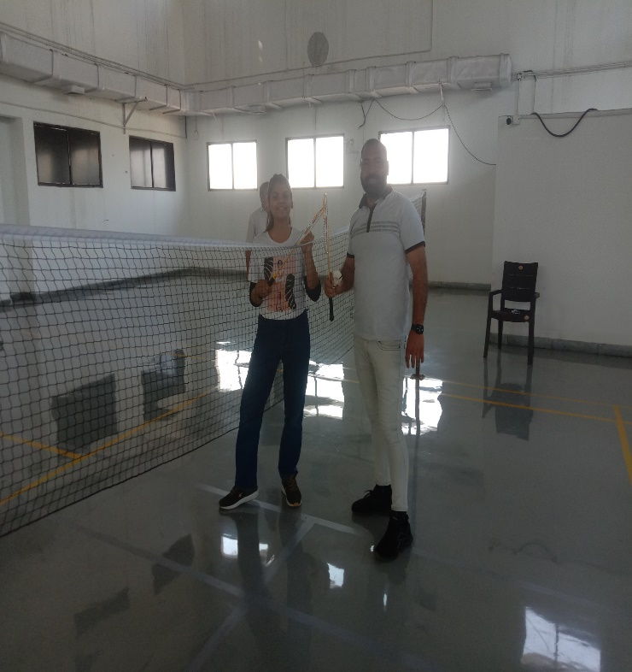

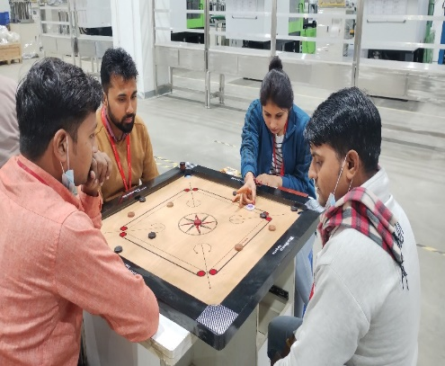
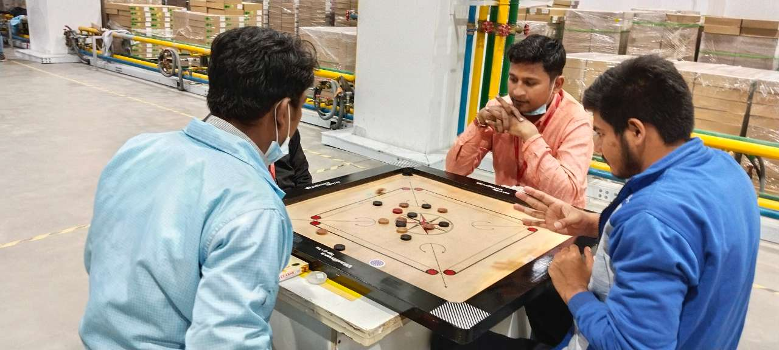

Mr. Rohit-Winner (Badminton)
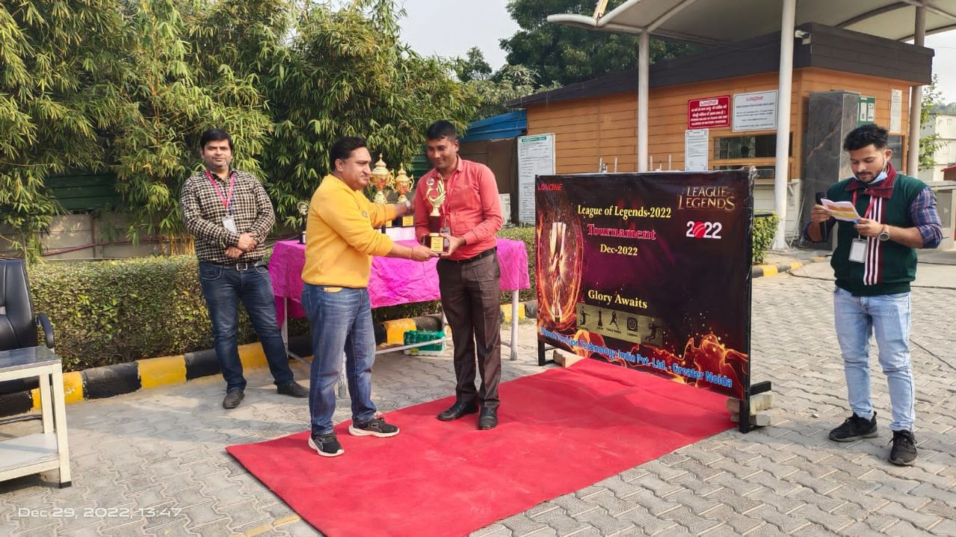
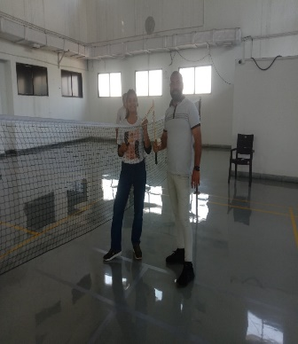
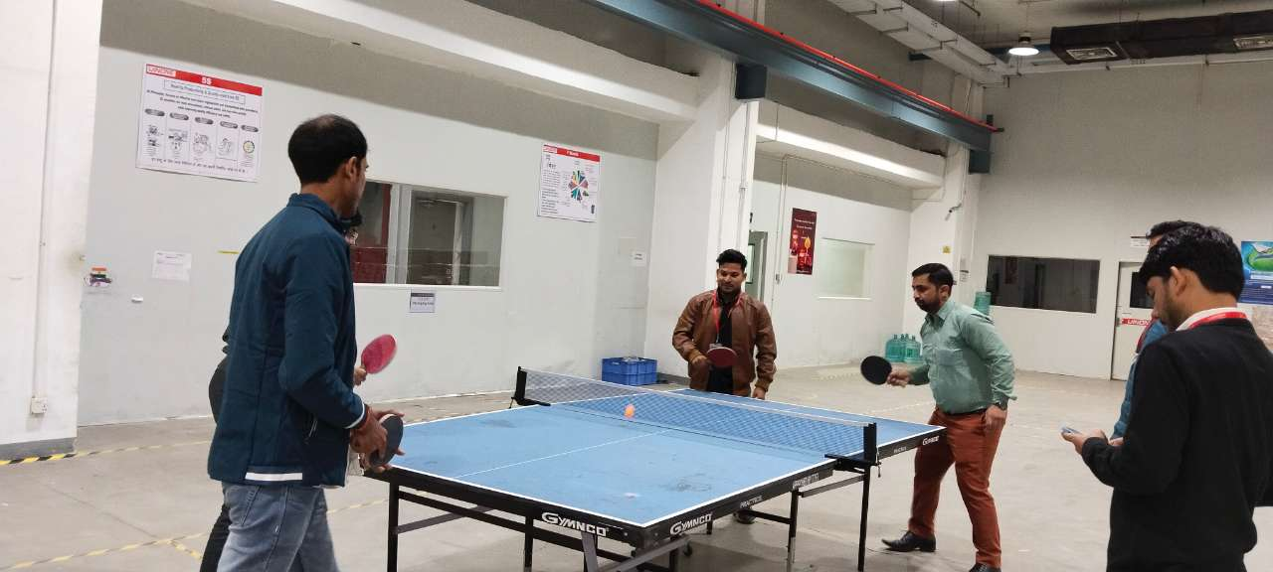
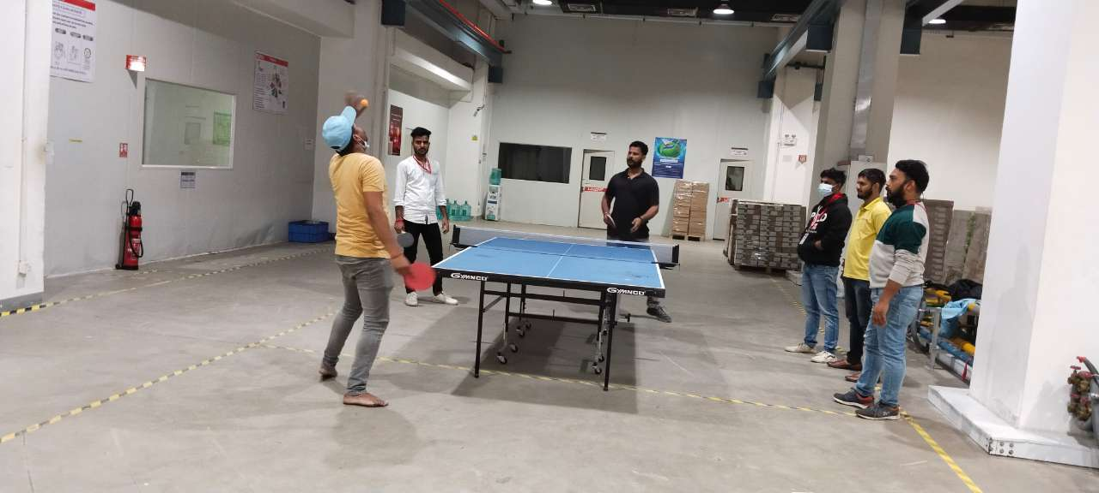

Mr. Rajesh-Winner (Carrom)
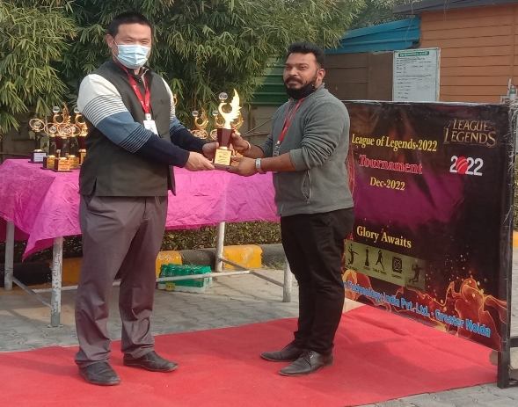
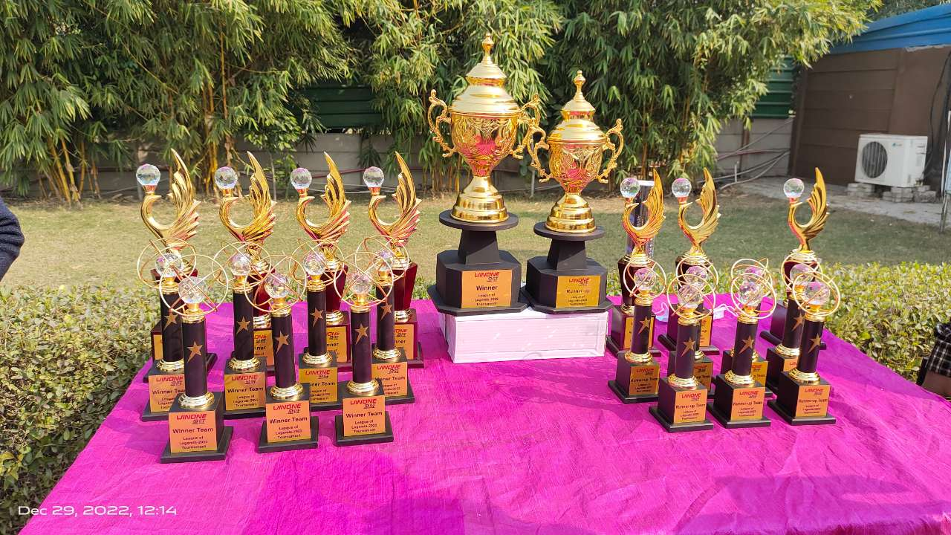

Mr. Tej Singh-Winner (TT)

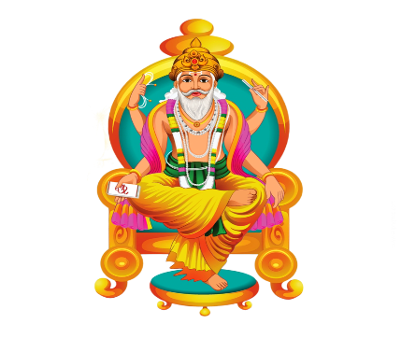
Vishwakarma Puja
Like Last year, this year also on 17th Sept 2021, we have organized Vishwakarma Puja.
Every employees with high energy and zeal participated in the Puja. Here are brief about
conducting Vishwakarma Puja i.e. Vishwakarma Puja, also known as Vishwakarma Jayanti, is
an important festival celebrated by the Hindu community. On this day, the divine architect or the architect of the Gods, Lord Vishwakarma is worshipped. The festival falls on the last day of Bhadra, known as Kanya Sankranti or Bhadra Sankranti.
Shops, factories, and industries primarily observe the festival. On this occasion, workers of factories and industrial areas worship their tools and offer prayers to Lord Vishwakarma to keep their livelihoods secure. They pray for the smooth functioning of machines and refrain from using their tools on the day of Vishwakarma Puja. On this occasion, pictures and special statues of Lord Vishwakarma are installed in factories and workplaces.

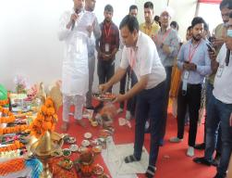
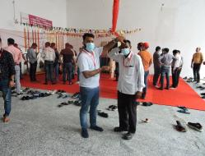
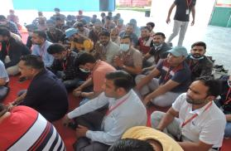
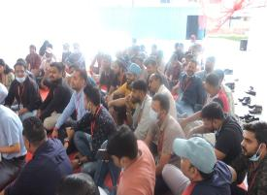

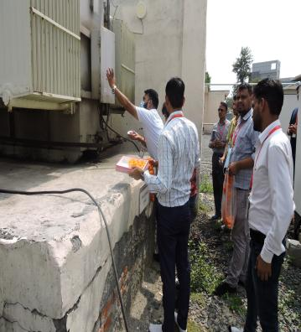
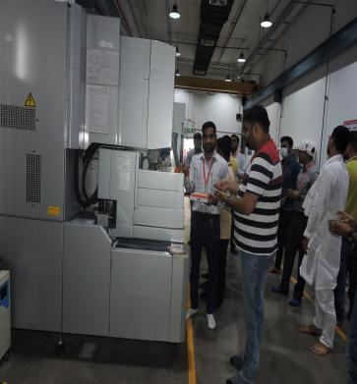
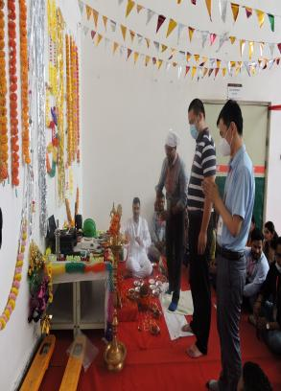
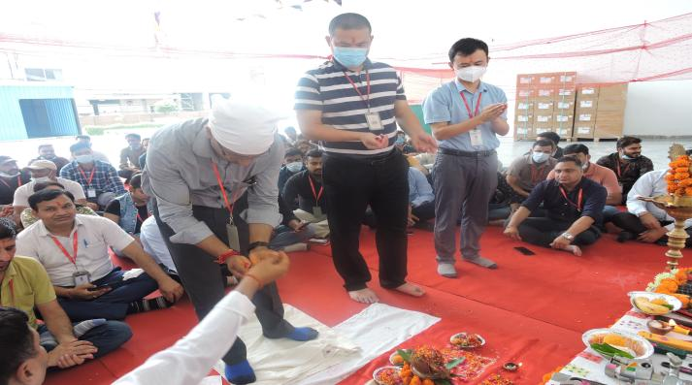


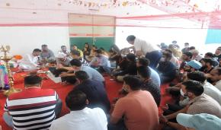
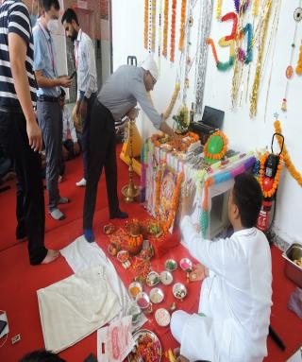


Annual Award Ceremony 2022

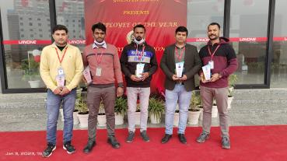
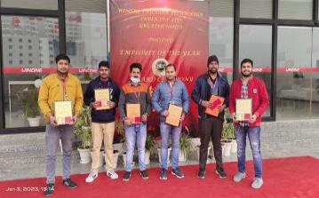
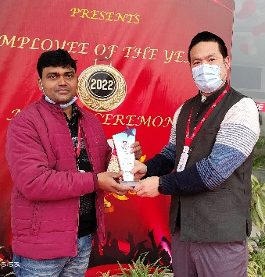
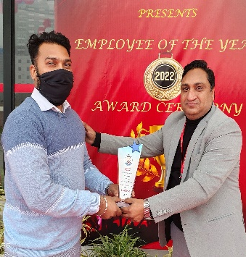
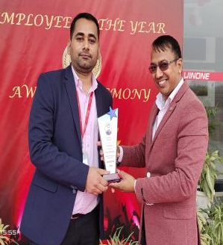

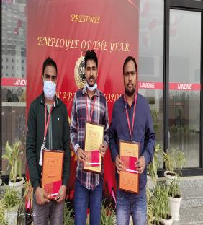
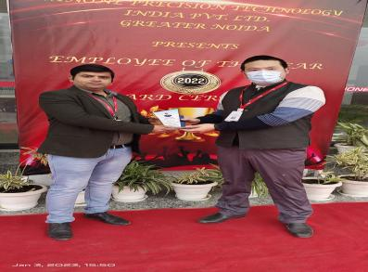
We at Winone believes in Recognizing your employees is a win for everyone, keeping this into consideration Annual Award Ceremony was organised by Winone India on 03-Jan 2023. The Annual Award ceremony recognized outstanding contributions and achievements of our Employees during the year 2022. The award ceremony was held amidst much joy, cheer and applause for all the Winone Employee in the presence of August gathering.

This year we have made impressive progress in our Business goals, constantly and rapidly evolving against the backdrop of a very competitive trading environment The Annual Award Ceremony recognized outstanding contribution and achievements of our employees during the Year 2022.
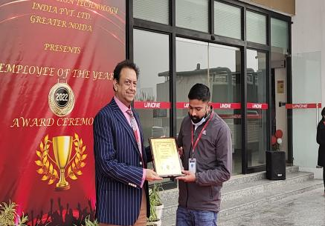
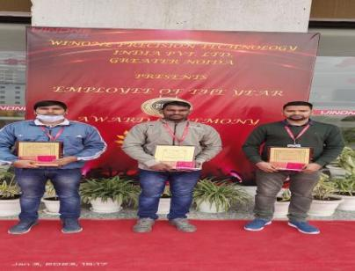

The Award Ceremony was held amidst much Joy, cheer and applause for all the Winone Employees in the presence of August gathering whole company employee are conjoined, in the Annual Award Ceremony. Best performer was honoured with the Prizes.
There are various range of the awards such as:
- Excellent New comer of the Year - 2022
- Safety Star of the Year - 2022
- Best Attendance Award of the Year - 2022
- Excellent Technician of the Year - 2022
- Excellent Line Leader of the Year - 2022
- Win one Quality star of the Year - 2022
- Best Safety Management of the Year - 2022
- Excellent Team Leader of the Year - 2022
- Excellent Manager of the Year - 2022
- Excellent Department of the Year - 2022
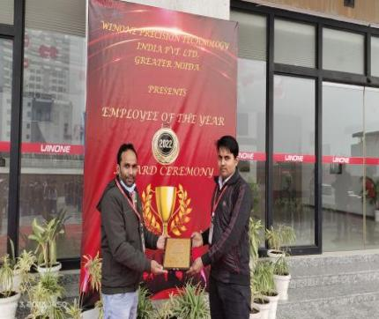
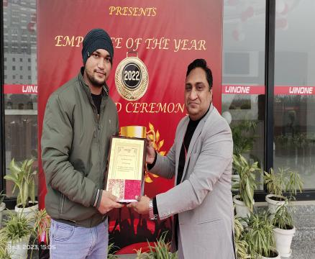

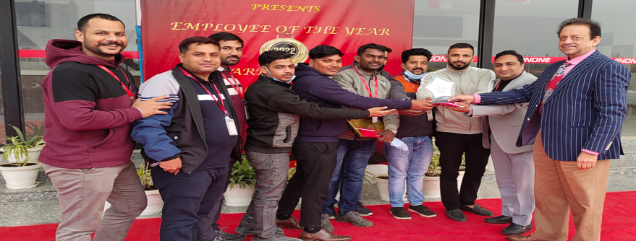

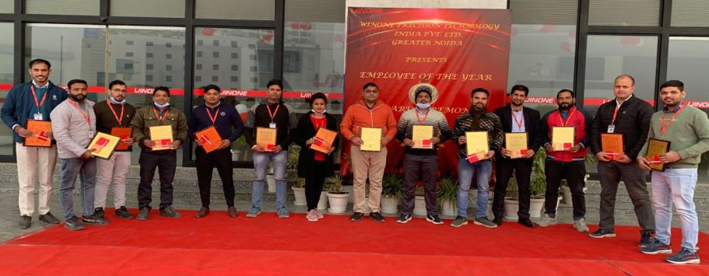

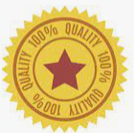

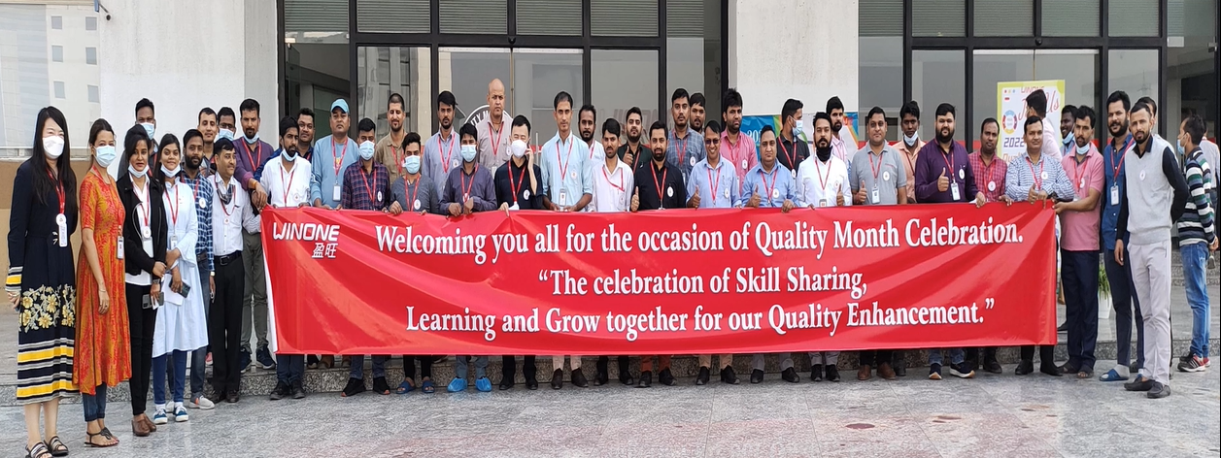
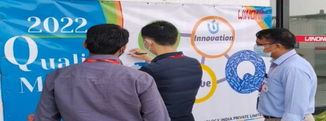
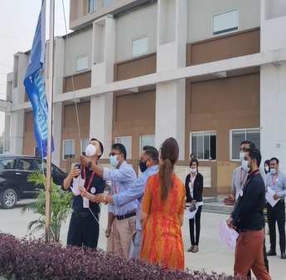
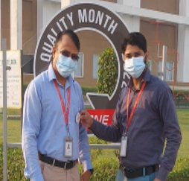
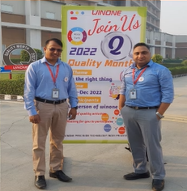
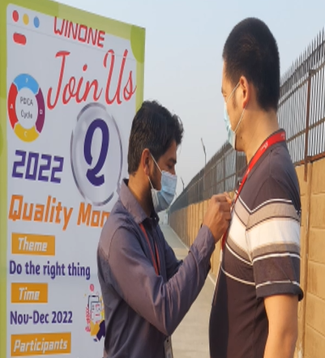
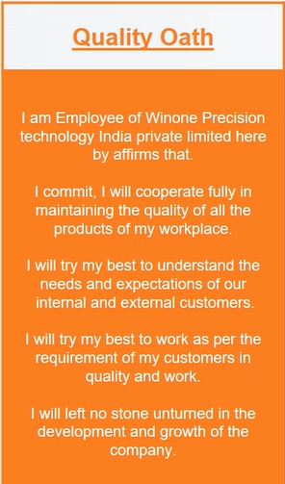
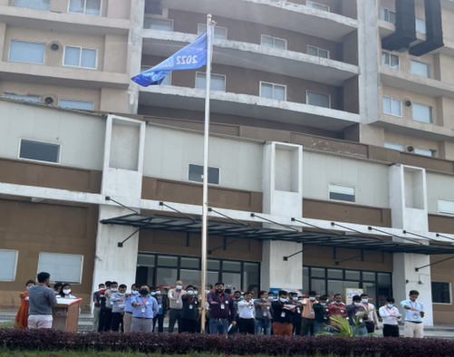

‘Quality Month Celebration’ 2022
On 14 November 2022. Winone celebrate world quality month with the theme of “Do the right thing”. The quality pledge to all employees was administered, and the significance of celebrate quality month and providing real-time feedback to the employees. Various employee engagement activities, such as badge distribution, QMS Training, quality oath, flag hoisting, posters and slogans, were also organized to encourage shop floor employees.
The quality field is known for keeping our noses to the grindstone. And that is important, considering how much depends on the contributions of quality professionals. However, let us not forget to take a minute – or even a month – to celebrate each other.
Welcome to world quality month, where quality professionals across organization come together to celebrate each other.
“The main purpose of the day is to raise quality awareness and to support economic prosperity for individuals and organizations around the world to adopt high-quality standards.”

CLOTHING DONATION CAMPAIGN
Winone is committed to making a difference in the community by providing support and assistance to those who are less fortunate. Our company recognizes the need to redefine the way we come together as a community and to find new ways to uplift and empower those who are struggling to meet their basic needs. To this end, we have launched a series of regular Corporate Social Responsibility (CSR) activities aimed at providing clothing Blankets and stationery to those in need. Our office team buy Blankets, winter wears and stationery items, which are then carefully segregated and distributed to underprivileged and vulnerable individuals, especially children who lack these basic necessities like Stationary for study, Woolen Caps,Gloves and Clothes etc .
Our outreach efforts have included donating clothes and stationery to various locations, such as the ILM School, Tugalpur Slum Area, Durga Talkies, and the Surajpur Slum Area near the court & Some random Locations in Greater Noida. Through these efforts, we have been able to provide winter clothing and school kits to approximately 350 people, including many students who were in dire need of these items.
At Winone, we are proud to be making a positive impact in the lives of those around us, and we remain committed to continuing our efforts to uplift and empower our community.

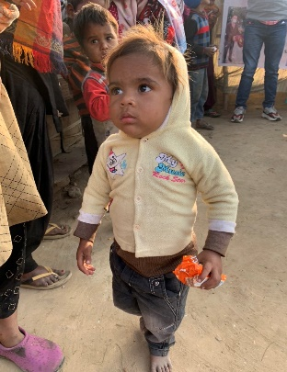
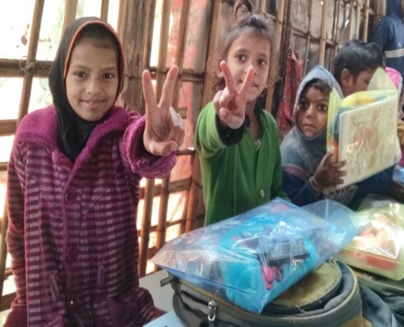

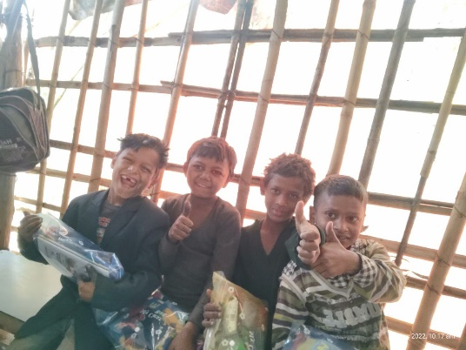
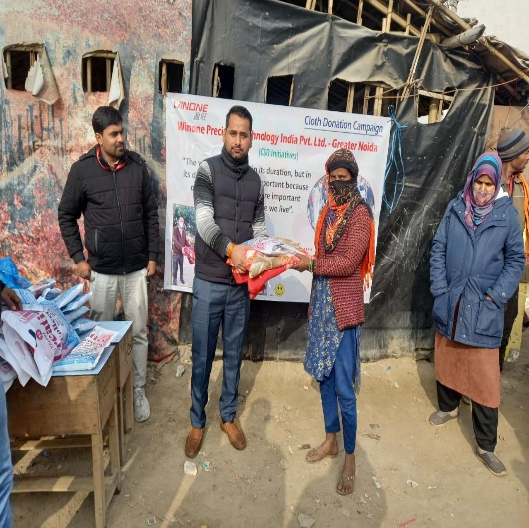
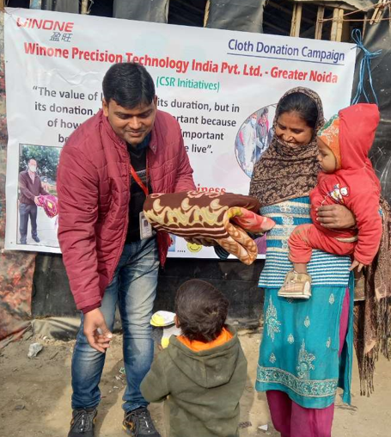
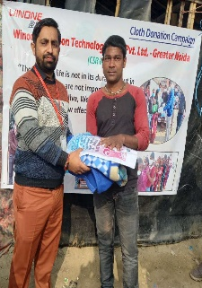
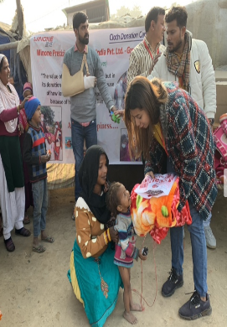
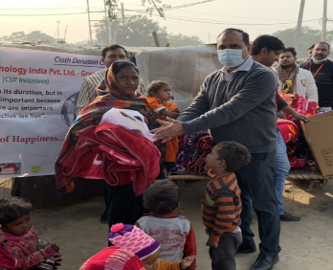
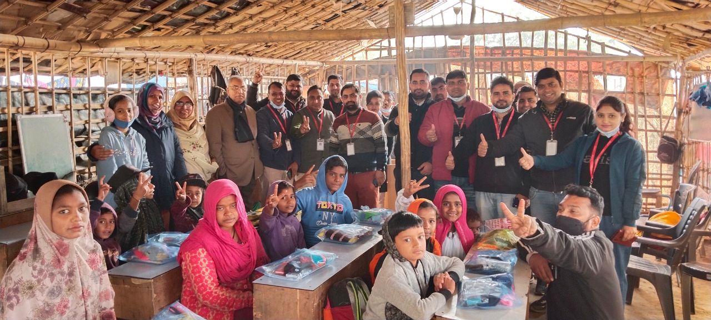
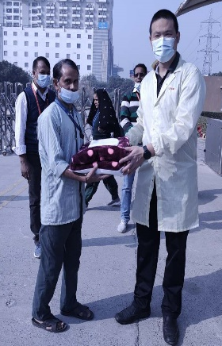
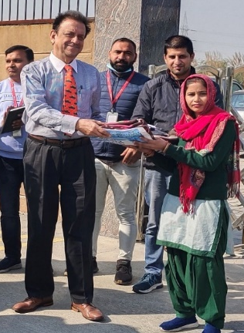
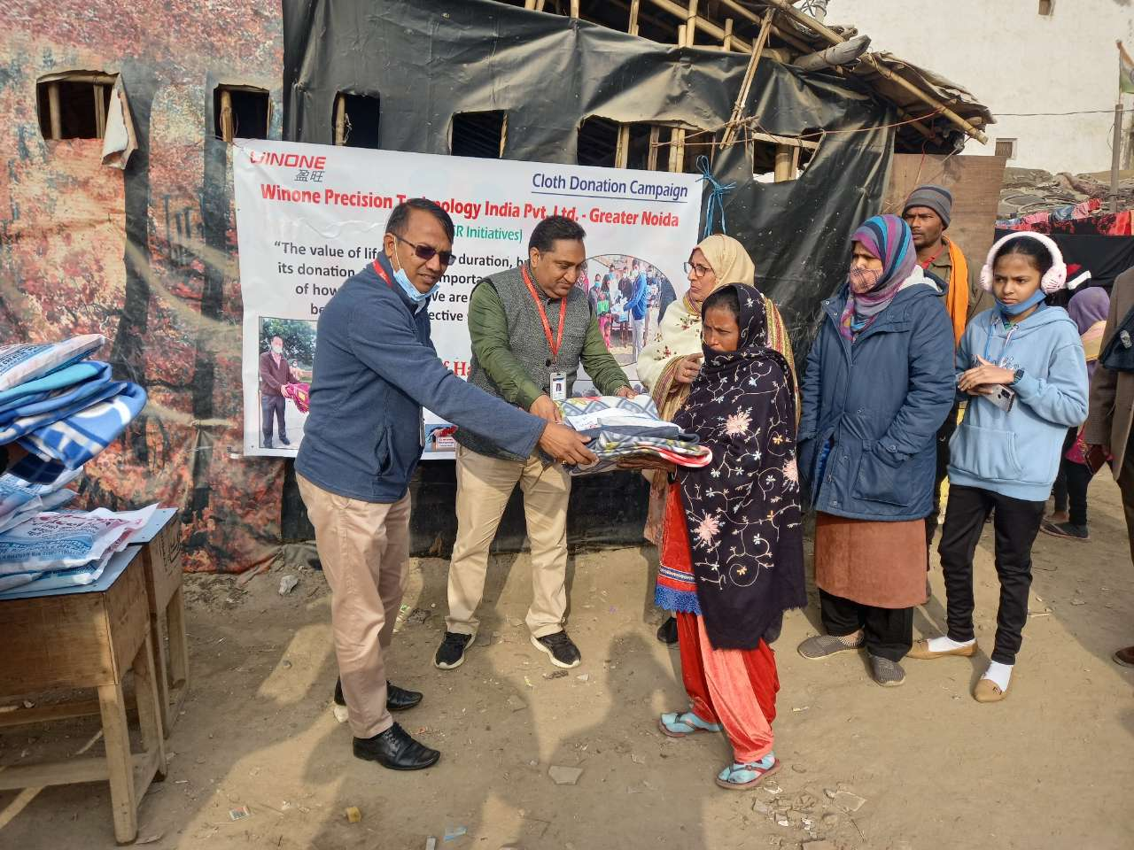
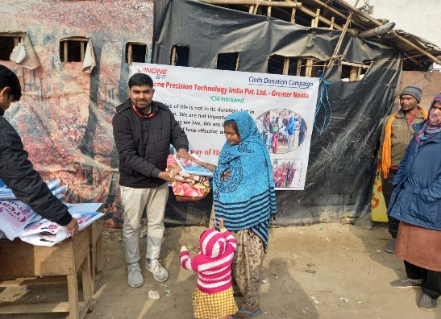

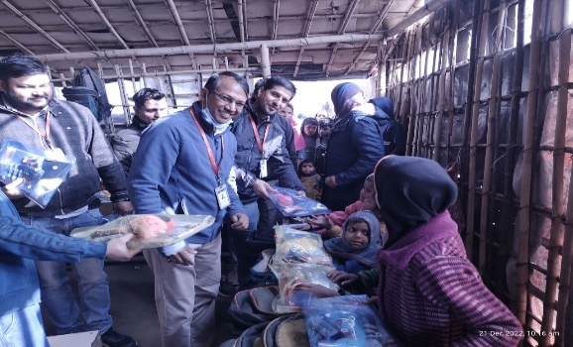
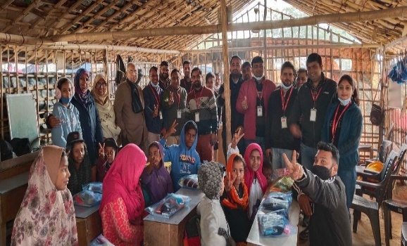
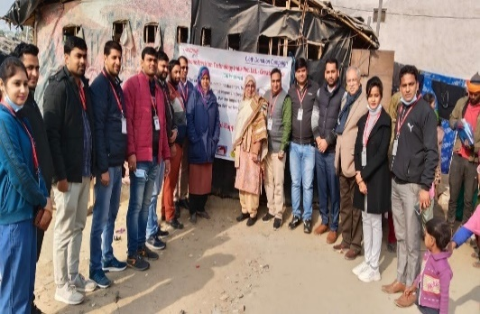

Upcoming Events



ChatGPT: The Intelligent Conversationalist
In today's age of technology and rapid advancement in artificial intelligence, chatbots have become an integral part of our lives. Chatbots are software programs that use artificial intelligence and natural language processing to communicate with humans through text or voice commands. Among the many chatbots available today, ChatGPT stands out as one of the most advanced and intelligent conversationalists.
ChatGPT is a large language model developed by OpenAI, based on the GPT-3.5 architecture. It is an AI-based conversational agent that can respond to a wide range of topics and questions. ChatGPT is built on a large database of text data that includes books, articles, and other written materials, which allows it to understand and respond to a wide range of language input.
One of the most impressive features of ChatGPT is its ability to understand and generate natural language responses. It can carry on a conversation with a human user, respond to queries, and provide helpful information. The responses generated by ChatGPT are natural-sounding and contextual, making it easy for users to interact with the bot as if it were a human.
ChatGPT's interface is simple and intuitive, making it easy for users to interact with the bot. It can be accessed through a variety of platforms, including messaging apps, social media platforms, and websites. Users can ask ChatGPT questions, get help with a problem, or engage in casual conversation.
One of the unique features of ChatGPT is its ability to generate creative content. It can write stories, articles, and even poetry based on user prompts. This makes ChatGPT a useful tool for writers, marketers, and content creators looking for inspiration or help with their work.
ChatGPT is also constantly learning and improving. As users interact with the bot, it learns from their input and adjusts its responses accordingly. This means that the more users interact with ChatGPT, the more accurate and useful its responses become.
In terms of its potential applications, ChatGPT has a wide range of uses. It can be used as a customer support tool, providing assistance to customers with questions or problems. It can also be used in education, as a tool for students to get help with their studies or to practice their language skills. ChatGPT can also be used in marketing, as a tool to generate content and engage with customers.
Overall, ChatGPT is an impressive AI-based conversational agent that has the potential to revolutionize the way we interact with technology. Its ability to understand and generate natural language responses, its creative capabilities, and its constant learning and improvement make it an invaluable tool for a wide range of applications.
With ChatGPT, the future of conversational AI is looking bright.
Visit Websites:- https://chat.openai.com/chat


 | 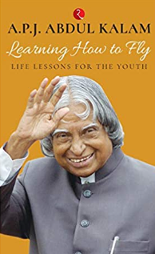  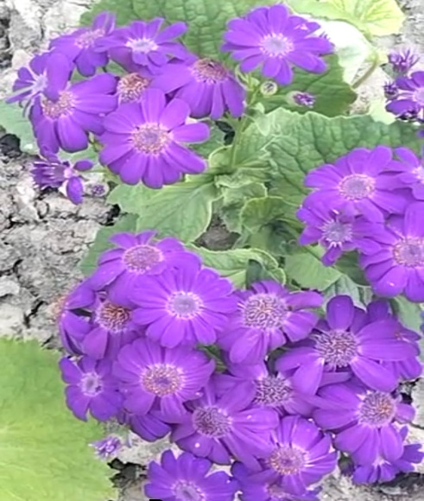 |  | 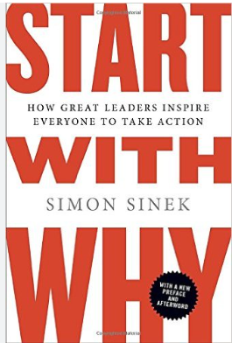   | Some Amazing Books to Study  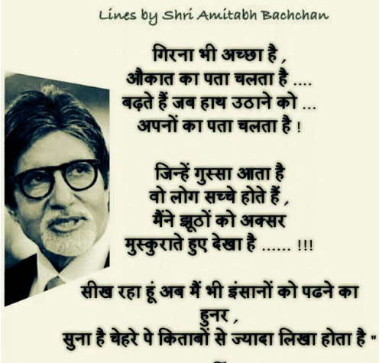
Fun Corner
क्या खोजते हो दुनिया में,
जब सब कुछ तेरे अन्दर है।
क्यों देखते हो औरों में,
जब तेरा मन ही दर्पण है।

दुनिया बस एक दौड़ नहीं,
तू भी अश्व नहीं है धावक।
रुक कर खुद से बातें करले,
अन्तर मन को शान्त तो करले।

सपनों की गहराई समझो,
अपने अन्दर की अच्छाई समझो।
स्वाध्याय की आदत डालो,
जीवन को तुम खुलकर जीलो।

आलस्य तुम्हारा दुश्मन है तो,
पुरुशार्थ को अपना दोस्त बनालो।
जीवन का ये रहस्य समझलो,
और खुशीयों से तुम नाता जोड़ो।

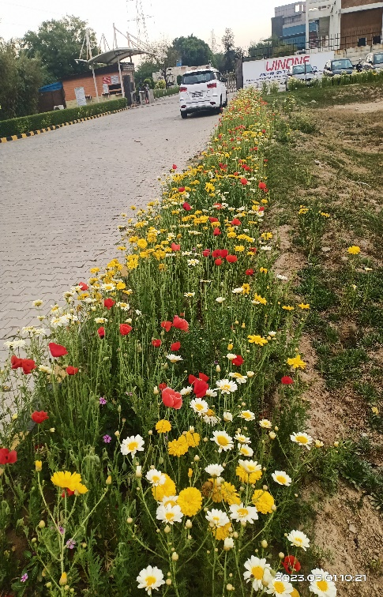
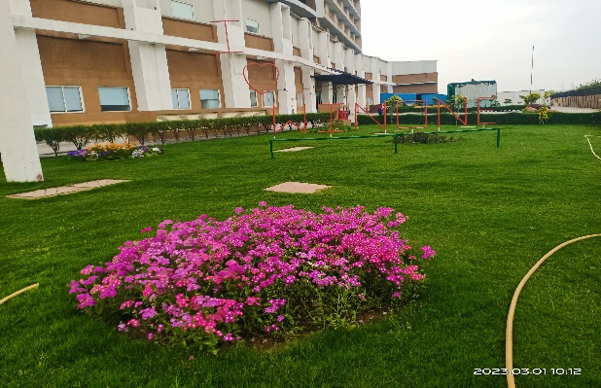

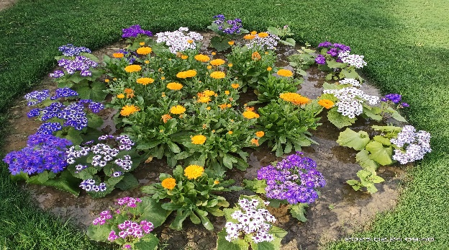
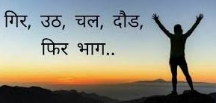

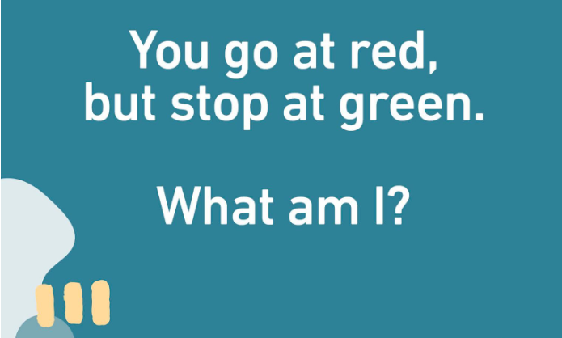
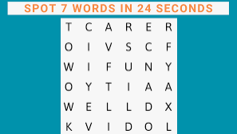
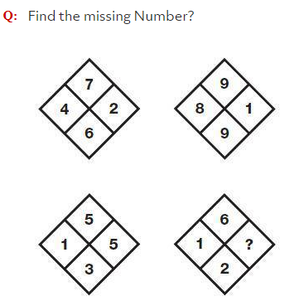
What 8 letter word can have a letter taken away and it still makes a word. Take another letter away and it still makes a word. Keep on doing that until you have one letter left. What is the word?

Riddle
Can you name three consecutive days without using the words Monday, Tuesday, Wednesday, Thursday, Friday, Saturday, or Sunday?


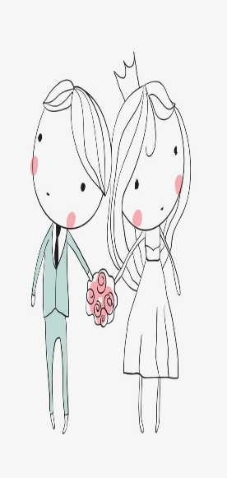

"May your joining together bring you more joy than you can imagine."
Ram Gopal
Bhanu Pratap Yadav
Anshul Kumar
Shiv Kumar
Bhupesh Chandra
Vivek Kumar Sharma
Bipan Kumar
Chandan Kumar Bind
Amit
Ritesh Kumar Sah
Pallavi Suman
Deepak Joshi
Heartily Congratulations to All of You.
Wishing you a lifetime of love and happiness.






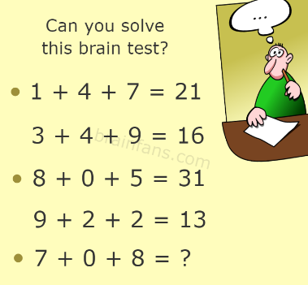

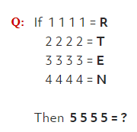

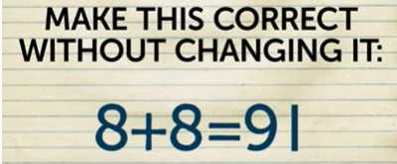


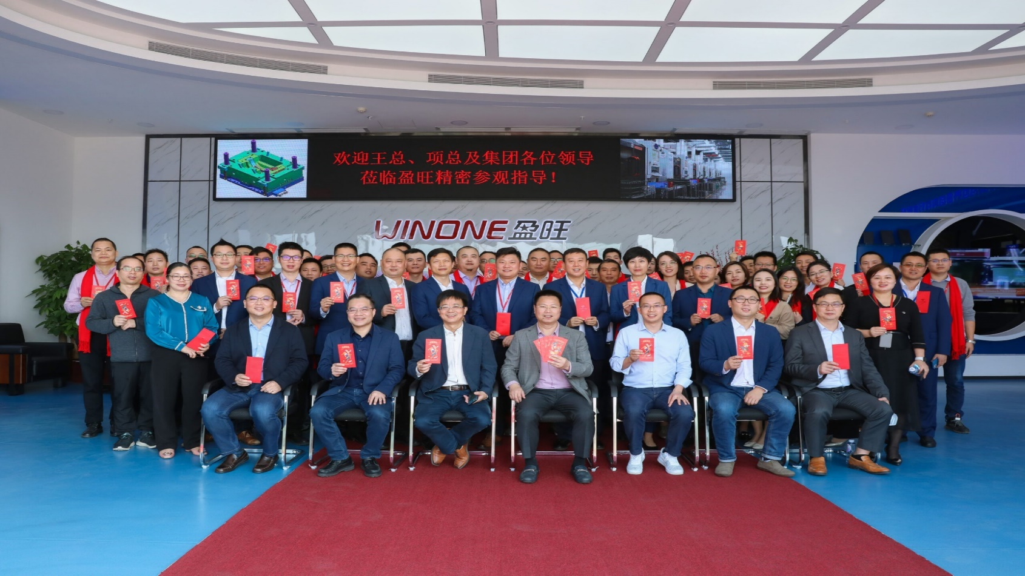
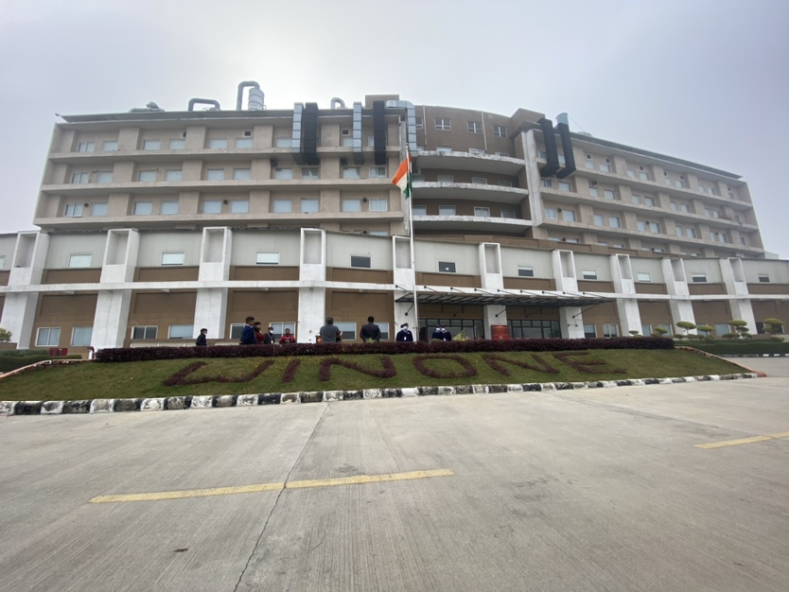

Regd. office: Plot No.2, Knowledge Park 3, Greater Noida, UP-201306, India

Contact No: - +91-8826331151

Email:-india.infohr@hz-winone.com

You can now connect with us on YouTube channel

“Winone Precision Technology -GN India”

